ANNA ADARSH COLLEGE FOR WOMEN(AUTONOMOUS)
CHENNAI - 40
(M.Sc. Chemistry)

Organic Reaction Mechanism and Stereochemistry
Semester : I Max. Marks : 75
Sub Code: 24PMSCH101 Time : 3 Hours
SECTION A – (10 X 1= 10)
ANSWER ANY TEN QUESTIONS

- What is partial rate factor?
The rate of substitution at one specific site in an aromatic compound relative to the rate of substitution at one position in benzene. For example, the partial rate factor for para-substitution in a monosubstituted benzene C6H5Z is related to the rate constants and for the total reaction (i.e. at all positions) of C6H5Z and benzene, respectively, and % para (the percentage para-substitution in the total product formed from C6H5Z)
- Explain Hammett and Taft equation.
The Hammett equation is a linear free energy relationship used in chemistry to relate the rates of reaction or equilibrium constants of substituted aromatic compounds to a standard compound. It quantitatively describes how the electronic properties of substituents affect reaction properties, typically expressed as:
log⁡(kk0)=σ⋅ρlog(k0​k​)=σ⋅ρ

3.Define ambident nucleophile. Give two examples.

Ambident nucleophiles are species that can attack an electrophile at two different sites, thus having the ability to act as nucleophiles via more than one atom. This dual reactivity can lead to different products depending on which site is involved in the reaction.
Two examples of ambident nucleophiles are:
- Cyanide ion (CN-): Can attack through the carbon or the nitrogen atom.
- Nitrite ion (NO2-): Can participate in reactions through the nitrogen atom or one of the oxygen atoms.

4.Give the limitation of Friedal Craft alkylation.
The three key limitations of Friedel-Crafts alkylation are:
- Carbocation Rearrangement - Only certain alkylbenzenes can be made due to the tendency of cations to rearrange.
- Compound Limitations - Friedel-Crafts fails when used with compounds such as nitrobenzene and other strong deactivating systems.
- Polyalkylation - Products of Friedel-Crafts are even more reactive than starting material. ...

5.Give the two factors in which the stereochemistry of electrophilic addition to C-C multiple bond is effected.
- The structure of the electrophile and its steric and electronic properties.
- The stereochemistry of the starting alkene, specifically whether it is cis or trans.

6.State Markownikoff and Antimorkownikoff addition to C-C double bond.
Markovnikov's addition refers to the rule stating that when HX (where X is a halogen or similar group) adds to an alkene, the hydrogen (H) will attach to the carbon with more hydrogen substituents, while the more electronegative atom (X) attaches to the carbon with fewer hydrogens. This results in the formation of the more stable carbocation intermediate.
Antimarkovnikov's addition, on the other hand, involves the opposite outcome, where the hydrogen adds to the carbon with fewer hydrogen atoms, and the electronegative group adds to the carbon with more hydrogen atoms. This type of addition is often facilitated by specific reagents, like peroxides in the case of HBr.

7.Write short notes on chiral shift reagents
Chiral shift reagents are substances used in NMR (nuclear magnetic resonance) spectroscopy to induce a difference in chemical shifts of enantiomers, allowing for the differentiation of chiral molecules. These reagents work by forming diastereomeric complexes with the chiral analyte, which then exhibit different resonance frequencies due to their distinct environments. Common examples include Lanthanide(III) ions, such as Eu(fod)3 (europium tris(2,6-difluoro-3-oxooctanoyl)), which selectively interacts with one enantiomer over the other.

8.Give any two criteria for optical activity.
- Chirality: A substance must have chiral centers, meaning it should exist in non-superimposable mirror image forms (enantiomers). This property is essential for any substance to exhibit optical activity.
- Absence of Internal Symmetry: The molecule must lack a plane of symmetry, which prevents it from being superimposable on its mirror image, making it capable of rotating plane-polarized light.

9.State Brett’s rule

Bredt's Rule states that bridged ring systems cannot have a double bond at the bridgehead position. Bretd’s Rule cautions us on the type of rings that could bear a double bond.

10.What is the function of amalgamated zinc in clemmenson redfuction?

Amalgamated zinc acts as a reducing agent in Clemmensen reduction, which is a method for converting ketones or aldehydes into alkanes. In this process, the amalgamated zinc (often zinc in mercury) facilitates the removal of oxygen, leading to the formation of hydrocarbons from carbonyl compounds.
11.What is the function of barium sulphate in Rosemunds reduction? What happens when barium sulphate is not added?
Barium sulfate reduces the activity of the palladium due to its low surface area, thereby preventing over reduction. To prevent further reduction, (as in the case of more reactive acyl chlorides), poison can be added to totally deactivate the palladium catalyst.
12.Draw the structure of (2R,3S)-2,3 dichloropentane.

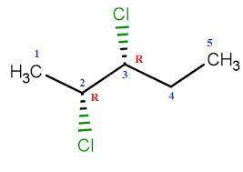

SECTION B – (5 X 5 = 25)
ANSWER ANY FIVE QUESTIONS

13. Using isotopic labelling method how will you determine the mechanism of reaction?

Isotopic labeling can be used to determine the mechanism of a chemical reaction by tracking the incorporation and movements of isotopes throughout the reaction process. This involves replacing certain atoms in reactants with their isotopes (for example, using ^13C instead of ^12C). By analyzing the products of the reaction, researchers can deduce the pathways and intermediates involved, as specific isotopes will appear in specific products according to the mechanisms at play. Techniques such as NMR spectroscopy, mass spectrometry, or chromatographic methods can be utilized to detect these isotopes and provide insights into the reaction mechanism.
14.How will you convert phenol to salicylaldehyde? Give the mechanism
When phenol, i.e. C₆H₅OH, is treated with CHCl₃ (chloroform) in the presence of NaOH (sodium hydroxide), an aldehyde group (-CHO) is introduced at the ortho position of the benzene ring leading to the formation of o-hydroxybenzaldehyde. The reaction is popularly known as the Reimer Tiemann reaction.
⇒
A common example of the Reimer Tiemann reaction is the conversion of phenol to salicylaldehyde (2-hydroxy benzaldehyde),
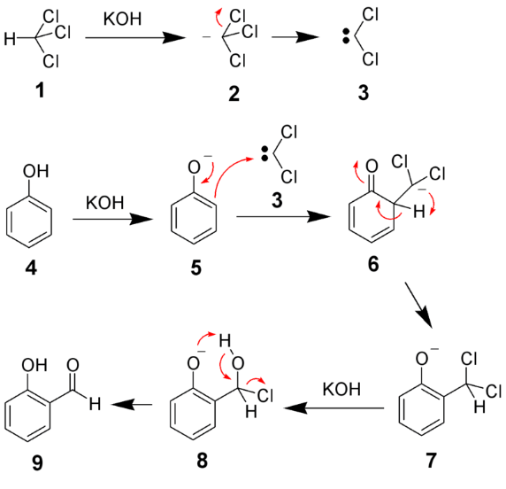

15. Explain the aromaticity exhibited by azulene.

A zulene exhibits aromaticity due to its unique structure and electron distribution. It is a bicyclic compound with a fused five-membered and seven-membered ring. Azulene has a total of 10 pi electrons—5 from the five-membered ring and 5 from the seven-membered ring—which follow Hückel's rule of aromaticity (4n + 2, where n = 2). Additionally, azulene is non-planar but still manages to maintain aromatic character through resonance and delocalization of its electrons, which contributes to its stability and distinctive properties, such as its deep blue color. Always verify specific details from reliable sources.
16. Explain the order of double bond reactivity towards electrophilic addition of following compounds
CH₃CH=CH₂, CCl₃CH=CH₂, ClCH₂CH=CH₂, Cl₂CH-CH=CH₂

he reactivity of the double bonds towards electrophilic addition in the given compounds is influenced by the electron-withdrawing or electron-donating nature of substituents. The order of reactivity from highest to lowest is as follows:
- CH3CH=CH2 (Propene) - Least hindered and has electron-donating alkyl group, promoting reactivity.
- ClCH2CH=CH2 (Allyl chloride) - The chlorine is less electron-withdrawing compared to others, making it more reactive than others with stronger electron-withdrawing groups.
- CCl3CH=CH2 (Trichloroethylene) - The presence of three electronegative chlorine atoms makes this compound less reactive due to strong electron withdrawal.
- Cl2CH-CH=CH2 (Dichlorovinyl) - With two chlorine atoms adjacent to the double bond, it has significant electron-withdrawing effects, making it the least reactive.
Thus, the order is: CH3CH=CH2 > ClCH2CH=CH2 > CCl3CH=CH2 > Cl2CH-CH=CH2.

17.Give the mechanism of free radical addition to C-C multiple bonds
he mechanism of free radical addition to C-C multiple bonds typically involves three main steps: initiation, propagation, and termination.
- Initiation: A free radical is generated, often by the decomposition of a peroxide or by using heat or light to break a bond, producing two free radicals.
- Propagation: The free radical adds to the C-C multiple bond, forming a new radical intermediate. This intermediate can then react with another molecule, regenerating a free radical and continuing the chain reaction. For example, when a radical adds to an alkene (C=C), it forms a radical on the carbon atom that was part of the double bond.
- Termination: The reaction proceeds until two free radicals combine, forming a stable product and effectively terminating the chain reaction.

18.Write short notes on (i) cotton Effect (ii) ORD curves

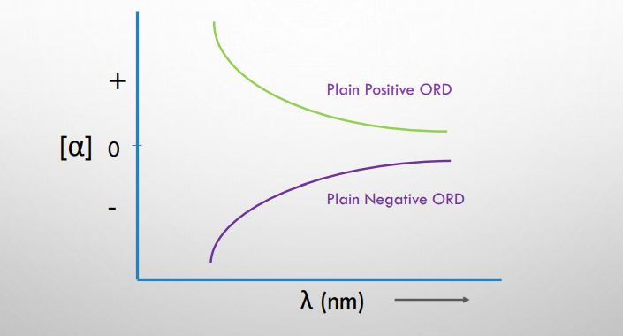
PRINCIPLE chemicals are those that have the capacity to rotate the plane of polarized light. Optically active substances have this characteristic. Polarimeter is used to measure it. In the wavelength range of optically active compounds, a phenomenon known as circular dichroism (CD) occurs when the amount of absorption of left and right circularly polarized light varies.
By shining left and right circularly polarized light through an optically active material, CD measurements may identify these variations. The resulting elliptically polarization of the transmitted light is known as circular dichroism (CD).
Cotton effect curve
Cotton effect curves are also known as anomalous dispersion of optical rotation. Cotton effect curves are obtained for the compound with asymmetric carbon and chromophore which absorbs near UV region. Cotton effect curves are mainly classified into two types:
- Single cotton effect curve
- Multiple cotton effect curve
- Single cotton effect curve
At maximal absorption, the cotton effect curve exhibits both the maximum and the minimum curve. Positive cotton effect occurs when the crest first passes through the trough and moves toward the cotton effect region and negative cotton effect occurs when the trough moves first through the crest and moves toward the cotton effect region. The vertical distance between crest and trough is called amplitude.
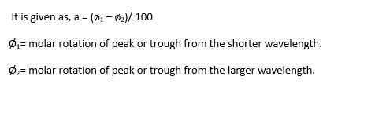

19. Complete the reaction and give the mechanism of following reactions

(i)COCl₂,(2) DMSO
R-CH2OH ?
(3) Et₃N

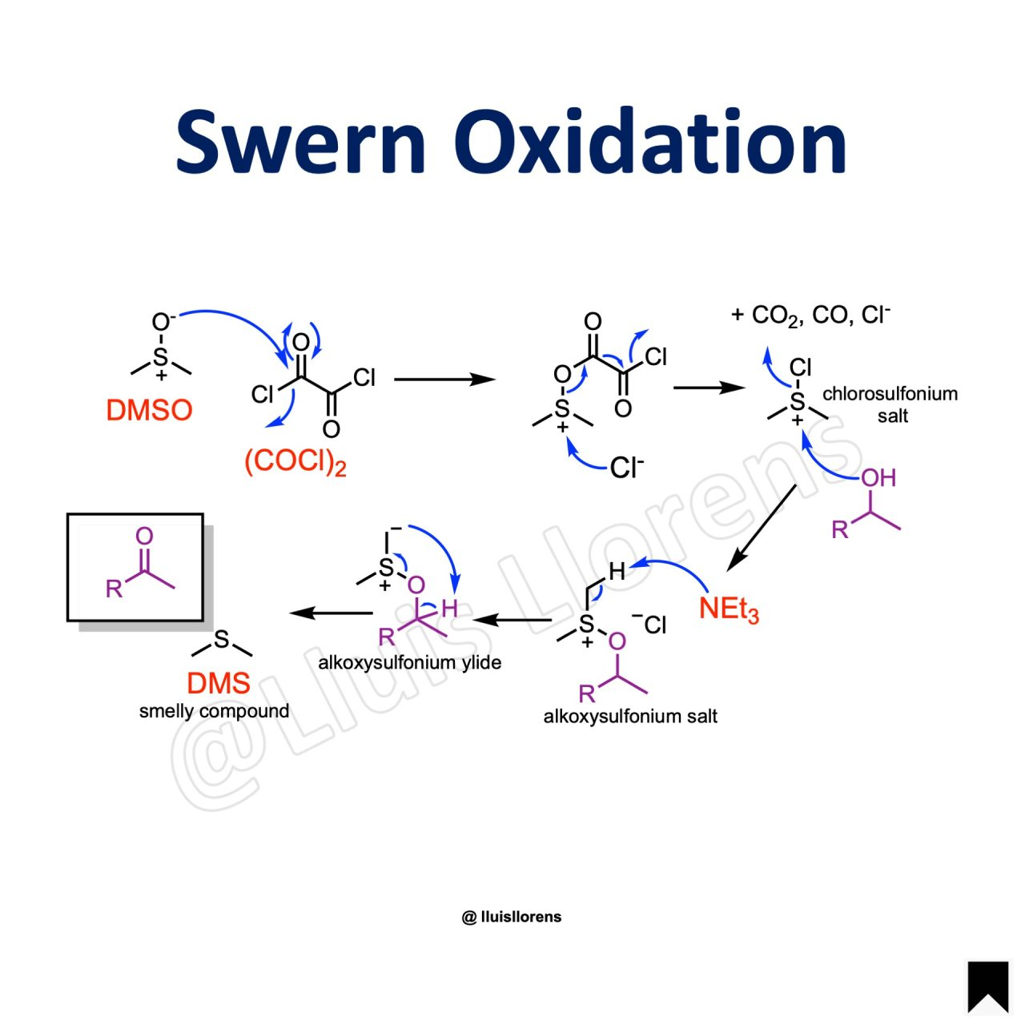

SECTION C – (4 X 10 = 40)
ANSWER ANY FOUR QUESTIONS

20. Explain the stereochemical evidence , determination of intermediates and product analysis methods for determining the mechanism of reaction
Stereochemical evidence 3 Marks
Determination of intermediates 4 marks
Product analysis 3 Marks

21. Complete and Give the mechanism of following reaction
(i)KCN(ii) aqueous Ethanol
- (Br)C6H4 (NO2) ?

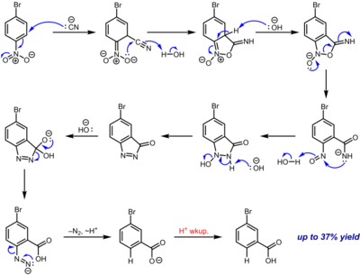

- Smiles Rearrangement
The Smiles rearrangement is a chemical reaction involving the conversion of an aromatic or aliphatic amine into an aryl- or alkyl-substituted hydrazine via a process typically involving a rearrangement mechanism. This transformation usually starts with the formation of an intermediate azine, which subsequently rearranges in the presence of a suitable acid catalyst to give the desired product
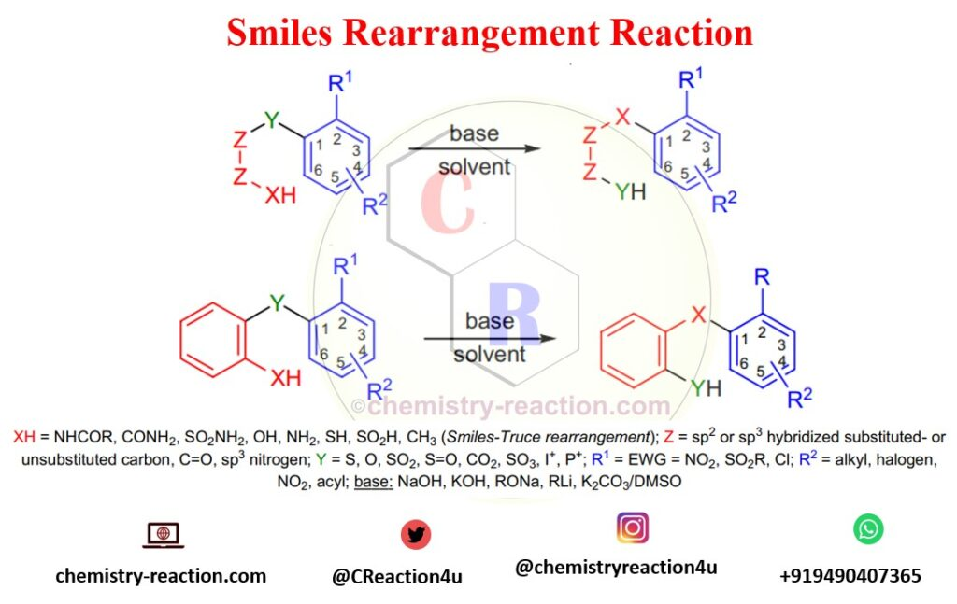

22. Complete the reaction and give the mechanism of following conversions
Na (metal)
(i) R₁COOR₂ RCH₂OH + R₂-OH

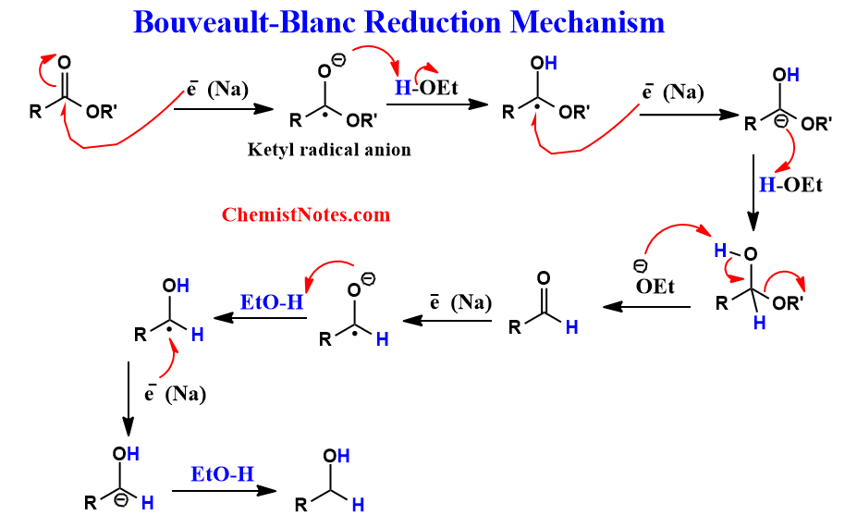

Al(i-Pro)₃
(ii) CH3COCH3 ?
IPA
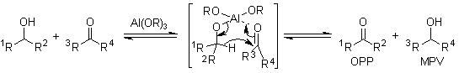
23. Give the sequence rule to determine the order of priority of groups attached to chiral carbon.

Sequence rules any 5 10 Marks

24.Complete and give the mechanism of the following reactions
(i) NCS (ii) Me₂S
- CH₃-CH(OH)CH₃ ?
(iii)Et₃N

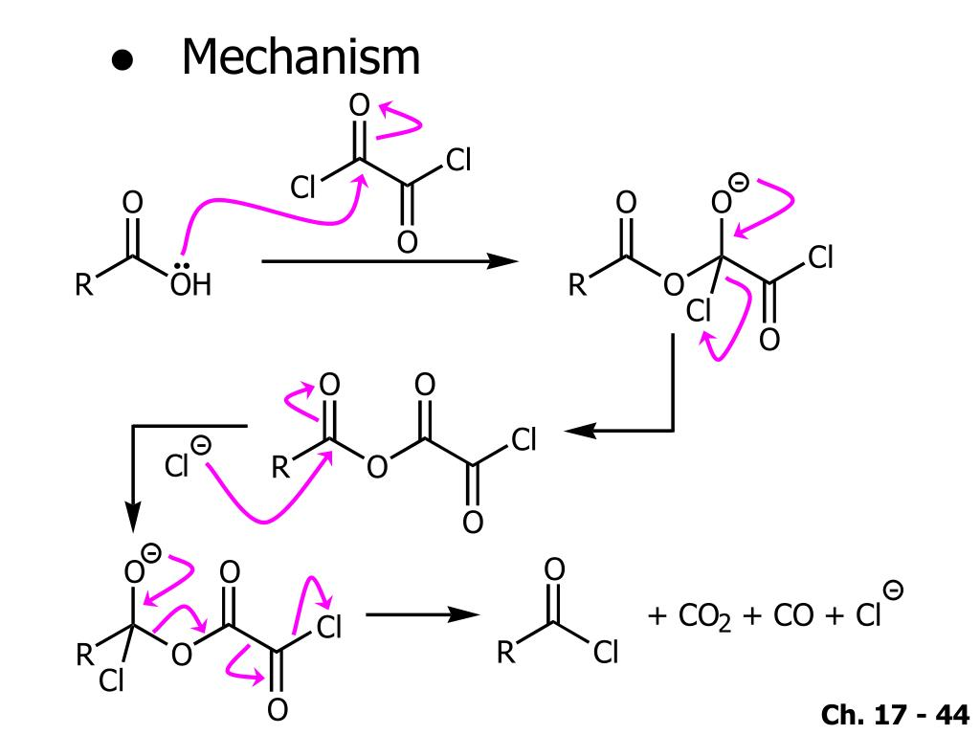

(i)NH2-NH2 (ii)KOH
- CH3COCH3 ?

Wolff Kishner Reduction Mechanism

Step 1: Formation of hydrazone
The aldehyde or ketone is subjected to hydrazine. This yields the hydrazone required for the process. The reaction is illustrated below.
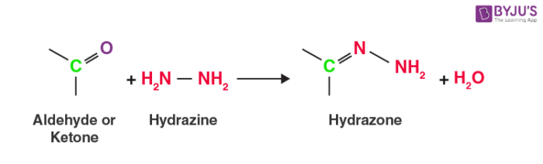

Step 2: Deprotonation of Nitrogen
The terminal nitrogen atom is deprotonated, and it proceeds to form a double bond with the neighbouring nitrogen atom. The released proton attaches itself to the hydroxide ion from the basic environment to form water.
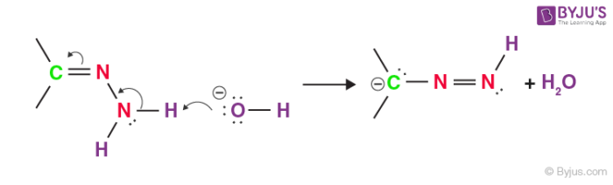

Step 3: Protonation of the Carbon
Since oxygen is more electron-withdrawing than carbon, the carbon is protonated by the water molecule as shown below.
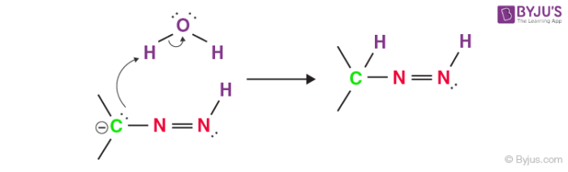

Step 4: Deprotonation of Nitrogen
The terminal nitrogen is deprotonated again, this time forming a triple bond with its neighbouring nitrogen atom. This results in the formation of a carbanion where the two triple-bonded nitrogens are released as nitrogen gas. Similar to step 2, the ejected proton forms water along with the basic environment.
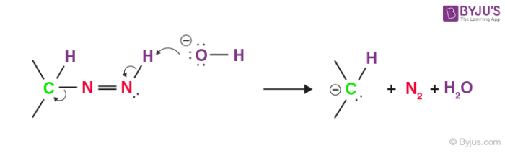

Step 5: Protonation of Carbon
Similar to step 3 of the Wolff-Kishner reduction mechanism, the carbon is protonated by water, resulting in the formation of the desired hydrocarbon product as shown. Thus, the aldehyde or ketone is converted to an alkane.
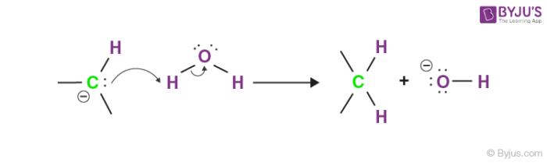
The rate-determining step of this reaction is the bond formation of the terminal carbon with hydrogen (in the hydrazone anion). The carbon-hydrogen bond formation is helped by mildly electron-withdrawing substituents. Highly electron-withdrawing substituents decrease the negative charge of the terminal nitrogen, making it difficult to break the N-H bond.
The Wolff-Kishner reduction has been modified into several techniques, each with its own advantages and disadvantages. For example – the Huang Minlon modification (using the carbonyl compound, 85% hydrazine and potassium hydroxide as the reagent) offers reduced reaction time and the achievement of higher temperatures but requires distillation.
25. (i) Discuss the chemoselectivity of electrophilic addition to C-C double bond.
5 Marks
- What is nucleophilic addition to C-C multiple bond? How is it different from free radical addition to C-C double bond.
5 Marks
.

