ANNA ADARSH COLLEGE FOR WOMEN(AUTONOMOUS)
CHENNAI - 40
(M.Sc. Chemistry)

Bio Inorganic Chemistry
Semester : I Max. Marks : 75
Sub Code: Time : 3 Hours
SECTION A – (10 X 1= 10)
ANSWER ANY TEN QUESTIONS

- Write short notes on calcium signalling proteins.
The process of calcium signaling comprises a series of molecular and biophysical events that link an external stimulus to the expression of some appropriate intracellular response through an increase in cytoplasmic Ca²⁺ as a signal.
- Define coenzyme and Apoenzyme and give examples.
Coenzymes are organic cofactors, and metal ions are inorganic cofactors. All cofactors assist in enzyme function, and inorganic cofactors have the ability to activate enzymes. An activated enzyme with a cofactor attached is called a holoenzyme. An inactive enzyme without a cofactor is called an apoenzyme.
- Define cytochromes. Give their classification
Cytochromes are proteins that contain heme groups and are involved in electron transport and redox catalysis. They are classified based on the type of heme and how it binds:
- Heme type: The type of heme in the cytochrome, such as heme a, heme b, heme c, or heme d
- Mode of heme-iron axial ligation: The structure and how the heme attaches to the protein
- Amino acid sequence similarity: The similarity of the amino acid sequences
- How do haemoglobin and myoglobin differ in their structure?
- Number of subunits
Hemoglobin is a tetramer, meaning it's made up of four subunits, while myoglobin is a monomer, meaning it's made up of a single subunit.
- Structure type
Hemoglobin has a quaternary structure, while myoglobin has a tertiary structure.
- Composition
Hemoglobin is made up of four polypeptide chains, while myoglobin is made up of a single polypeptide chain.
- Amino acid content
Hemoglobin's polypeptide chains are made up of 141 (alpha) and 146 (beta) amino acid residues, while myoglobin is made up of 154 amino aci

- What are the characteristic feature of nitrogenase enzyme?
- Oxygen sensitivity: Nitrogenase is very sensitive to oxygen and is deactivated in its presence.
- Anaerobic conditions: Nitrogenase requires anaerobic conditions to function.
- ATP-dependent: Nitrogenase is dependent on ATP for its activity.
- Consists of two proteins: Nitrogenase is made up of two proteins: the molybdenum-iron protein (MoFeP) and the iron protein (FeP).
- Heterotetramer: Nitrogenase is a heterotetramer, meaning it consists of two alpha and two beta subunits.
- Mo-Fe protein: Nitrogenase is a Mo-Fe protein.
- Fe-S clusters: Nitrogenase contains Fe-S clusters between the alpha and beta subunits.
- Oxidation state: The oxidation state of Mo in the nitrogenase enzyme is Mo(III).
- Name the two components of nitrogenase.
T he two components of nitrogenase are the iron (Fe) protein and the molybdenum-iron (MoFe) protein:
- Name the two anti-cancer drugs containing Pt.
Two anti-cancer drugs that contain platinum are cisplatin and carboplatin:
- Cisplatin: The first platinum compound to be discovered with anti-cancer activity.
- Carboplatin: One of the two platinum drugs that received widespread regulatory approval after cisplatin

- Give the ill effects of non- threshold toxin mercury.
The health impacts of mercury are numerous including kidney and nervous system damage and skin problems. Exposure of the fetus to methylmercury poses danger to the unborn child. The inorganic salts of mercury are corrosive to the skin, eyes and gastrointestinal tract, and may induce kidney toxicity if ingested.

- Define enzymes.Explain their nomenclature.
Enzymes are proteins or RNA that catalyze biological reactions in living cells. They are named based on the substrate they interact with or the chemical reaction they catalyze, and often end with the suffix "-ase":
- Nomenclature
Enzymes are named after the substrate or reaction they catalyze, and often end with the suffix "-ase". For example, the enzyme that catalyzes the hydrolysis of maltose into glucose is named maltase

- Discuss the role of catalyst in enzyme action.
A catalyst is a substance that speeds up a chemical reaction without being chemically altered itself. Enzymes are biological catalysts that increase the rate of biochemical reactions in living organisms. Here's how enzymes work as catalysts:
- Substrate attachment
The substrate attaches to the enzyme's active site, which is a specific region of the enzyme with a distinct geometric shape.
- Electron distribution
The substrate's attachment to the enzyme changes the distribution of electrons in the substrate's chemical bonds.
- Reaction
This change leads to reactions that create products.
- Product release
The products are released from the enzyme, which can then be used again in another reaction.
- Activation energy
Enzymes lower the activation energy of a reaction, which allows the reaction to progress towards equilibrium more quickly.

- Give the structure of carboxy peptidase A
Carboxypeptidase A (CPA) is a digestive enzyme that breaks down peptide bonds in polypeptide chains. Its structure includes:
- Zinc metal center: A tetrahedral zinc (Zn2+) metal center at the active site, surrounded by amino acid residues that facilitate catalysis and binding
- Amino acid residues: The amino acid residues Glu-270, Arg-71, Arg-127, Asn-144, Arg-145, and Tyr-248 are important for catalysis and binding
- Polypeptide chain: A single polypeptide chain with a mixture of α-helices and β-sheets
- Disulfide bond: A disulfide bond connects the residues Cys138 and Cys161
- Active forms: Six
12.Name the two steps involved in the nitrogen fixation.

The two steps involved in nitrogen fixation are:
- Atmospheric fixation: Involves lightning
- Industrial fixation: Involves manufacturing ammonia under high temperature and pressure conditions

SECTION B – (5 X 5 = 25)
ANSWER ANY FIVE QUESTIONS

- What is nitrogenase and what are the three types of nitrogenase found in nitrogen fixing bacteria
Nitrogenase is an enzyme that catalyzes the reduction of nitrogen (
N2cap N sub 2
𝑁2
) into ammonia (
NH3cap N cap H sub 3
𝑁𝐻3
), a key step in the global nitrogen cycle. The three types of nitrogenase found in nitrogen-fixing bacteria are:

- Molybdenum (Mo) nitrogenase
The most common and efficient nitrogenase in nature. It contains the iron-molybdenum cofactor (FeMo-co).

- Vanadium (V) nitrogenase
A homologous nitrogenase that resembles Mo-nitrogenase in primary sequence and cluster type.

- Iron-only (Fe) nitrogenase
A homologous nitrogenase that resembles Mo-nitrogenase in primary sequence and cluster type.
- Define Cooperativity Effect.
cooperativity, in enzymology, a phenomenon in which the shape of one subunit of an enzyme consisting of several subunits is altered by the substrate (the substance upon which an enzyme acts to form a product) or some other molecule so as to change the shape of a neighbouring subunit.
- With a neat graph explain Bohr Effect
The Bohr effect is a phenomenon that describes how hemoglobin's affinity for oxygen decreases as the pH of the blood decreases. This can be illustrated using an oxygen-hemoglobin dissociation curve, where the x-axis represents the partial pressure of oxygen (pO2) and the y-axis represents the percentage saturation of hemoglobin with oxygen.

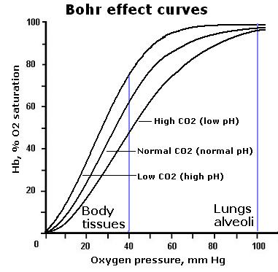
- Explain the structure of peroxide and give the reaction of how it functions in breaking the peroxide linkage
Peroxides are a group of compounds with the structure R-O-O-R, where R represents any kind of atom. The O-O bond is called the peroxide group.
- Vanadium have been found to mimic insulin . Explain
Both inorganic and organic vanadium compounds have been shown to lower plasma glucose levels, increase peripheral glucose uptake, improve insulin sensitivity, decrease plasma lipid levels, and normalize liver enzyme activities in a variety of animal models of both type I and type II diabetes. Vanadium treatment of diabetic animals does not restore plasma insulin levels but may spare pancreatic insulin. Elucidation of the mechanism(s) of action and potentiation of vanadium's insulin-mimetic effect by appropriate ligand binding

18.How are enzymes classified based on the type of reaction they catalyse.
Enzymes are classified into seven categories based on the type of reaction they catalyze:
- Oxidoreductases: Catalyze oxidoreduction between two substrates
- Transferases: Catalyze the transfer of a group between a pair of substrates
- Hydrolases: Catalyze hydrolysis of ester, ether, peptide, and halides
- Lyases: Catalyze removal of groups from substrates by mechanisms other than hydrolysis leaving double bonds
- Isomerases: Catalyze inter conversion of optical, geometric, or positional isomers
- Ligases: Catalyze the linking together of two compounds
- Translocases: Another category of enzymes

19. Discuss the effect of pH and temperature on enzyme reaction with a neat graph
emperature: Raising temperature generally speeds up a reaction, and lowering temperature slows down a reaction. However, extreme high temperatures can cause an enzyme to lose its shape (denature) and stop working. pH: Each enzyme has an optimum pH range. Changing the pH outside of this range will slow enzyme activity

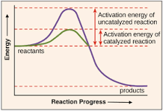
SECTION C – (4 X 10 = 40)
ANSWER ANY FOUR QUESTIONS

20. Discuss the role of ferritin and transferrin in the selective transport and storage of metal ions.
Ferritin and transferrin are proteins that work together to transport and store iron in a nontoxic form:
- Ferritin
Stores iron in a cavity within its molecule. Ferritin can store up to 4,500 iron atoms per protein. It also helps regulate iron homeostasis and acts as an antioxidant by sequestering iron when iron concentrations are high.
- Transferrin
Transports iron to most cells in the body. Transferrin binds to the transferrin receptor on the surface of cells, and then releases iron into the cell. Transferrin can bind to iron(III), chromium(III), and calcium, but not to zinc(II) or rubidium(I)

21. Discuss primary , secondary and tertiary structure of proteins .
The primary, secondary, and tertiary structures of a protein are the different levels of organization of its amino acid chain, and they are determined by the sequence of amino acids, the interactions between atoms, and the folding of the polypeptide chain:
- Primary structure: The sequence of amino acids in the polypeptide chain.
- Secondary structure: The local arrangement of the polypeptide backbone atoms, which can include alpha helices and beta pleated sheets.
- Tertiary structure: The three-dimensional folding of the entire polypeptide chain, which is driven by interactions between R groups.

22. Explain in detail the structure and function of Chlorophyl
Chlorophyll is a green pigment found in plants, algae, and cyanobacteria that's essential for photosynthesis:
- Structure
Chlorophyll's central structure is an aromatic porphyrin or chlorin ring system with a magnesium atom in the center. The molecular formula of chlorophyll is C55H72MgN4O5.
- Function
Chlorophyll is a photoreceptor that absorbs light energy from the sun and converts it into chemical energy. This energy is used to produce glucose from carbon dioxide and water, releasing oxygen in the proces

.
23. Write short notes on the following (i) MRI (ii) Chelation therapy
24.Derive Michaelis – Menten equation.

Michaelis-Menten Enzyme Kinetics
Enzymes are highly specific catalysts for biochemical reactions, with each enzyme showing a selectivity for a single reactant, or substrate. For example, the enzyme acetylcholinesterase catalyzes the decomposition of the neurotransmitter acetylcholine to choline and acetic acid. Many enzyme–substrate reactions follow a simple mechanism that consists of the initial formation of an enzyme–substrate complex, ESES, which subsequently decomposes to form product, releasing the enzyme to react again.
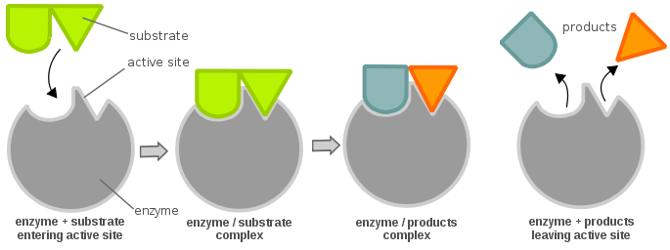Figure 10.2.110.2.1: An enzyme catalyzes the reaction of two substrates and to form one product. from Wikipedia.
This is described within the following multi-step mechanism
E+S⇌k1k−1ES⇌k2k−2E+P(10.2.1)(10.2.1)E+S⇌k1k−1ES⇌k2k−2E+P
where k1k1, k–1k–1, k2k2, and k–2k–2 are rate constants. The reaction’s rate law for generating the product [P][P] is
rate=d[P]dt=k2[ES]−k−2[E][P](10.2.2)(10.2.2)rate=d[P]dt=k2[ES]−k−2[E][P]
However, if we make measurement early in the reaction, the concentration of products is negligible, i.e.,
[P]≈0(10.2.3)(10.2.3)[P]≈0
and we can ignore the back reaction (second term in right side of Equation 10.2.210.2.2). Then under these conditions, the reaction’s rate is
rate=d[P]dt=k2[ES](10.2.4)(10.2.4)rate=d[P]dt=k2[ES]
To be analytically useful we need to write Equation 10.2.410.2.4 in terms of the reactants (e.g., the concentrations of enzyme and substrate). To do this we use the steady-state approximation, in which we assume that the concentration of ESES remains essentially constant. Following an initial period, during which the enzyme–substrate complex first forms, the rate at which ESES forms
d[ES]dt=k1[E][S]=k1([E]0−[ES])[S](10.2.5)(10.2.5)d[ES]dt=k1[E][S]=k1([E]0−[ES])[S]
is equal to the rate at which it disappears
−d[ES]dt=k−1[ES]+k2[ES](10.2.6)(10.2.6)−d[ES]dt=k−1[ES]+k2[ES]
where [E]0[E]0 is the enzyme’s original concentration. Combining Equations 10.2.510.2.5 and 10.2.610.2.6 gives
k1([E]0−[ES])[S]=k−1[ES]+k2[ES](10.2.7)(10.2.7)k1([E]0−[ES])[S]=k−1[ES]+k2[ES]
which we solve for the concentration of the enzyme–substrate complex
[ES]=[E]0[S]k−1+k2k1+[S]=[E]0[S]Km+[S](10.2.8)(10.2.8)[ES]=[E]0[S]k−1+k2k1+[S]=[E]0[S]Km+[S]
where KmKm is the Michaelis constant. Substituting Equation 10.2.810.2.8 into Equation 10.2.410.2.4 leaves us with our final rate equation.
d[P]dt=k2[E]0[S]Km+[S](10.2.9)(10.2.9)d[P]dt=k2[E]0[S]Km+[S]
A plot of Equation 10.2.910.2.9, as shown in Figure 10.2.110.2.1, is instructive for defining conditions where we can use the rate of an enzymatic reaction for the quantitative analysis of an enzyme or substrate.
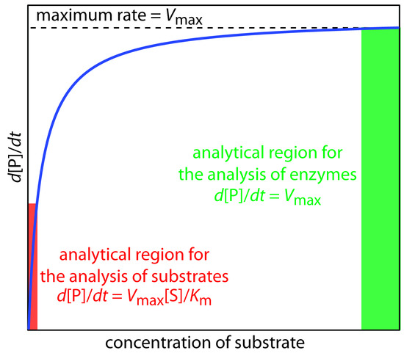

25. Discuss the role of plastocyanin in the process of photosynthesis.

Plastocyanin (PC) is a copper protein that acts as an electron carrier in photosynthesis, transferring electrons between photosystem II and photosystem I:
- Function
PC transfers electrons from cytochrome f in photosystem II to P700+ in photosystem I.

