ANNA ADARSH COLLEGE FOR WOMEN(AUTONOMOUS)
CHENNAI - 40
(M.Sc. Chemistry)

Bio Inorganic Chemistry
Semester: I Max. Marks: 75
Sub Code: Time: 3 Hours
SECTION A – (10 X 1= 10)
ANSWER ANY TEN QUESTIONS

1. Name any two zinc metal containing enzymes and write its uses.
Here are some enzymes that contain zinc and their uses:
- Carbonic anhydrase: Helps with respiration, buffering, and hydrating carbon dioxide
- Carboxypeptidase: Helps with protein digestion in the intestine
2. Give TWO functions of transferrin.
- Transporting iron
Transferrin binds and transports iron from the duodenum and macrophages to all tissues in the body. It's the primary source of iron for red blood cells.
- Storing iron
Transferrin facilitates the storage of iron outside of cells. It binds iron so tightly that almost no free iron is available to create free radicals.
3. Draw the structure of hemocyanin.
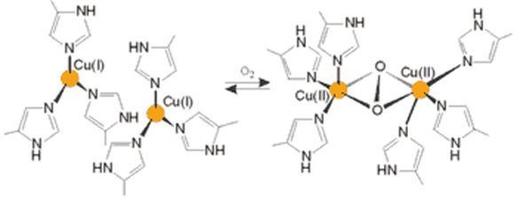
4. State the importance of Iron Sulphur proteins.
Iron–sulfur (Fe/S) proteins are involved in numerous key biological functions such as respiration, metabolic processes, protein translation, electron transport, Enzyme catalysis, sensing, photosynthesis, Nitrogen fixation, DNA synthesis, and DNA repair.
5. What is the role of iron nitrogenase?
- Iron nitrogenase is an enzyme that plays a vital role in reducing atmospheric nitrogen into ammonia.
- Nitrogenase acts as a catalyst, reducing this energy barrier such that the reaction can take place at ambient temperatures.
6. Name the types of nitrogen-fixing microorganisms.
Examples of nitrogen-fixing bacteria are species of Bacillus, Azotobacter, Klebsiella, and Clostridium
7. Write the name of the vanadium compounds used in treating of diabetes.
In vivo, at low doses, vanadate and vanadyl have been shown to repeatedly counteract both the hyperglycemia and hyperlipidemia of diabetes, T1D and T2D diabetic animal models.
8. Why is cis-platin used in cancer therapy in preference to trans -isomer?
- The extent of DNA shrinkage was higher for cisplatin than for transplatin
- The energy cost to remove a Cl atom is less from cisplatin than transplatin.
9. Define enzyme? Write its uses.
An enzyme is a biological catalyst and is almost always a protein.
- It speeds up the rate of a specific chemical reaction in the cell.
- The enzyme is not destroyed during the reaction and is used over and over.
10. Mention the importance of optimum temperature and pH in enzyme
reaction.
- Raising temperature generally speeds up a reaction, and lowering temperature slows down a reaction. However, extreme high temperatures can cause an enzyme to lose its shape (denature) and stop working.
- Each enzyme has an optimum pH range. Changing the pH outside of this range will slow enzyme activity.
11. List the functions of plastocyanin.
Plastocyanin is a blue copper protein which is located in the lumen of the thylakoid where it functions as a mobile electron carrier shuttling electrons from cytochrome in Photosystem I.
12. What is chelating therapy?
When metals like lead, mercury, iron, and arsenic build up in your body, they can be toxic. Chelation therapy is a treatment that uses medicine to remove these metals so they don't make you sick.
SECTION B – (5 X 5 = 25)
ANSWER ANY FIVE QUESTIONS

13. Discuss the structure and biological functions of ceruloplasmin.
Ceruloplasmin (CP) is a multicopper oxidase and antioxidant that is mainly produced in the liver. CP not only plays a crucial role in the metabolic balance of copper and iron through its oxidase function but also exhibits antioxidant activity. In addition, CP is an acute-phase protein.
14. Explain the catalytical cycle for metalloenzyme cytochrome P-450.
The designation P-450 arises from the characteristic Soret band (high energy π-π* transition of the porphyrin ring) at 450 nm is the CO derivative of enzyme. Unusually low energy for a carbonyl derivative of heme protein due to axial thiolate ligand
- Cytochrome P-450, unlike other cytochromes, transfers an O atom rather than transporting electrons ie, one O-atom of dioxygen is inserted into the substrate while the second O-atom is reduced to water (in dioxygenases both O-atoms are inserted into the substrate)

RH+O₂+2H+2e⁻ 2 ROH + H₂O

- The key features of the presently accepted catalytic cycle for a cytochrome P-450 enzyme in the oxidation of hydrocarbon are summarized in the following steps (fig.)

- (1) The resting enzyme (6-coordinate Fe(III), low spin) loses the coordinated H₂O. Five coordinated Fe(III), high spin is formed due to weakening of ligand field.

- (ii) Substrate binds to the hydrophobic part of the protein at a position close to the iron center, but is not directly coordinated to the metal ion.

- (ui) The enzyme-substrate complex is then reduced to ferrous, Fe(II), 5-coordinate (out of plane)

- (iv) Dioxygen then binds to form an oxy complex, FeO, or Fell

- (v) The oxy complex is then reduced by another electron to form a peroxo complex-the Fe(III), 6-coordinate, low spin.

- (vi) The ferric peroxy form of the enzyme-substrate complex then undergoes heterolytic 0-0 bond cleavage, giving a high valent Fe(IV) oxo center with the porphyrin ligand oxidised by one equivalent.

- (vii) This species then transfers a neutral oxygen atom to the bound substrate, which in thes released, giving the oxygenated product and regenerating the resting form of enzyme. This type of reaction pathway was referred as 'peroxide shunt"
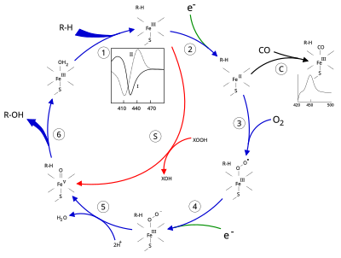
15. Outline the role of chlorophyll in photosynthesis and mention its significance.
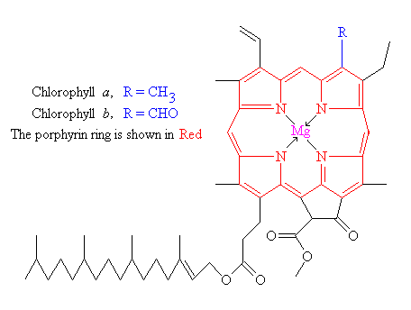

16. Write a short note on the Technetium imaging agent.
Medical professionals administer isotopes like Tc-99m to a patient, and these isotopes bind to specific areas of the body. Scanners, including SPECT (single photon emission computerized tomography) machines then detect these isotopes as they decay, producing an image of what is going on inside the patient's body.
17. Illustrate the various factors that affect enzyme activity.
1.Effect of Temperature:
▪ With increase in the temperature, kinetic energy of the reacting molecules increases. Chances of collision of molecules increases so that the rate of reaction increases.
▪ Velocity of enzyme reaction increases with increase in temperature upto a maximum called optimum temperature and then declines.
▪ A bell shaped curve is observed.
▪ The optimum temperature for most of the enzyme is between 40° to 45°c.
▪ Its nearly 35.5°c for the enzyme of human body.
▪ Above optimum temperature enzymes are denatured and becomes inactive.

2. Effect of pH
- Enzyme catalysis requires appropriate interaction between the enzyme and the substrate. As the pH changes, the charge of the substrate and the amino acid residues in the active site change, thus decreasing the interaction between the enzyme and substrate with a resulting decrease in catalysis.
- Thus increase in the hydrogen ion concentration pH considerably influence the enzyme activity.
- A bell shaped curve is normally obtained.
- Each and every enzyme has an optimum pH for catalysis at which the velocity is maximum.
- Most of the enzyme of higher organisms show optimum activity around neutral
pH (6-8).

18. Cytochrome c is a redox protein but myoglobin is an oxygen storage protein. Justify
the statement.
Heme group in cytochrome c has a polypeptide chain attached and around it. This chain contains a variable number of amino acids ranging from 103 to 112. A nitrogen atom from a histidine segment and a sulphur atoms from a methionine segment of this chain are coordinated to the fifth and sixth coordination sites of the iron atoms. Thus unlike myoglobin there is no position for further coordination. Therefore, it can bind a dioxygen molecule cytochrome c, therefore, cannot react by simple coordination but must react indirectly by an electron transfer mechanism. It can reduce the dioxygen and transmit its oxidising power towards the burning of transfer mechanism. It can reduce the dioxygen and transmit its oxidising power towards the burning of food and release of energy in respiration. Thus cytochrome c is a redox protein and myoglobin is a oxygen storage protein.
19. Compare the activities of catalase and superoxide dismutase.
- Superoxide dismutase (SOD) and catalase are enzymes that protect cells from radical attack. Catalase disproportionates hydrogen peroxide, and SOD is an oxidoreductase that serves to dismutate the superoxide anion.
- Superoxide dismutase, catalase and glutathione peroxidase are antioxidant enzymes which do not only play fundamental but indispensable role in the antioxidant protective capacity of biological systems against free radical attack.
SECTION C – (4 X 10 = 40)
ANSWER ANY FOUR QUESTIONS

20. Bring out the important structural features of the active sites of metal centers of
Vitamin B₁₂ and its biochemical importance.
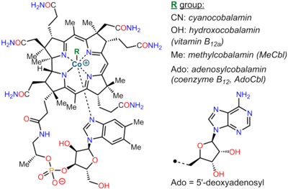
21. Discuss the structure, functions, and mechanism of di-oxygen binging of hemoglobin.
Max Perutz described the molecular structure of haemoglobin in 1959. Haemoglobin is a tetrameric protein. The main type of haemoglobin in adults is made up of two subunits each of ‘𝜶’ and ‘𝝱’ polypeptide chains. Each polypeptide chain is linked to a heme prosthetic group.
𝜶 subunit – It is made up of alpha polypeptide chain having 141 amino acid residues.
𝝱 subunit – It is made up of beta polypeptide chain having 146 amino acid residues.
Heme group – It is an iron-containing prosthetic group, which is attached to each polypeptide chain. It contains iron in the centre of the porphyrin ring.

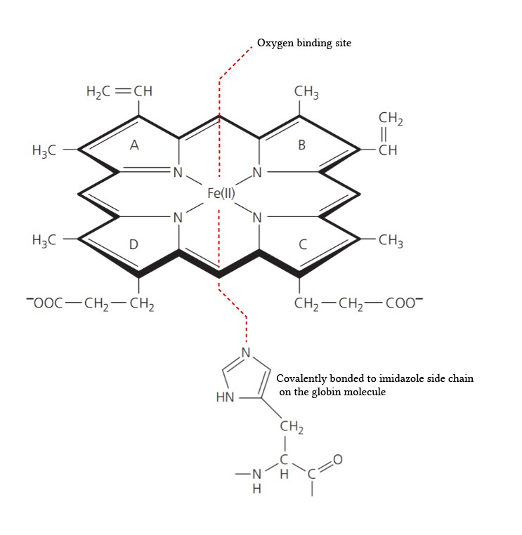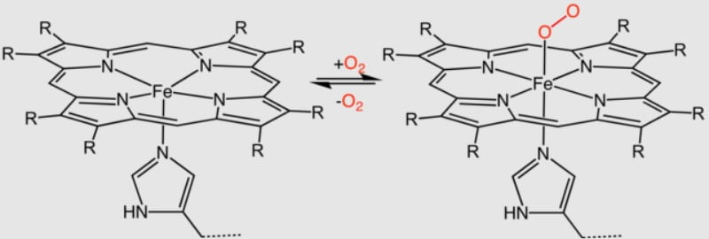

22. Briefly summarize the PS-I and PS-II systems involved in photosynthesis.
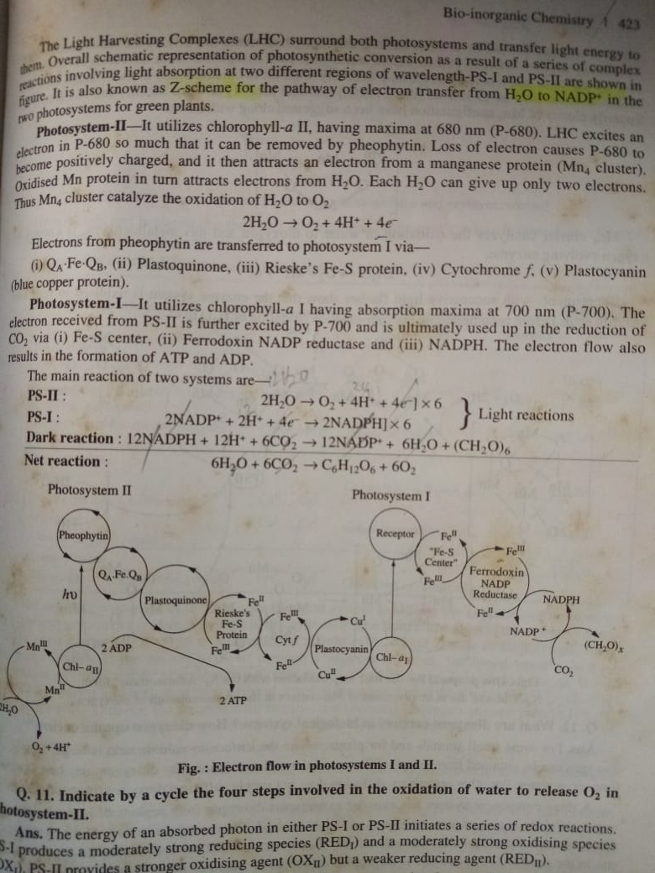

23. Comment on the biological functions and toxicity of metals Hg, Zn, Pb, and As.
- Mercury vapor is more hazardous than the liquid form. Container breakage causes Hg0 spills and inhaling large amounts of Hg vapor can be fatal.
- Zinc is generally considered a nontoxic metal (Haase, Rink, 2009). Although it is an essential trace metal, it is a potentially toxic heavy metal. The oral median lethal dose (LD50) of zinc in rats is >2000 mg/kg body weight (bw).
- Lead (Pb) is a toxic heavy metal, having profound threats to the global population. Multiple organs such as kidney, and liver, as well as nervous, hematologic, and reproductive systems, are commonly considered the targets of Pb toxicity.
- Metal toxicity depends upon the absorbed dose, the route of exposure and duration of exposure, i.e. acute or chronic. This can lead to various disorders and can also result in excessive damage due to oxidative stress induced by free radical formation.

24. Derive the Michaelis – Menten equation to explain the kinetics of enzyme catalysed
reaction.
The following key characteristics of several enzymes that catalyze reactions are taken into account when constructing the Michaelis Menten equation. It’s important to understand the key factors that were taken into making the Michaelis-Menten equation. This makes it possible to determine when the equation can be utilized and when it cannot.
- The initial rate of product formation is proportional to the total concentration of enzyme [E]_{o} for a given initial concentration of substrate [S]_{o}.
- In the context of low substrate concentrations, it can be observed that the rate of product formation exhibits a linear relationship with the substrate concentration, denoted as [S]_{o}. This implies that the rate is directly proportional to the substrate concentration.
- Another assumption of the Michaelis-Menten model is that the concentration of the enzyme-substrate complex [ES] is constant. This is referred to as steady-state approximation.
- At a high concentration of substrate, the rate of product formation becomes independent of substrate concentration and reaches a maximum velocity, Vmax, at which substrate concentration has no effect.
- The substrate concentration [S] is approximately equal to the total substrate concentration. Technically, the total substrate concentration in the solution is equal to the sum of the concentrations of substrate [S] and enzyme-substrate complex [ES]. However, given that [S]>>>[E], the substrate concentration [S] is about equal to the total substrate concentration. This is referred to as free ligand approximation.
The equation arises from the general equation for an enzymatic reaction.
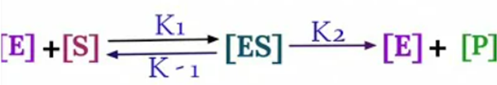
During Initial
Rate of Formation of [ES] = Rate of Breakdown of [ES]
K₁ [E][S] = K₋₁ [ES]
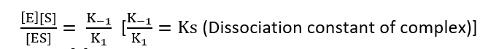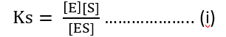
Total enzymes = E₀
[E₀] = [E] + [ES]
[E] = [E₀] – [ES]
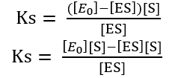
Ks [ES] + [ES][S] = [E₀] [S]
[ES] (Ks + [S]) = [E₀] [S]
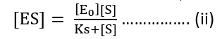
Now, velocity of reaction from [ES] to Product
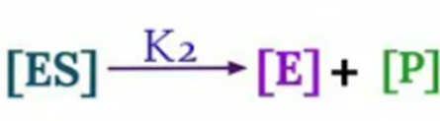
V₀ = K₂ [ES]
Substituting value of [ES] from equation (ii)
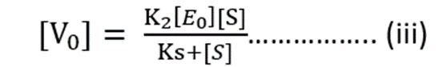
Maximum Rate of Reaction = V_{max}
V_{max} = K₂ [E₀] ……………. (iv)
Substituting value of equation (iv) into (iii)
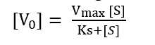
This is Michaelis-Menten equation

25. Justify the following metalloenzymes role in performing diverse physiological
functions: a) Carbonic anhydrase and b) Carboxypeptidase.
Carbonic anhydrase is an enzyme that facilitates the conversion between carbon dioxide (CO2) and water (H2O) to form carbonic acid (H2CO3) and its dissociative ions (HCO3− and H+). It plays a key role in regulating pH and aiding in the transport of CO2 in biological systems.
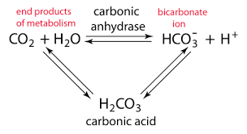
A carboxypeptidase is a protease enzyme that hydrolyzes (cleaves) a peptide bond at the carboxy-terminal (C-terminal) end of a protein or peptide. This is in contrast to an aminopeptidase, which cleave peptide bonds at the N-terminus of proteins.
