SECTION A – (1 mark)

1. Let E be a set. Let $x$ be an element of E. Then a fuzzy subset $\overset{̰}{A}$ of E is a set of the ordered pairs {$x|μ_{\overset{̰}{A}}\text{(x)\},}$ $∀x∈E$ where $μ_{\overset{̰}{A}}\text{(x)}$ is the membership function of $x$ in $\overset{̰}{A}.$
2. Membership function >= 0.5
3. Envelope of a fuzzy relation.
4. The support of a fuzzy relation $\overset{̰}{R}$ is the ordinary subset of ordered pairs (x,y) for which the membership function is non zero.
5.anti-reflexive fuzzy relation.

6. Fuzzy preorder - A fuzzy binary relation that is reflexive and transitive
is called a fuzzy preorder.
7. De-Morgan’s Laws | 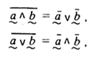
8. $D_{\overset{̰}{a}}=[0,6 , 0,9[$and $D_{\overset{̰}{b}}=[0,2 ,0,7[$ | 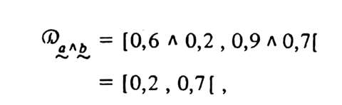
9. 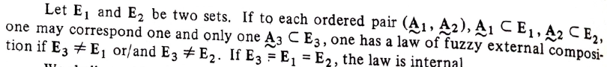
10. commutative fuzzy monoid – A fuzzy sub-groupoid that is associative, has an identity and is commutative.
11. $Δ=\{\left(0,0\right),(\frac{1}{2},1)\}$ is closed and has identity (0,0) hence it is a sub-monoid.

12. A fuzzy graph is a mapping from the Cartesian space $X × Y$to the interval $[0,1],$where the strength of the mapping is expressed by the membership function of the relation $µ (x,y)$

SECTION B – (5 Marks)
13. Generalized hamming distance$=d\left(\overset{̰}{A},\overset{̰}{B}\right)=\sum_{i=1}^{n}{\left|μ_{\tilde{A}}\left(x_{i}\right)-μ_{\tilde{B}}\left(x_{i}\right)\right|}$
$$=\left|0.7-0.2\right|+\left|0.2-0\right|+\left|0-0\right|+\left|0.6-0.6\right|+\left|0.5-0.8\right|+\left|1-0.4\right|+\left|0-1\right|$$
$$=0.5+0.2+0.3+0.6+1=2.6$$
Euclidean distance $=e\left(\overset{̰}{A},\overset{̰}{B}\right)=\sqrt{\sum_{i=1}^{n}{{\left(μ_{\overset{̰}{A}}\left(x_{i}\right)-μ_{\overset{̰}{B}}\left(x_{i}\right)\right)}^{2}}}$
$$\sqrt{{\left(0.7-0.2\right)}^{2}+{\left(0.2-0\right)}^{2}+{\left(0.5-0.8\right)}^{2}+{\left(1-0.4\right)}^{2}+{\left(0-1\right)}^{2}}$$
$=\sqrt{{0.5}^{2}+{0.2}^{2}{+0.3}^{2}+{0.6}^{2}+1^{2}}=\sqrt{1.74}=$1.32
14. The transitive closure of any fuzzy binary relation is a transitive binary relation.
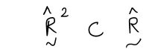
15. A fuzzy binary relation that is reflexive, symmetric, and transitive is called a relation of similitude or fuzzy equivalence relation.
16. $\overset{̰}{f}(\overset{̰}{a},\overset{̰}{b})=(\overset{̰}{a}∧\bar{\overset{̰}{a}})∨(\bar{\overset{̰}{a}}∧\overset{̰}{b}∧\bar{\overset{̰}{b}})$. Prove by truth table
17. $c(\overset{̰}{A},\overset{̰}{B})=\left[μ_{\overset{̰}{A}}(a)∧μ_{\overset{̰}{B}}(a)\right]∨\left[μ_{\overset{̰}{A}}(b)∧μ_{\overset{̰}{B}}(b)\right]$ - forming the table

18. Proof of decomposition theorem for fuzzy subset $\overset{̰}{A}$

19. $\overset{̰}{a}∧(\overset{̰}{b}∨\overset{̰}{c})=(\overset{̰}{a}∧\overset{̰}{b})∨(\overset{̰}{a}∧\overset{̰}{b})$ Prove by considering various cases
SECTION C – (10 marks)

20. 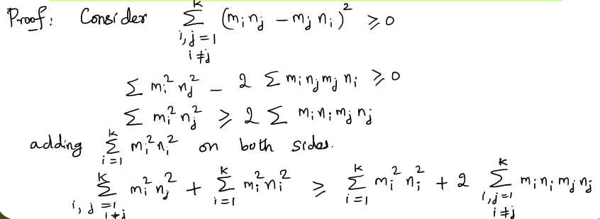
21.
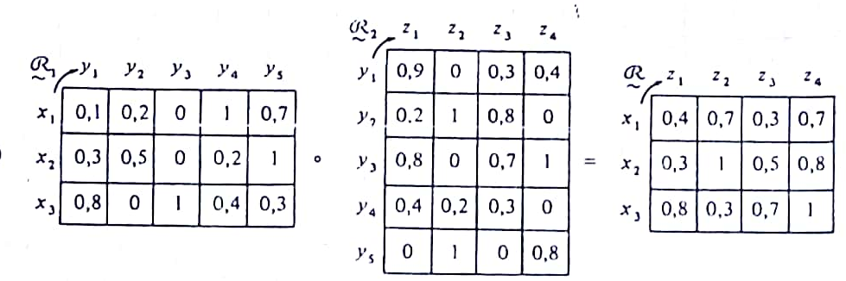
22.
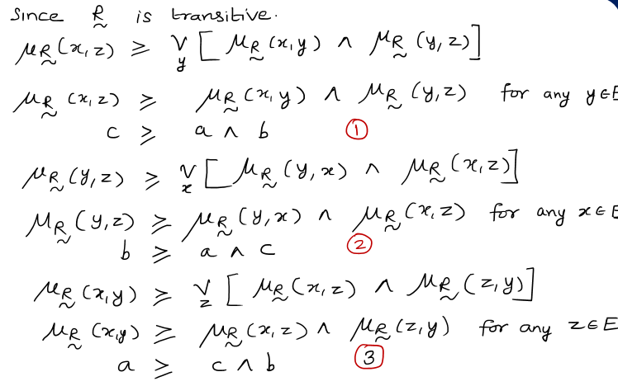
23. The tables to represent $\overset{̰}{a}∧\overset{̰}{b} and$ $\bar{\overset{̰}{a}}∧\overset{̰}{b}$
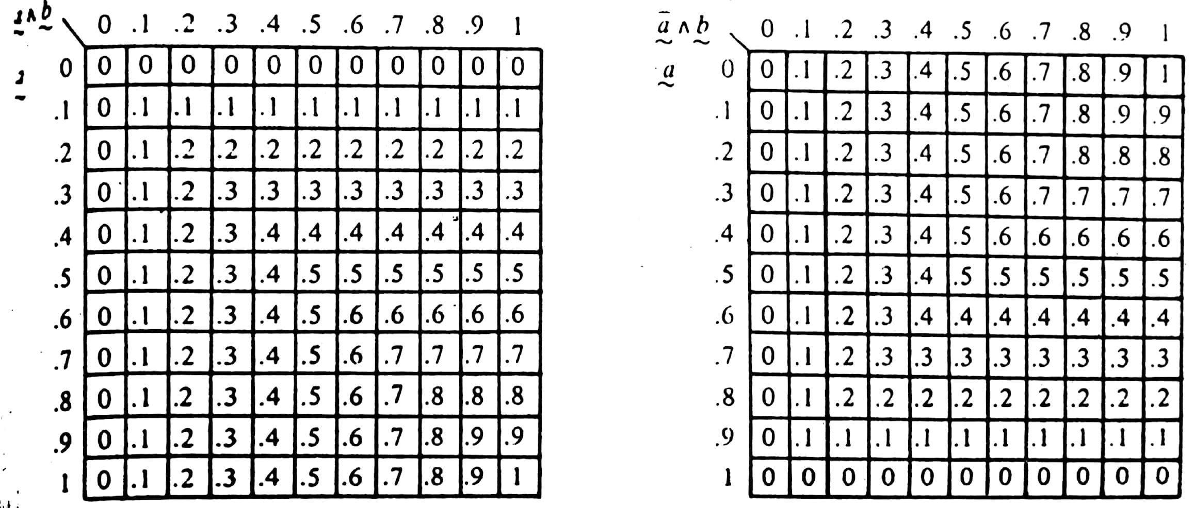
24. Explanation of Geometric fuzzy integers.

25. The operation $⊙$, defined by $a⊙b=a+kb-ab,$ $k∈[0,1]$,




