ANNA ADARSH COLLEGE FOR WOMEN(AUTONOMOUS)
POST GRADUATE DEPARTMENT OF CHEMISTRY
B.Sc CHEMISTRY - GENERAL CHEMISTRY I - 24UBSCH301
Scheme of valuation
1. Both position and momentum can be measure simultaneously.
2. 200 nm
3. Sigma – end-on-end overlap, s-s, s-p or p-p orbital involved, rotation is possible, pi bond-lateral overlapping, only p-p orbitals involved and rotation restricted.
4. 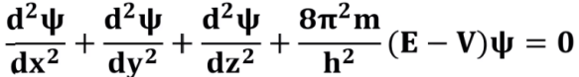

5. 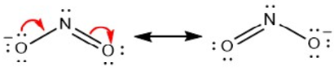
6. effective nuclear charge, small atomic size and outmost electron shielded with nucleus. Cl>F>Br>I
7. Covalent bond - high positive charge, a small cation, and large anion have more polarising power.
8. sp3d3 and pentagonal bipyramidal
9. VBT does not give magnetic property, weak and strong ligands differentiation, stability of coordination compounds
10. bond order – 2; diamagnetic
11. C₆H₅NH₂ < NH₃ < C₂H₅NH₂< (C₂H₅)₂NH₂
12. inductive – permanent effect, no reagents needed, polarity essential; electromeric – temporary, attacking reagents required, polarity non-essential.
13. carbocation – carry positive charge, sp2 hybridization, highly reactive, stabilized by resonance; carbanion – negative charge with 8 electrons, sp3, stability by resonance, inductive effect; carbenes - CH2 (or methylene)are highly reactive; arynes-benzynes are neutral, highly reactive, sp2 hybrid; nitrynes – electron deficient species with R-N formula and it exist as singlet and triplet state.
14. Compton effect -scattering of high frequency photon after an interaction with electron results decrease in energy of photon. Photoelectric effect - single electron absorbs the entire energy of an incident photon.
15. system specified by ψ (r,t), eigen values satisfy eigen functions, The wave function should be continuous ,finite and single valued for all values of x, ψ should be normalized, $HΨ =E Ψ$
16. For second IE of Na, the outer shell is complete hence it is difficult to remove electrons, fluorine is small in size which causes strong electron-electron repulsion. K+ has high effective nuclear charge than that of chlorine hence K+ is small in ionic radius.
17. sublimation (Na to Na+), dissociation (Cl2 to Cl), ionization (Na+), 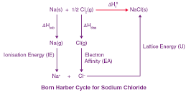
18. VBT – bonding between two atoms, no explanation of magnetic character of oxygen, hybridization and resonance plays important role; MOT – bonding between two atoms and molecules, O2 magnetic property explained, no hybridization and no resonance concepts incorporated.
19. delocalization of electrons from a sigma bond (typically C-H or C-C), to an adjacent empty or partially filled p-orbital or π-system.
20. wave nature of electrons through diffraction. 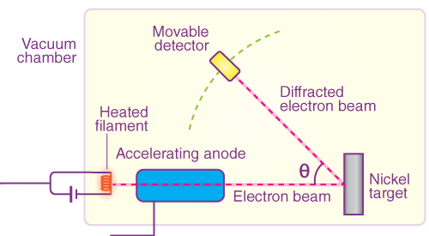
21. i) Bohrś orbit - definite boundary, fixed energy at different distances from the nucleus and circular in shape; Orbitals - no definite boundary.
ii) ψ - probability amplitude and no physical significance; ψ may be positive, negative or imaginary. [ψ]2 - probability density and determines the probability of finding an electron.
22. BeCl₂ – linear & sp; ii) NH₃ – trigonal pyramidal & sp3; iii) SF₄ – trigonal bipyramidal & sp3d; iv) PF₅ – trigonal bipyramidal sp3d; v) SF₆ – octahedral & sp3d2.
23. i) maximum bond strength or (bond order 2.5) is O₂+
ii) NH3 donated lone pair electrons and forms co-ordinated covalent bond.
iii) electronic devices, solar cells, optical sensors, etc.
24. addition, substitution, elimination and rearrangement reactions with one example.

