24UBSHS3E1
Chemistry for Biological Sciences I – scheme of valuation
1. 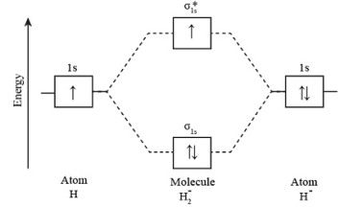
2. isotope- same atomic number different mass number, isobar – different at no and same mass no.; isotone - same no of neutrons but diff mass and atomic nos.
3. When a radioactive element emits α-particles from its nucleus, the atomic number of the new element or daughter element created is reduced by two units, and four units reduce the atomic weight.
4. superphosphate – phosphorous rock and H2SO4; TSP – phosphorous rock with phosphoric acid;
5. NPK – nitrogen, phosphorous, and pottasiusm
6. CH4 – sp3 and tetrahedral
7. hyperconjugation – delocalization of sigma electrons with nearby pi orbitals.
8. C6H6 + CH3Cl gives C6H5CH3 with HCl in presence of AlCl3
9. drugs – a chemical substance which causes biological effect; antibiotics- used to treat bacterial infections.
10. A drug or other substance that causes a loss of feeling or awareness.
11. to determine the concentration of a solution by measuring the volume of a reaction in the solution.
12. precise separation, analysis and purification.
13. BMO – less electron density and low energy, overlapping of atomic orbitals; Helium molecule = 0.
14. nitration and sulphonation reactions; R-COCl reacts with benzene to form ketone.
15. halogenation – chlorination of methane
16. pencilin - 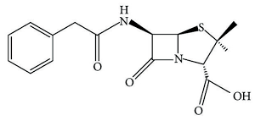 chloremphenical - 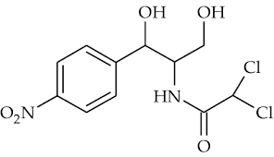
17. liquid-liquid extraction, based on solubility & non-volatile; vapour-liquid separation, based on boiling point.
18. fission-U235 bombarded with neutrons, chain reactions, radioactive, tremendous amount of energy; fussion- two light nuclei combine to form, not chain reaction, connot control, more energy than fission.
19 ii) For the deuteron Z=1 and A=2. The mass defect for the deuteron is Δm=mp+mn−mD=1.008665 u+ 1.007825 u- 2.014102u = 0.002388u. The binding energy of the deuteron is then B= Δm c2 = Δm ×931.5 MeV/u=2.224 MeV.
20. 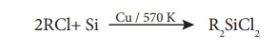 hydrolysis of R2SiCl2 gives polymer.
low temperature lubrication, making water proofing clothes; insulting; mixed with paints and enamels to make them resistant towards high temperature, sunlight, dampness and chemicals.
21. electron withdrawing groups (-I) increases acidity of carboxylic acid and phenols and decreases basicity of amines. ii) furan + NH3+ Al2O3/steam gives pyrrole. Pyrrole undergoes diazotization, reamer-tieman reaction, electrophilic sub.
22. paracetamol 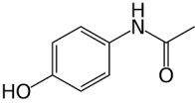
ii) Teflon – polytetrafluroethylene; Freon- non-combustible gas used in refrigerators.
23. Rf – ratio of distance travelled by solute & solvent; applications –purification of aminoacids, analysis of food colors and adulterants, identify the impurities in drugs, heavy metal analysis.

