Economics is the study of how people and societies use resources to create, distribute, and consume wealth. It's a broad discipline that can help us understand historical trends, interpret current events, and predict future outcomes. Here are some key aspects of economics:

scarcity

Economics is the study of how people respond to scarcity and use resources.

Production and consumption

Economics examines how people and businesses produce and consume goods and services.

Efficiency

Economics focuses on how to produce and exchange goods and services efficiently.

Two determinants of demand are:

Price of the product : According to the law of demand, when other factors remain the same, a decrease in price leads to an increase in demand, and an increase in price leads to a decrease in demand.Income of the consumers : When incomes increase, consumers demand more goods, and when incomes decrease, consumption levels decrease.
- 2 types of inflation:
The two main types of inflation are demand-pull inflation and cost-push inflation:
Demand-pull inflation :This type of inflation occurs when demand for goods and services increases faster than supply. This can be caused by an expanding economy, increased government spending, or overseas growth.
Cost-push inflation: This type of inflation occurs when the cost of producing goods and services increases. This can be caused by an increase in the cost of raw materials or labor. When production costs increase, producers pass on the higher costs to consumers, which leads to increased consumer prices.
- outline the law of supply:
The law of supply is a fundamental economic principle that states that when other factors remain constant, the quantity of a good or service supplied increases as the price increases.
Here are some key points about the law of supply: Explanation: Suppliers are motivated to increase the quantity of a product they sell when prices rise because it increases their profits.
supply curve: The law of supply is represented by the upward slope of the supply curve.
relationship with demand : The law of supply and demand is relevant to business decisions because it predicts how supply, demand, and pricing interact.
perishable goods: The law of supply doesn't always apply to perishable goods, such as vegetables, which may have increased supply even when prices decrease.
- Recall the meaning of consumer behaviour. : Consumer behavior is the study of how people make decisions about what to buy, how to use it, and how they dispose of it. It also includes how consumers think about brands, how they are influenced by marketing, and how social and economic pressures affect their decisions.
Consumer behavior is important for businesses because it helps them understand why consumers make the decisions they do. This helps businesses target their marketing more effectively and increase their return on investment.

Consumer behavior is studied through focus groups, surveys, and tracking sales history. It's an interdisciplinary social science that blends elements from psychology, sociology, anthropology, marketing, and economics.
- Show market demand curve with the help of indifference curves.

An indifference curve can be used to derive a market demand curve by showing the relationship between price and quantity demanded: Start with a consumer's utility function, which represents their preferences for combinations of two goods. Draw several indifference curves, each representing a different level of utility. Find the point of tangency (intersection) between an indifference curve and the budget constraint. Repeat step 3 for different budget constraints. Convert the prices in the indifference diagram into a standard demand diagram.

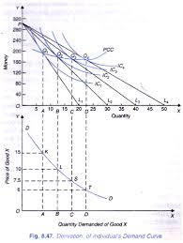 The demand curve slopes downward because as the price of a good increases, the quantity demanded decreases. This is known as the law of demand.
- Write the meaning of Economies of Scale.

Economies of scale refer to the cost advantage experienced by a firm when it increases its level of output. The advantage arises due to the inverse relationship between the per-unit fixed cost and the quantity produced. The greater the quantity of output produced, the lower the per-unit fixed cost.
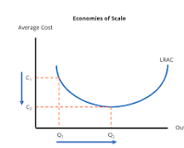
- Why there is Production?

production is important for many reasons, including:

Economic value : Production creates value in the economy by applying labor to land. It also improves the quality of life by providing goods and services. Cost efficiency: Production scheduling can help ensure that resources are used optimally, which can lead to cost savings.

Effective decision-making : Production planning can help manufacturers make informed decisions about production strategies, resource allocation, and capacity management. Product quality : Production schedules can help increase product quality and ensure that customer orders are fulfilled on time.
- Describe Price discrimination.

Price discrimination is a business strategy where a seller charges different prices to different customers for the same product or service. The goal is to capture the difference between what customers are willing to pay and what they actually pay, also known as consumer surplus. Here are some examples of price discrimination:

Bulk buying: Buyers who order large quantities of a product pay less than those who order smaller quantities. Two-for-one deals: Buyers pay less per unit when they buy more of a good.
- Name the different kinds of Competition. Here are some types of competition:

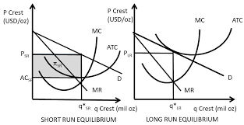

Monopolistic competition: A market with many firms, each offering a differentiated product. Each firm is a monopoly for the product it offers, but competes with other firms because their products are substitutes.
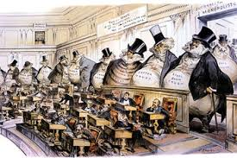



Monopoly : An economic market structure where a single person or business is the only supplier of a particular product or service.
- Compare positive with normative economics.
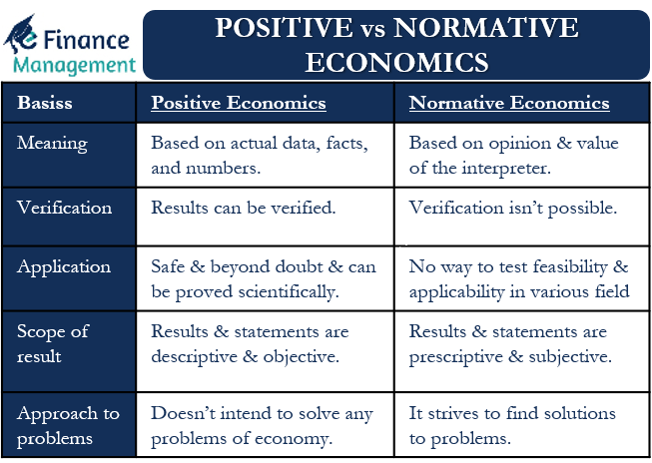
- Extend Business cycle with a suitable diagram.
The business cycle model shows the fluctuations in a nation's aggregate output and employment over time. The model shows the four phases an economy experiences over the long-run: expansion, peak, recession, and trough.

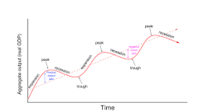
SECTION – B
ANSWER ANY FIVE (5*5=25)

- Examine the scarcity views on Economics.
Scarcity is a fundamental economic concept that describes when the demand for a resource is greater than its supply. It can be caused by a number of factors, including:
Demand-driven scarcity: When demand increases and supply decreases
Supply-driven scarcity: When supply decreases and demand increases
Structural scarcity: When scarcity is dependent on location
Scarcity can have a number of effects, including:
Pricing: The price of a scarce good will increase until supply and demand are in equilibrium.
Consumer choices: Consumers must make choices based on what they have and what they want. They tend to value scarce goods more.
Resource use: Scarcity can indicate that current resource use is unsustainable.
Some examples of scarce resources include:
Non-renewable resources: Natural resources like oil and precious metals that cannot be replenished
Renewable resources: Natural resources like fresh water, fish, and trees that are consumed faster than they can be replenished
Goods that become scarce: Non-scarce goods like air, sunlight, and ideas can become scarce. For example, industrialization has led to a decrease in the world's drinkable water supply.
- Identify Time and discounting principle.
Time discounting is the idea that the value of something decreases over time, while the value of something that is delayed increases over time. It is also known as time preference, delay discounting, or temporal discounting.
Time discounting is a factor in decision making, and it can be influenced by a number of factors, including: Uncertainty, Changing tastes, and Whether the person is seeking instant gratification.
Time discounting is used in a variety of fields, including:
Finance: Discounting is used to value and price financial assets, such as bonds.
Behavioral economics: Time discounting is used to understand how people value receiving a good or money at different times.
Environmental economics: Time discounting is used in the context of environmental economics.
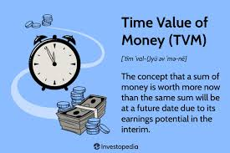
- Illustrate types of Price elasticity of demand .
The price elasticity of demand (PED) measures how a change in price affects the quantity demanded of a good. There are several types of PED, including:
Unit elastic
When the percentage change in price is equal to the percentage change in quantity demanded. This is more of a theoretical concept.
Inelastic
When the percentage change in price is greater than the percentage change in quantity demanded. This is often the case for essential goods that consumers have no substitutes for.
Elastic
When the percentage change in price is less than the percentage change in quantity demanded.
Perfectly elastic
When demand changes substantially even with a minimal price change.
Perfectly inelastic
When demand is constant or there is no change in demand even if the price changes.
The PED is calculated by dividing the percentage change in quantity demanded by the percentage change in price.
Here are some examples of products with price elasticity of demand:
Movie tickets
When ticket prices rise, people may choose to wait for discounts or stream options instead of going to theaters.
Fast food
When fast food prices increase, people may cook at home or choose cheaper alternatives.
Ride-sharing services
Services like Uber use surge pricing to raise prices in real time when there are more users requesting rides in a given area.
- Essentials of a good forecasting.
Be methodical: The best outcomes derive from forecasting that adheres to a systematic, well-defined process. Using a systematic, repeatable approach ensures consistency, allows for continuous improvement, and improves the reliability of your predictions.
Look back to look forward: A rule some researchers cite is looking back at least twice as far into the past as you are forecasting into the future. This simply means looking back at history. Forecasters can identify patterns that can help predict the future if they examine trends over a long period. The recent past is unreliable, so forecasters should look back at least twice as far into the past as they forecast into the future. The unexpected happens, and history doesn't always repeat itself. Be mindful of history, not a prisoner of it.
Embrace uncertainty: Perfect forecasts are for the gods, not for you. All predictions carry a degree of uncertainty, reflecting the complex and dynamic nature of business environments.
Quantify your uncertainty where possible: Forecasts that can provide a "distribution" of possibilities—an airline predicting the price of jet fuel between minimum and maximum likely prices, for example—help the most in planning since that doesn't make the prediction an all-or-nothing affair.
Be aware of wild cards: These are low-probability events with high potential impact at the edges of the possible range. Acknowledging outliers and unexpected events is crucial for comprehensive forecasting and, especially, for risk management.
Greater accuracy is found in the aggregate: Forecasts are more precise when applied to broader categories or groups rather than individual items. This principle, known as the law of large numbers, is at the heart of statistics and means that forecasts yield more reliable predictions for aggregate data.
The longer the time, the more that can go wrong: The accuracy of forecasts typically diminishes as the time horizon extends. Near-term predictions generally offer greater precision than long-range projections. Unforeseen variables can simply compound their effects over time.
- Simplify Consumer equilibrium with a suitable diagram
Consumer equilibrium can be represented graphically as the point where a consumer's budget line and indifference curve meet. This is when the slopes of the two lines are equal.
Indifference curves
These curves show the consumer's preferences between different combinations of goods.
Budget line
This line shows the combinations of goods that a consumer can afford to buy with their income and the prices of the goods.
Consumer equilibrium occurs when a consumer is unable to rearrange their purchases and is deriving maximum satisfaction from their goods. This happens when:
The marginal utility per rupee spent equals the price
The marginal rate of substitution between goods equals the ratio of their prices
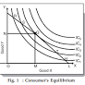
- Distinguish between coordinal and ordinal concepts of utility.
Cardinal utility
Utility can be measured in numbers, like 1, 2, or 3. Cardinal utility is based on the idea that utility can be quantified, and the satisfaction derived from consuming a good or service can be expressed in units of utility.
Ordinal utility
Utility can only be ranked or ordered according to the consumer's preference. Ordinal utility is based on the idea that utility is an emotion that cannot be measured, and that consumers rank their preferences rather than measuring them.

Here are some other differences between cardinal and ordinal utility:

Measuring term
The measuring term for cardinal utility is utils, while the measuring term for ordinal utility is ranks.
Evaluation
Cardinal utility evaluates utility objectively, while ordinal utility measures utility subjectively.
Realism
Ordinal utility is considered more realistic than cardinal utility because quantitative evaluation of utility is not practical.
Theory
Alfred Marshall and his followers presented the cardinal utility approach, while Hicks and Allen pioneered the ordinal utility idea.
Basis
Cardinal utility is based on marginal utility evaluation, while ordinal utility is based on indifference curve analysis.
- Compare law of variable proportion and laws of returns to scale.
The law of variable proportion and the law of returns to scale are both economic laws that analyze production, but they differ in the time period they analyze and the factors they consider:
Law of variable proportion
Analyzes production in the short term, and focuses on the relationship between a variable factor and output when other factors are constant. This law is also known as the law of diminishing returns.
Law of returns to scale
Analyzes production in the long term, and focuses on how productivity changes when all production inputs are increased simultaneously.
The law of variable proportion has three stages:
Increasing returns: The total product increases at an increasing rate.
Diminishing returns: The total product increases at a diminishing rate until it reaches the maximum point.
Negative returns: The total product declines and the marginal product becomes negative.

SECTION – C
ANSWER ANY THREE(10*3=30)

- Explain price and output determination under perfect competition.

In a perfectly competitive market, the price and output of a product are determined by the market forces of supply and demand:
Price

The price of a product is determined by the intersection of the supply and demand curves. This price is called the equilibrium price.

Output

A firm's output is determined by ensuring that marginal revenue (MR) equals marginal cost (MC). If MR > MC, the firm should expand production, and if MR < MC, the firm should reduce output.

In a perfectly competitive market, buyers and sellers cannot influence the market price by changing their purchases or output. Firms must accept the price determined by the market and sell their output at that price.

n a perfectly competitive market, the price and output of a product are determined by the intersection of the market's demand and supply curves. This point is known as the equilibrium point, and the price and quantity at this point are the equilibrium price and quantity, respectively.
Here's how price and output are determined in a perfectly competitive market:

Price
The market determines the price through the forces of supply and demand. The price at which supply and demand are equal is the equilibrium price.
Output
Firms accept the price determined by the industry and try to sell as much as they can at that price. The demand curve facing a firm in a perfectly competitive market is horizontal at the level of the market price. Firms choose the output level that yields maximum profit.

In a perfectly competitive market, firms are price-takers, meaning they have to accept the price determined by the industry. They can't increase the price individually because they risk losing customers to other firms.

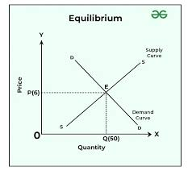

- Assess Equilibrium of firm in Monopolistic competition.

The long-run equilibrium of monopolistically competitive firms is achieved when average revenue is equal to average cost. In such a case, the firms receive normal profits. In Fig. 11.5, P is the point at which AR curve touches the average cost curve (LAC) as a tangent.

The equilibrium output at the profit maximization level (MR = MC) for monopolistic competition means consumers pay more since the price is greater than marginal revenue. As indicated above, monopolistic competitive companies operate with excess capacity. They do not operate at the minimum ATC in the long run.
In monopolistic competition, supply and demand forces do not dictate pricing. Firms are selling similar, yet distinct products, so firms determine the pricing. Product differentiation is the key feature of monopolistic competition, where products are marketed by quality or brand.

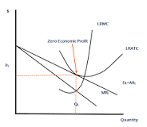
Features
Monopolistic competition is one form of imperfect competition. Monopolistically competitive markets have a number of specific features:
Many firms - There are many firms in monopolistically competitive markets, and this is part of what sets them apart from monopolies.
Product differentiation - Although the products sold by different firms in monopolistically competitive markets are similar enough to one another to be considered substitutes, they are not identical. This feature is what sets monopolistically competitive markets apart from perfectly competitive markets.
Free entry and exit - Firms can freely enter a monopolistically competitive market when they find it profitable to do so, and they can exit when a monopolistically competitive market is no longer profitable.
In essence, monopolistically competitive markets are named as such because, while firms are competing with one another for the same group of customers to some degree, each firm's product is a little bit different from that of all the other firms, and therefore each firm has something akin to a mini-monopoly in the market for its output.
- Criticize the law of Diminishing Marginal utility.
The Law of Diminishing Marginal Utility states that the additional utility gained from an increase in consumption decreases with each subsequent increase in the level of consumption. Marginal Utility is the change in total utility due to a one-unit change in the level of consumption

Diminishing Marginal Utility

Diminishing marginal utility refers to the phenomenon that each additional unit of gain leads to an ever-smaller increase in subjective value. For example, three bites of candy are better than two bites, but the twentieth bite does not add much to the experience beyond the nineteenth (and could even make it worse). This effect is so well established that it is referred to as the “law of diminishing marginal utility” in economics (Gossen, 1854/1983), and is reflected in the concave shape of most subjective utility functions (eg, Kahneman & Tversky, 1979; Rabin, 2000; see Fig. 13.2). An important consequence of diminishing marginal utility is that subjective value changes most dynamically near the zero point, and quickly levels off as gains (or losses) accumulate.

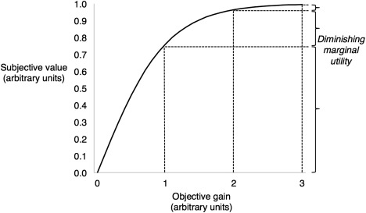

Figure 13.2. Diminishing marginal utility of gains. Given a concave relationship between objective gains (x-axis) and subjective value (y-axis), each one-unit gain produces a smaller increase in subjective value than the previous gain of an equal unit. The marginal utility, or the change in subjective value above the existing level, diminishes as gains increase (shown on the y-axis to the right).

The tendency for returns on subjective value to diminish with repetition is relevant to how self-control plays out over time. By our definition, self-control is required when there is a conflict between a high-level goal and a low-level goal or impulse. Both options have some degree of subjective value, even if that value is derived from a different source (such as the immediate physical gratification associated with a positive experience or the sense of accomplishment that accompanies goal completion). Therefore, recent positive experiences that diminish the subjective value of one but not the other goal will influence self-control. Take, for example, the case of a smoker who is trying to quit and experiences a self-control conflict between the desire to smoke a cigarette (hedonic value) and the desire to quit (abstract goal value). According to the law of diminishing marginal utility, the subjective value of smoking an additional cigarette will be diminished if the smoker has just had a cigarette.

The law of diminishing marginal utility also applies to the case of ego depletion, a claim we will argue in a section later. First, however, we present neuroscientific data in support of the valuation model of self-control.

The law of diminishing marginal utility (DMU) has several limitations and criticisms, including:

Unrealistic assumptions

The law assumes that tastes, habits, fashion, income, and other factors remain constant, but this is not realistic.

Inapplicable to certain goods

The law doesn't apply to goods like televisions and air conditioners, where marginal consumption doesn't decrease.

Doesn't apply to all units

The law only applies to uniform units of a commodity, which are the same in shape, size, and length.

Doesn't apply to all consumption

The law doesn't apply when the units being consumed are very small, of different sizes, or when there are long breaks between consuming them.

Doesn't apply to irrational consumers

The law doesn't apply when the consumer is thinking or behaving irrationally, or if they are suffering from a mental illness or addiction.

Doesn't apply to rare objects

The law doesn't apply when the units being consumed are part of a collection or are rare objects.
- Determine the Nature and scope of Business Economics.

Business Economics is the study of all the factors which affect the working, management, and prosperity of a business or firm. The scope of Business Economics is large as it deals with both internal factors within the business as well as factors that are beyond the business owner's control.

Nature of Business Economics
1. Managerial Orientation: It is also referred to as managerial economics, this area of study facilitates choice-making for managers by means of offering frameworks and contraptions for strategic making plans, risk control, coverage formation, and aid allocation.
2. Microeconomic Perspective: It stresses the examination of particular companies, clients, and markets, targeting microeconomic thoughts like supply, demand, price, and marketplace structure.
3. Interdisciplinary Approach: To very well study complex commercial enterprise problems, it combines understanding from the fields of economics, finance, accounting, statistics, and operations studies.
4. Dynamic and Evolving Field: Business economics continues to keep up with the latest findings and strategies while also adjusting to shifts within the corporate surroundings, technological traits, and marketplace dynamics.
5. Decision Support Function: Within organizations, it performs the role of a decision support function by giving managers pertinent data, analysis, and insights to help them make well-informed decisions.
Scope of Business Economics
1. Demand Analysis: Market demand for products and services as well as customer behavior are examined by business economists. In order to guide pricing strategies and marketing decisions, they evaluate demand-influencing elements such as price elasticity, consumer preferences, income levels, and market trends.
2. Supply Analysis: It is vital for organizations to understand the supplier side of the industry. To assess the supply of goods and services, business economists look at variables influencing supplier behavior, such as technology, resource availability, and production costs. Businesses may ensure appropriate inventory levels, streamline production processes, and manage supply chains more effectively with the use of this study.
3. International Business: Business economists look at global trade, foreign funding, change prices, and geopolitical elements that impact cross-border commercial enterprise operations in an increasingly globalized financial system. They guide organizations in developing international enlargement strategies, handling forex threats, and comparing overseas market prospects.
4. Investment Decisions: Capital spending, enlargement initiatives, acquisitions, and new businesses are a number of the many investment choices that corporations should make. To guide strategic investment decisions and ensure the maximum efficient use of financial sources, commercial enterprise economists analyze funding possibilities, weigh dangers, and project returns, and perform feasibility research.
5. Planning and Forecasting: Business economists use economic indicators, statistical fashions, and forecasting strategies to project future market circumstances, call for patterns, and enterprise performance. With their accurate forecasts and situation studies, they help agencies plan strategically, budget, and make choices by helping them count on possibilities and hazards.
24. Analyse the different methods of demand forecasting.
There are several methods for demand forecasting, including:
Statistical methods
These methods are often cost-effective and reliable. Some examples include:
Moving average: Uses the average of a previous period to predict future demand. This is useful for short-term demand.
Time series analysis: Analyzes historical data to project seasonal, cyclical, and trend patterns into the future. This is useful for long-term demand.
Market research
This method involves collecting data from consumers through surveys. It can provide valuable insights into consumer demand.
Delphi method
This method involves talking to market experts to get their opinion on market demand.
End-use method
This method examines the number of devices in households and businesses that use a utility service.
Conjoint analysis
This method uses surveys to obtain consumer input about the most favorable attributes of their products.
Macro and micro demand forecasting
Macro-demand forecasting models consider external factors that affect the economy, while micro-demand forecasts consider the impacts that specific factors have on an industry.

Barometric method
This method uses economic indicators to predict future trends of the business.
Other methods of demand forecasting include:
Sales force composite method
Expert opinion
Econometric method
A/B experimentation
Linear regression
Multiple linear regression
Stochastic analysis

