Key
- Data mining is the process of extracting knowledge or insights from large amounts of data using various statistical and computational techniques. The data can be structured, semi-structured or unstructured, and can be stored in various forms such as databases, data warehouses, and data lakes.
Application areas: healthcare, fraud detection, market basket analysis, customer segmentation, risk management, intrusion detection, scientific research, retail analysis, telecommunications, manufacturing engineering, financial forecasting, anomaly detection, and education
- The goal of "knowledge discovery in data mining" (KDD) is to extract meaningful, novel, and potentially useful patterns from large datasets, essentially transforming raw data into actionable insights and knowledge that can be understood and applied by humans, often through the use of data mining techniques; it focuses on finding patterns that are not only statistically significant but also interpretable and relevant to the problem at hand.
- A decision tree is a graphical representation of different options for solving a problem and show how different factors are related. A decision tree is a structure that includes a root node, branches, and leaf nodes. Each internal node denotes a test on an attribute, each branch denotes the outcome of a test, and each leaf node holds a class label. The topmost node in the tree is the root node.
4. Classification is a task in data mining that involves assigning a class label to each instance in a dataset based on its features. The goal of classification is to build a model that accurately predicts the class labels of new instances based on their features.
There are two main types of classification: binary classification and multi-class classification. Binary classification involves classifying instances into two classes, such as “spam” or “not spam”, while multi-class classification involves classifying instances into more than two classes.
5. Neural networks are a type of artificial neural network (ANN) that process data to perform tasks like image recognition and forecasting. They are a fundamental component of deep learning algorithms, which are a subfield of machine learning
6. Support Vector Machines: Support Vector Machines (SVMs) are a popular classification algorithm used for both linear and nonlinear classification problems. SVMs are based on the concept of maximum margin, which involves finding the hyperplane that maximizes the distance between the two classes.
7. Cluster analysis, also known as clustering, is a method of data mining that groups similar data points together. The goal of cluster analysis is to divide a dataset into groups (or clusters) such that the data points within each group are more similar to each other than to data points in other groups. This process is often used for exploratory data analysis and can help identify patterns or relationships within the data that may not be immediately obvious.
Methods:
- Partitioning Method
- Hierarchical Method
- Density-based Method
- Grid-Based Method
- Model-Based Method
- Constraint-based Method
8. Outlier is a data object that deviates significantly from the rest of the data objects and behaves in a different manner. They can be caused by measurement or execution errors. The analysis of outlier data is referred to as outlier analysis or outlier mining.
An outlier cannot be termed as a noise or error. Instead, they are suspected of not being generated by the same method as the rest of the data objects.
9. Star schema is the fundamental schema among the data mart schema and it is simplest. This schema is widely used to develop or build a data warehouse and dimensional data marts. It includes one or more fact tables indexing any number of dimensional tables. The star schema is a necessary cause of the snowflake schema. It is also efficient for handling basic queries.
Advantages:
- Simpler Queries 2.Simplified Business Reporting Logic .
- Feeding Cubes

10. An E-R model represents a business data structure in graphical form containing boxes of various shapes to represent activities, functions, or “entities” and lines to represent associations, dependencies, or “relationships.” The E-R model is then used to create a relational database with each row representing an entity and the fields in that row contain attributes. As in all relational databases, “key” data elements are used to link tables together.

11. A data mart is a smaller, focused subset of a data warehouse, containing data specifically relevant to a single department or business unit within an organization, while a data warehouse is a centralized repository that stores data from across the entire enterprise, allowing for broader analysis and reporting across different departments
12. Metadata is data that describes and contextualizes other data. It provides information about the content, format, structure, and other characteristics of data, and can be used to improve the organization, discoverability, and accessibility of data.
13. There are a number of data mining tasks such as classification, prediction, time-series analysis, association, clustering, summarization etc.
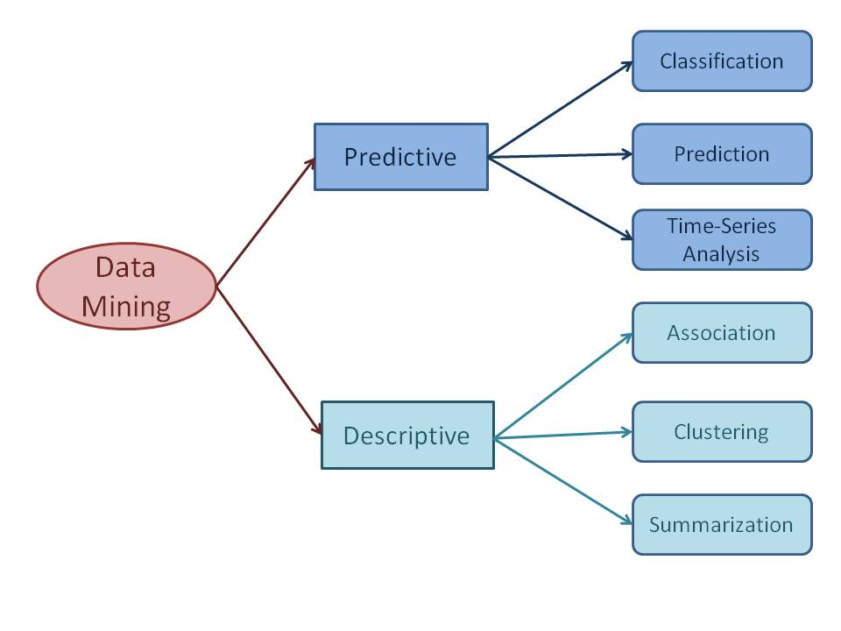
Predictive data mining tasks come up with a model from the available data set that is helpful in predicting unknown or future values of another data set of interest. A medical practitioner trying to diagnose a disease based on the medical test results of a patient can be considered as a predictive data mining task.

a) Classification:Classification derives a model to determine the class of an object based on its attributes. A collection of records will be available, each record with a set of attributes. Using the available data, it is possible to know which customers purchased similar products and who did not purchase in the past.

b) Prediction:Prediction task predicts the possible values of missing or future data. example, a model can predict the income of an employee based on education, experience and other demographic factors like place of stay, gender etc

c) Time - Series Analysis:Time series is a sequence of events where the next event is determined by one or more of the preceding events. Stock market prediction is an important application of time- series analysis.

d) Association:Association identifies the relationships between objects. Association analysis is used for commodity management, advertising, catalog design, direct marketing etc. A retailer can identify the products that normally customers purchase together or even find the customers who respond to the promotion of same kind of products.

e) Clustering:Clustering is used to identify data objects that are similar to one another.example, an insurance company can cluster its customers based on age, residence, income etc. This group information will be helpful to understand the customers better and hence provide better customized services.

f) Summarization:Summarization is the generalization of data. For example, the shopping done by a customer can be summarized into total products, total spending, offers used, etc.

14.
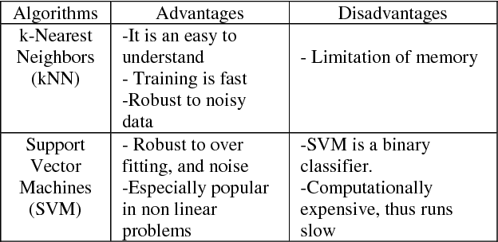

15. 1. Agglomerative Clustering :every data point as an individual Cluster and at every step, merge the nearest pairs of the cluster. (It is a bottom-up method). At every iteration, the clusters merge with different clusters until one cluster is formed.
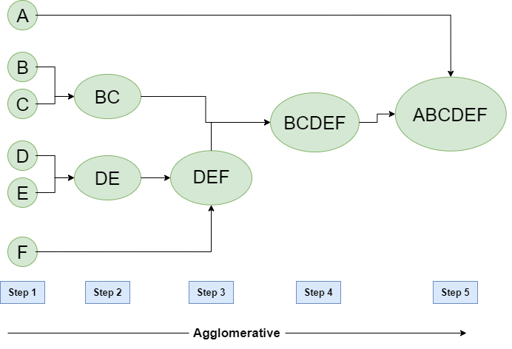
In Divisive Hierarchical clustering, we take into account all of the data points as a single cluster and in every iteration, we separate the data points from the clusters which aren’t comparable.
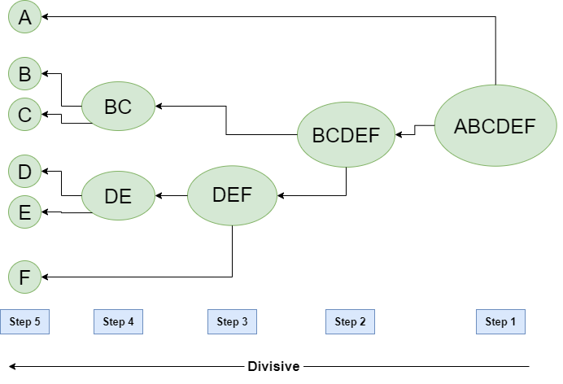
16.
Balanced Iterative Reducing and Clustering using Hierarchies, or BIRCH is a clustering technique used for very large datasets. A fast algorithm that scans the entire dataset in a single pass. It is dedicated to solving the issues of large dataset clustering by focusing on densely occupied spaces and creating a precise summary.
BIRCH fits in with any provided amount of memory and minimizes the I/O complexity. The algorithm only works to process metric attributes, which means the one with no categorical variables or the attribute whose value can be represented by explicit coordinates in a Euclidean space. The main parameters of the algorithm are the CR tree and the threshold.
- CF tree: The clustering Feature tree is a tree in which each leaf node consists of a sub-cluster. Each entry in a CF tree holds a pointer to a child node. The CF entry is made up of the sum of CF entries in the child nodes.
- Threshold: A maximum number of entries in each leaf node
Steps of BIRCH Algorithm
Step 1- Building the Clustering feature (CF) Tree: Building small and dense regions from the large datasets. Optionally, in phase 2 condensing the CF tree into further small CF.
Step 2 – Global clustering: Applying clustering algorithm to leaf nodes of the CF tree.
Step 3 – Refining the clusters, if required.

17.
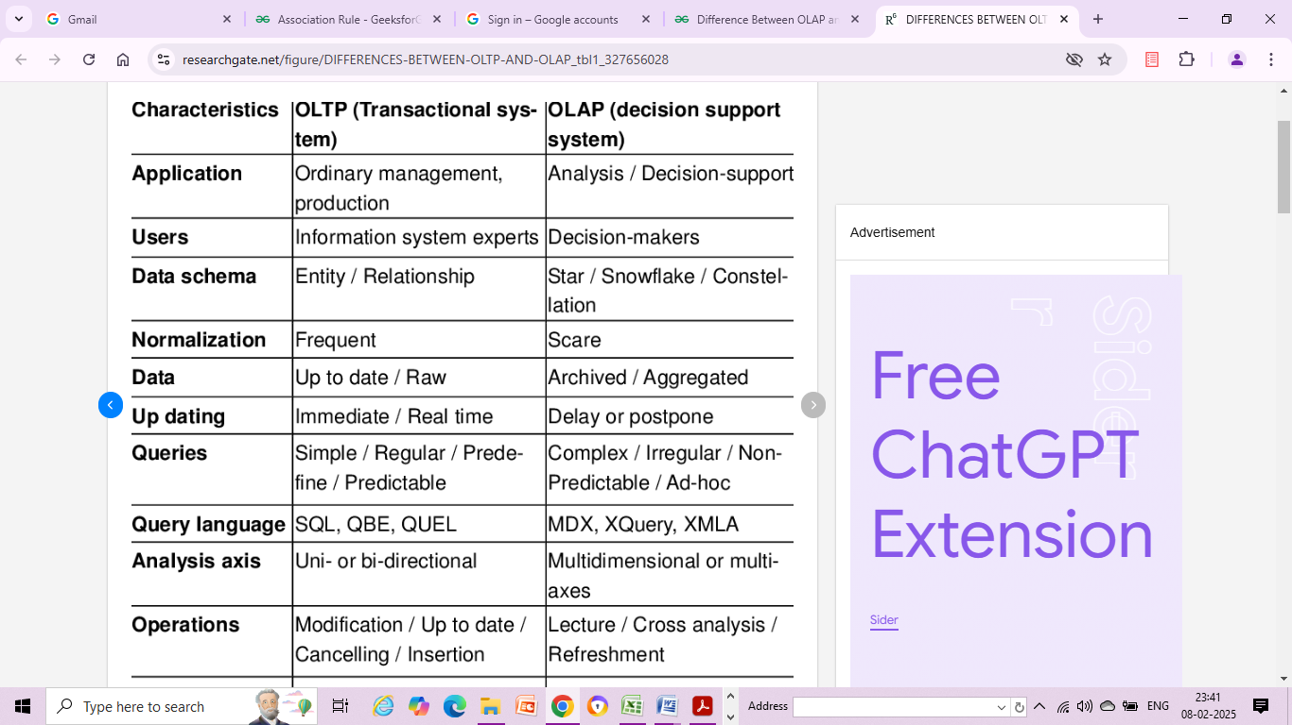
- 18.
- Normalization: The snowflake schema is a normalized design, which means that data is organized into multiple related tables. This reduces data redundancy and improves data consistency.
- Hierarchical Structure: The snowflake schema has a hierarchical structure that is organized around a central fact table. The fact table contains the measures or metrics of interest, and the dimension tables contain the attributes that provide context to the measures.
- Multiple Levels: The snowflake schema can have multiple levels of dimension tables, each related to the central fact table. This allows for more granular analysis of data and enables users to drill down into specific subsets of data.
- Joins: The snowflake schema typically requires more complex SQL queries that involve multiple tables joins. This can impact performance, especially when dealing with large data sets.
- Scalability: The snowflake schema is scalable and can handle large volumes of data. However, the complexity of the schema can make it difficult to manage and maintain.

19.
BigQuery is Google's fully managed data warehouse solution designed for scalability and flexibility. It enables businesses to analyze massive datasets using SQL and built-in machine learning capabilities.
- Serverless architecture eliminates infrastructure management
- Automatic scaling of storage and compute resources.
- Real-time data streaming and analysis:
- Integration with Google Cloud Platform services
Snowflake:Snowflake offers a cloud-native data warehousing solution that unifies data warehousing, data lakes, data engineering, data science, and data application development. Its unique architecture enables seamless scalability and performance.
- Decoupling of compute and storage for independent scaling
- Support for diverse data types and workloads
- Data sharing and collaboration across regions and clouds
- Pay-per-second pricing model for cost optimization
Azure Synapse Analytics:Azure Synapse Analytics is Microsoft's limitless analytics service that combines data warehousing with big data analytics. It provides a unified platform for data ingestion, exploration, and visualization.
- Massively Parallel Processing (MPP) architecture for high-performance querying
- Support for various data formats and sources
Amazon Redshift:Amazon Redshift is a fast, fully-managed data warehouse service provided by Amazon Web Services (AWS). It enables businesses to analyze petabytes of structured and semi-structured data across data warehouses, operational databases, and data lakes.
- Columnar storage and parallel processing for fast querying.
- Integration with AWS services like Amazon S3 and Amazon QuickSight
- Automated backup and disaster recovery
- Elastic resize to adjust compute and storage capacity

20.

1. Poor Quality of Data
Unclean and noisy data can make the whole process extremely exhausting. We don’t want our algorithm to make inaccurate or faulty predictions. Hence the quality of data is essential to enhance the output. Therefore, we need to ensure that the process of data preprocessing which includes removing outliers, filtering missing values, and removing unwanted features, is done with the utmost level of perfection.

2. Underfitting of Training Data
This process occurs when data is unable to establish an accurate relationship between input and output variablest signifies the data is too simple to establish a precise relationship. To overcome this issue:
- Maximize the training time
- Enhance the complexity of the model
- Add more features to the data
- Reduce regular parameters
- Increasing the training time of model

3. Overfitting of Training Data
Overfitting refers to a machine learning model trained with a massive amount of data that negatively affect its performances. consider a model trained to differentiate between a cat, a rabbit, a dog, and a tiger. The training data contains 1000 cats, 1000 dogs, 1000 tigers, and 4000 Rabbits. Then there is a considerable probability that it will identify the cat as a rabbit. In this example, we had a vast amount of data, but it was biased; hence the prediction was negatively affected.
We can tackle this issue by:
- Analyzing the data with the utmost level of perfection
- Use data augmentation technique
- Remove outliers in the training set
- Select a model with lesser features

4. Machine Learning is a Complex Process
The machine learning industry is young and is continuously changing. Rapid hit and trial experiments are being carried on. The process is transforming, and hence there are high chances of error which makes the learning complex. It includes analyzing the data, removing data bias, training data, applying complex mathematical calculations, and a lot more.

5. Lack of Training Data
The most important task you need to do in the machine learning process is to train the data to achieve an accurate output. Less amount training data will produce inaccurate or too biased predictions. For complex problems, it may even require millions of data to be trained. Therefore we need to ensure that Machine learning algorithms are trained with sufficient amounts of data.

6. Slow Implementation
This is one of the common issues faced by machine learning professionals. The machine learning models are highly efficient in providing accurate results, but it takes a tremendous amount of time. Slow programs, data overload, and excessive requirements usually take a lot of time to provide accurate results. Further, it requires constant monitoring and maintenance to deliver the best output.

7. Imperfections in the Algorithm When Data Grows
So you have found quality data, trained it amazingly, and the predictions are really concise and accurate. the model may become useless in the future as data grows. The best model of the present may become inaccurate in the coming Future and require further rearrangement. So you need regular monitoring and maintenance to keep the algorithm working.

21.
Distance-based algorithms are a class of machine learning algorithms that operate by measuring the distance between data points in a feature space. These algorithms are commonly used for clustering, classification, and anomaly detection tasks. Some notable distance-based algorithms include:
- K-nearest Neighbors (KNN):
  - A simple yet effective algorithm for classification and regression tasks. It classifies a data point by a majority vote of its k nearest neighbors, where the class label or output value is determined based on the majority class or average of the neighbors.
- K-means Clustering:
  - A popular clustering algorithm that partitions a dataset into k clusters by iteratively assigning data points to the nearest cluster centroid and updating centroids based on the mean of data points in each cluster. It aims to minimize the within-cluster sum of squares.
- Hierarchical Clustering:
  - A clustering algorithm that builds a hierarchy of clusters by recursively merging or splitting clusters based on proximity measures such as Euclidean distance or linkage criteria. It produces a dendrogram representing the clustering structure of the data.
- DBSCAN (Density-Based Spatial Clustering of Applications with Noise):
  - A density-based clustering algorithm that identifies clusters based on regions of high density separated by regions of low density. It does not require specifying the number of clusters in advance and is robust to noise and outliers.
- OPTICS (Ordering Points To Identify the Clustering Structure):
  - A variation of DBSCAN that produces a reachability plot representing the clustering structure of the data. It provides more flexibility in identifying clusters of varying densities and shapes.

22. Association rule mining finds interesting associations and relationships among large sets of data items.
Table with the rows of data.
Frequent items
Association applied.

23.

Single-Tier Architecture:Single-Tier architecture is not periodically used in practice. Its purpose is to minimize the amount of data stored to reach this goal; it removes data redundancies. The figure shows the only layer physically available is the source layer. In this method, data warehouses are virtual. This means that the data warehouse is implemented as a multidimensional view of operational data created by specific middleware, or an intermediate processing layer.
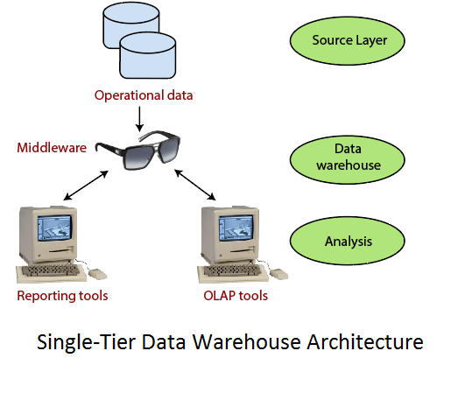
The vulnerability of this architecture lies in its failure to meet the requirement for separation between analytical and transactional processing. Analysis queries are agreed to operational data after the middleware interprets them. In this way, queries affect transactional workloads.

Two-Tier Architecture:The requirement for separation plays an essential role in defining the two-tier architecture for a data warehouse system, as shown in fig:
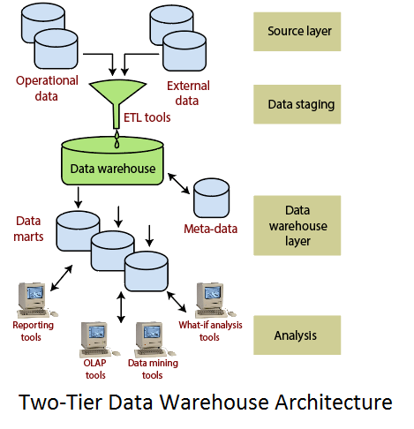
consists of four subsequent data flow stages:
- Source layer: A data warehouse system uses a heterogeneous source of data. That data is stored initially to corporate relational databases or legacy databases, or it may come from an information system outside the corporate walls.
- Data Staging: The data stored to the source should be extracted, cleansed to remove inconsistencies and fill gaps, and integrated to merge heterogeneous sources into one standard schema. The so-named Extraction, Transformation, and Loading Tools (ETL) can combine heterogeneous schemata, extract, transform, cleanse, validate, filter, and load source data into a data warehouse.
- Data Warehouse layer: Information is saved to one logically centralized individual repository: a data warehouse. The data warehouses can be directly accessed, but it can also be used as a source for creating data marts, which partially replicate data warehouse contents and are designed for specific enterprise departments. Meta-data repositories store information on sources, access procedures, data staging, users, data mart schema, and so on.
- Analysis: In this layer, integrated data is efficiently, and flexible accessed to issue reports, dynamically analyze information, and simulate hypothetical business scenarios. It should feature aggregate information navigators, complex query optimizers, and customer-friendly GUIs.

Three-Tier Architecture :The three-tier architecture consists of the source layer (containing multiple source system), the reconciled layer and the data warehouse layer (containing both data warehouses and data marts). The reconciled layer sits between the source data and data warehouse.
The main advantage of the reconciled layer is that it creates a standard reference data model for a whole enterprise. At the same time, it separates the problems of source data extraction and integration from those of data warehouse population. In some cases, the reconciled layer is also directly used to accomplish better some operational tasks, such as producing daily reports that cannot be satisfactorily prepared using the corporate applications or generating data flows to feed external processes periodically to benefit from cleaning and integration.This architecture is especially useful for the extensive, enterprise-wide systems. A disadvantage of this structure is the extra file storage space used through the extra redundant reconciled layer. It also makes the analytical tools a little further away from being real-time.
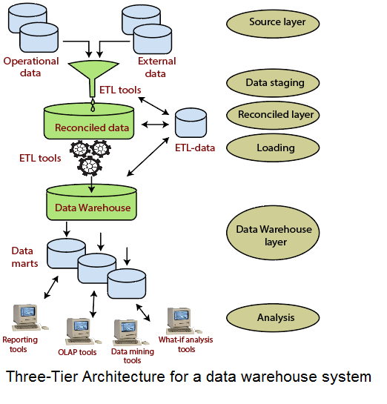
24.
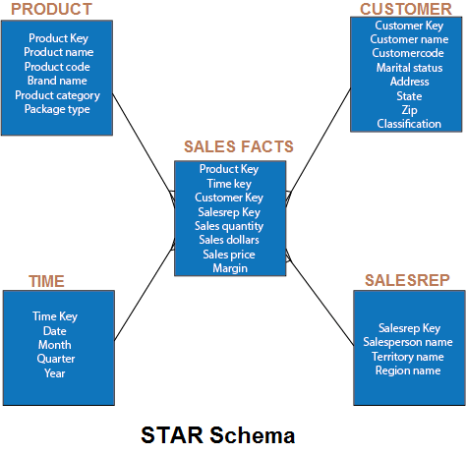
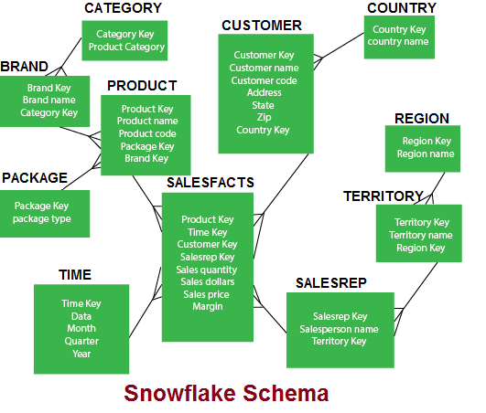
25
Building a Data Warehouse – Some steps are below:
- To extract the data (transnational) from different data sources: For building a data warehouse, a data is extracted from various data sources and that data is stored in central storage area. For extraction of the data Microsoft has come up with an excellent tool. When you purchase Microsoft SQL Server, then this tool will be available at free of cost.
- To transform the transnational data: There are various DBMS where many of the companies stores their data. Some of them are: MS Access, MS SQL Server, Oracle, Sybase etc. Also these companies saves the data in spreadsheets, flat files, mail systems etc. Relating a data from all these sources is done while building a data warehouse.
- To load the data (transformed) into the dimensional database: After building a dimensional model, the data is loaded in the dimensional database. This process combines the several columns together or it may split one field into the several columns. There are two stages at which transformation of the data can be performed and they are: while loading the data into the dimensional model or while data extraction from their origins.
- To purchase a front-end reporting tool: There are top notch analytical tools are available in the market. These tools are provided by the several major vendors. A cost effective tool and Data Analyzer is released by the Microsoft on its own.

