ANNA ADARSH COLLEGE FOR WOMEN (AUTONOMOUS)

Accounting for Managers – II – Answer Key

SECTION – A (10 X 2 = 20 Marks) Answer Any Ten Questions

- Cost Accounting is a branch of accounting that focuses on recording, classifying, and analyzing costs associated with the production of goods or services. It helps organizations determine the cost of their products, services, and business operations, enabling them to manage expenses effectively and make informed decisions.
- Prime Cost refers to the total direct costs incurred in the production of goods or services. It includes the essential costs that can be directly attributed to the production process and are essential for manufacturing a product.
- A Common Size Statement is a financial statement in which each line item is expressed as a percentage of a base figure. This technique helps in analyzing and comparing financial data over time or across different companies, regardless of their size.
- Cost Accounting, Overheads refer to the indirect costs incurred during the production of goods or services that cannot be directly traced to a specific product, service, or cost center. These are the costs necessary to support the production process but are not directly involved in the manufacturing of the product.
- The Current Ratio is a key liquidity metric used to evaluate a company's ability to meet its short-term obligations with its short-term assets. It is a measure of a company's financial health and its capacity to pay off its current liabilities using its current assets
- Financial Accounting is a branch of accounting that focuses on the recording, summarizing, and reporting of financial transactions of a business. Its primary purpose is to prepare financial statements—such as the Income Statement, Balance Sheet, and Cash Flow Statement—that provide a clear picture of a company’s financial performance and position to external stakeholders like investors, creditors, regulators, and analysts.
- Cash Flow refers to the movement of cash and cash equivalents into and out of a business over a specific period. It is a measure of the company’s liquidity and indicates how well the company can generate cash to meet its financial obligations, invest in operations, and return value to shareholders.
- A Fund Flow Statement is a financial statement that shows the movement of funds (i.e., financial resources) into and out of a business over a specific period. Unlike the cash flow statement, which focuses only on cash, the fund flow statement deals with changes in working capital, which can include non-cash items like depreciation, changes in inventories, receivables, and payables
- A Flexible Budget is a type of budget that adjusts or changes in response to actual activity levels or changes in business conditions, such as sales volume or production output. Unlike a static budget, which is fixed and does not change after it is set, a flexible budget can be modified based on the actual performance or changes in activity.
- The Breakeven Point (BEP) is the level of sales or revenue at which a company’s total revenues equal its total costs, resulting in neither a profit nor a loss. In other words, it is the point where a company's total fixed costs are exactly covered by its contribution margin (sales revenue minus variable costs).At the breakeven point, the company has zero profit but also zero loss, as it has just enough sales to cover its fixed costs and variable costs.
- Objectives of Management Accounting:
A) Assist in Decision Making: Management accounting provides managers with relevant financial and non-financial information to make informed decisions. This includes data on costs, revenues, profitability, and cash flows, which helps managers in planning, controlling, and directing business activities.
b) Aid in Performance Evaluation and Control: Management accounting helps in setting performance benchmarks and comparing actual results with these standards. This enables managers to evaluate the performance of departments, products, or processes and take corrective actions if necessary to improve efficiency and achieve organizational goals.
- Total Semi-variable Cost=₹12,000+₹24,000=₹36,000

SECTION – B (5 X 5 = 25 Marks) Answer any Five Questions
13. 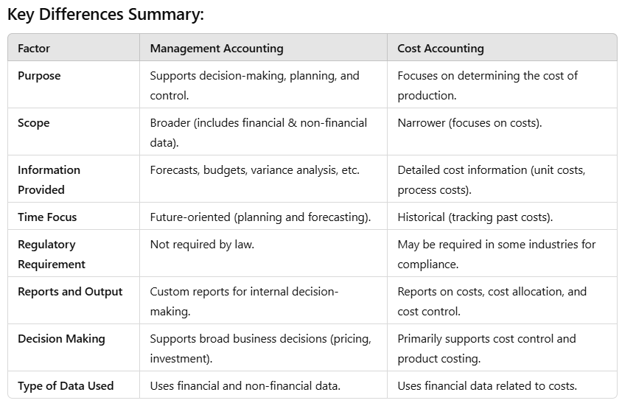
14. 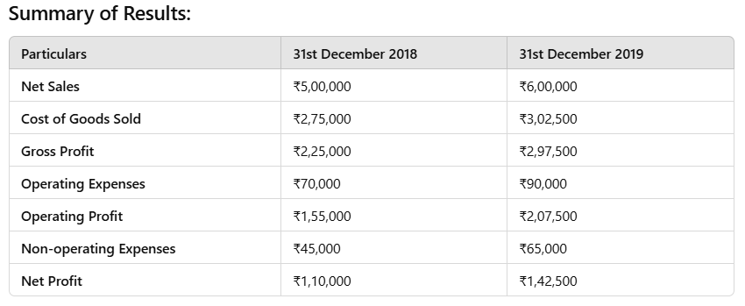
15. 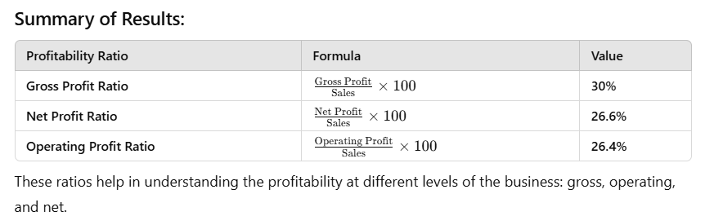

16. 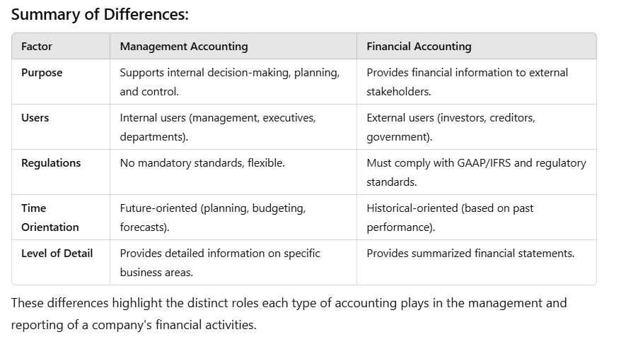
17. 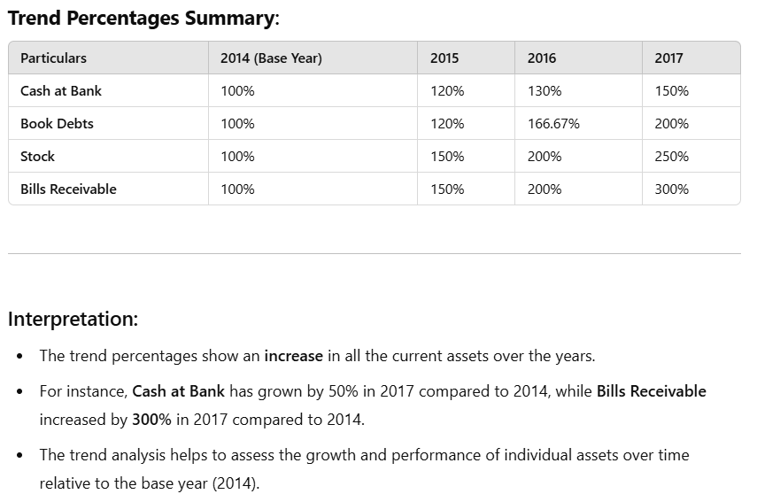
18.
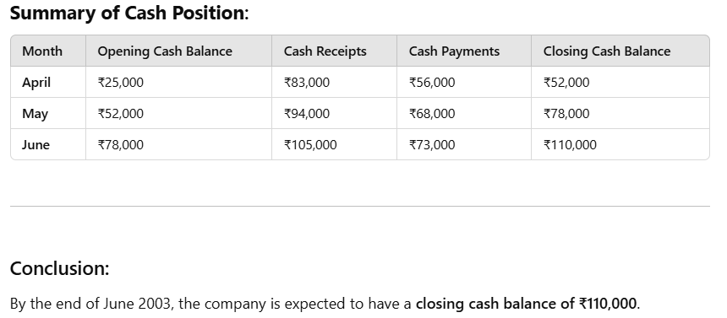

19.
1. Optimal Allocation of Resources
2. Long-term Financial Planning
3. Risk Management
4. Maximization of Shareholder Wealth
5. Profitability Analysis
6. Improved Decision-Making
7. Support for Expansion and Growth
8. Capital Cost Control
9. Resource Utilization Efficiency
10. Legal and Regulatory Compliance
11. Increased Competitiveness

SECTION – C (3 X 10 = 30 Marks) Answer any Three Questions
20. 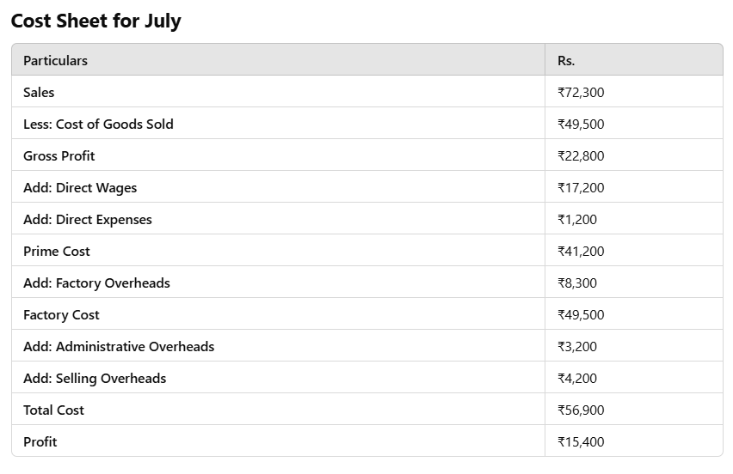
Conclusion:
The total cost incurred by the company for the month of July is ₹56,900.
After accounting for sales, the company made a profit of ₹15,400 during the month of July.
This cost sheet provides a comprehensive breakdown of all costs, enabling the company to understand its expenses and profitability for the month.

21.
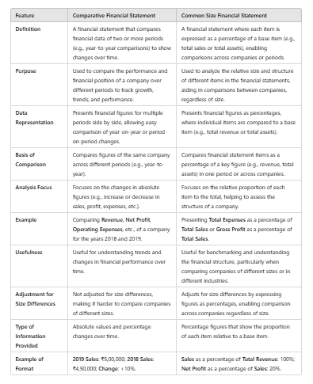
22. 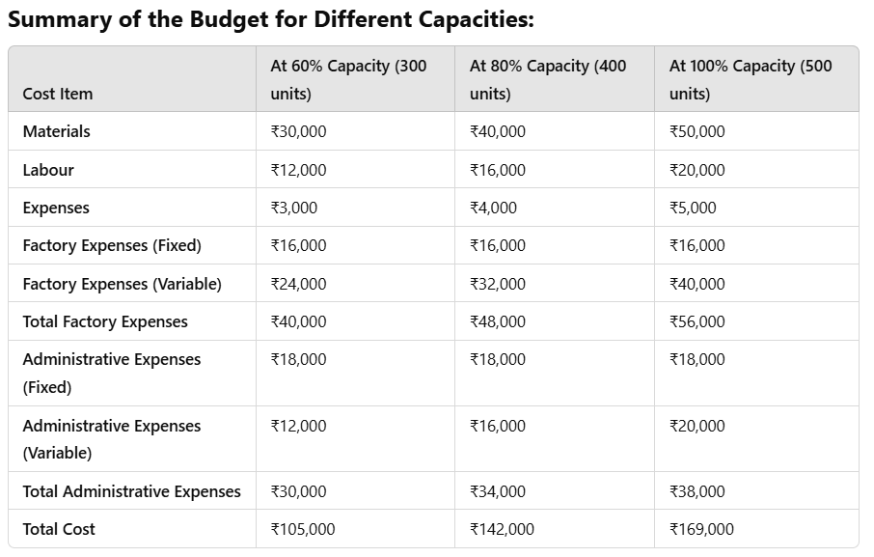
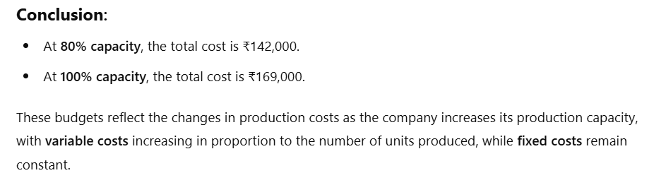

23. 
24. 