ANNA ADARSH COLLEGE FOR WOMEN (AUTONOMOUS)
END SEMESTER EXAMINATION – NOVEMBER 2025
B.Sc.Computer Science with Data Science
Java Programming – Answer Key
SECTION – A (10 X 2= 20 Marks) Answer any Ten Questions
Question No. | Question
1 | Recall about object-oriented programming.  Object-oriented programming (OOP) is a programming paradigm where software is designed by creating "objects" that contain both data (attributes) and the code (methods) to manipulate that data, allowing for a more organized and reusable approach to coding by modeling real-world entities and their interactions through classes and inheritance; the key principles of OOP include encapsulation, inheritance, and polymorphism.
2 | Explain about a variable.  A variable is any characteristic, number, or quantity that can be measured or counted. A variable may also be called a data item.
3 | Recall about constructors.  A constructor is a special function that creates an object in object-oriented programming. It prepares the object for use by setting its member variables.
4 | Outline about inheritance.  Inheritance is the capability of one class to acquire properties and characteristics from another class. The class whose properties are inherited by other class is called the Parent or Base or Super class. And, the class which inherits properties of other class is called Child or Derived or Sub class.
5 | What is an exception?  An exception in Java (or any programming language) is an error. It is an unexpected break in the program's flow that can cause the program to crash. If the program or runtime engine has no means of dealing with the error, it is considered unhandled and the program will crash. That is, unless you catch these errors
6 | Explain about a thread?  A Thread is a very light-weighted process, or we can say the smallest part of the process that allows a program to operate more efficiently by running multiple tasks simultaneously.
7 | What is AWT?  AWT stands for Abstract Window Toolkit, which is a Java API that allows users to create graphical user interfaces (GUIs) for Java applications. AWT is part of the Java Foundation Classes (JFC).
8 | Explain about swing.  Swing is a Java Foundation Classes [JFC] library and an extension of the Abstract Window Toolkit [AWT]. Java Swing offers much-improved functionality over AWT, new components, expanded components features, and excellent event handling with drag-and-drop support.
9 | What is an interface?  In Java, an interface is a blueprint for a class that specifies the methods a class must implement. Interfaces are used to define how software interacts, and to achieve abstraction, polymorphism, and multiple inheritance.
10 | Explain adapter class.  Java adapter classes provide the default implementation of listener interfaces. If you inherit the adapter class, you will not be forced to provide the implementation of all the methods of listener interfaces. So it saves code.
11 | What are java tokens?  Java tokens are the basic building blocks of a Java program. They are the smallest unit of a program, and they include keywords, identifiers, operators, literals, separators, and comments. Separators are symbols that separate different parts of a program.
12 | Illustrate the use of catch block.  The catch block catches and handles the try block exceptions by declaring the type of exception within the parameter. The catch block includes the code and it is executed if an exception inside the try block occurs. The catch block is where you handle the exceptions; so this block must be follow the try block.

SECTION – B (5 X 5 = 25 Marks) Answer any Five Questions
13 | Identify the features of Java.  Java has many features, including being platform independent, object oriented, and multithreaded.
14 | What is a package? How to create a package?  A package is a way to organize related classes and interfaces in a programming language. Packages can be used to structure code for easier management and reusability.  How to create a package in Java?  - Choose a name for the package  - Use the package keyword to create a package statement  - Place the package statement at the top of every source file that contains the types to include in the package  - Ensure the folder structure mirrors the package name
15 | Identify the difference between multitasking and multithreading.
  Multitasking | Multithreading
  In multitasking, users are allowed to perform many tasks by CPU. | While in multithreading, many threads are created from a process through which computer power is increased.
  Multitasking involves often CPU switching between the tasks. | While in multithreading also, CPU switching is often involved between the threads.
  In multitasking, the processes share separate memory. | While in multithreading, processes are allocated the same memory.
  The multitasking component involves multiprocessing. | While the multithreading component does not involve multiprocessing.
  In multitasking, the CPU is provided in order to execute many tasks at a time. | While in multithreading also, a CPU is provided in order to execute many threads from a process at a time.
  In multitasking, processes don’t share the same resources, each process is allocated separate resources. | While in multithreading, each process shares the same resources.
  Multitasking is slow compared to multithreading. | While multithreading is faster.
  In multitasking, termination of a process takes more time. | While in multithreading, termination of thread takes less time.
  Isolation and memory protection exist in multitasking. | Isolation and memory protection does not exist in multithreading.
  It helps in developing efficient programs. | It helps in developing efficient operating systems.
  Involves running multiple independent processes or tasks | Involves dividing a single process into multiple threads that can execute concurrently
16 | Discover about Jcheckbox.  The JCheckBox class is used to create a checkbox. It is used to turn an option on (true) or off (false). Clicking on a CheckBox changes its state from "on" to "off" or from "off" to "on ".It inherits JToggleButton class.  Declaration:  - public class JCheckBox extends JToggleButton implements Accessible  - import javax.swing.*;  - public class CheckBoxExample  - {  - CheckBoxExample(){  - JFrame f= new JFrame("CheckBox Example");  - JCheckBox checkBox1 = new JCheckBox("C++");  - checkBox1.setBounds(100,100, 50,50);  - JCheckBox checkBox2 = new JCheckBox("Java", true);  - checkBox2.setBounds(100,150, 50,50);  - f.add(checkBox1);  - f.add(checkBox2);  - f.setSize(400,400);  - f.setLayout(null);  - f.setVisible(true);  - }
17 | Experiment with inner classes  Java Inner Classes are classes defined within another class. They are used to logically group classes that are only used in one place, increase encapsulation, and can lead to more readable and maintainable code. Inner classes can access the members (including private members) of the outer class.  Types of Inner Classes  - Non-static Nested Class (Inner Class): Associated with an instance of the outer class.  - Static Nested Class: Not associated with an instance of the outer class and can access only static members of the outer class.  - Local Inner Class: Defined within a block, typically a method.  - Anonymous Inner Class: A class without a name, used to instantiate objects with certain "on-the-fly" functionality.
18 | Analyze about Java tokens  In Java, Tokens are the smallest elements of a program that is meaningful to the compiler. They are also known as the fundamental building blocks of the program. Tokens can be classified as follows: [explanation with example code]  - Keywords  - Identifiers  - Constants/Literals  - Operators  - Separators
19 | Examine arithmetic and bitwise operators.  Arithmetic Operators are used to perform simple arithmetic operations on primitive and non-primitive data types.  - : Multiplication  - / : Division  - % : Modulo  - + : Addition  - - : Subtraction  Bitwise Operators are used to perform the manipulation of individual bits of a number and with any of the integer types. They are used when performing update and query operations of the Binary indexed trees.  - & (Bitwise AND) – returns bit-by-bit AND of input values.  - | (Bitwise OR) – returns bit-by-bit OR of input values.  - ^ (Bitwise XOR) – returns bit-by-bit XOR of input values.  - ~ (Bitwise Complement) – inverts all bits (one’s complement).

SECTION – C (3 X 10 = 30 Marks) Answer any Four Questions
20 | Discover the basic data types used in Java. Explain with examples.  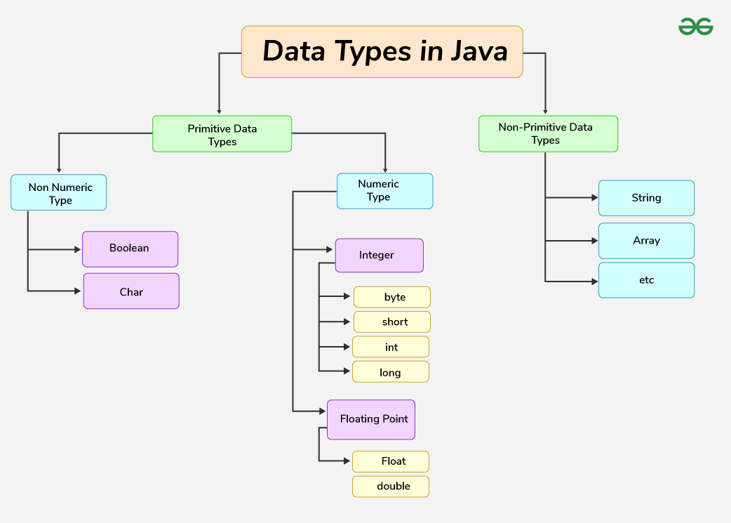
21 | Elaborate on method overriding. Write a Java program and explain.  - Definition: If subclass (child class) has the same method as declared in the parent class, it is known as method overriding in Java.  - Rules  - Uses  - Example:  //Java Program to illustrate the use of Java Method Overriding  - //Creating a parent class.  - class Vehicle{  - //defining a method  - void run(){System.out.println("Vehicle is running");}  - }  - //Creating a child class  - class Bike2 extends Vehicle{  - //defining the same method as in the parent class  - void run(){System.out.println("Bike is running safely");}  - public static void main(String args[]){  - Bike2 obj = new Bike2();//creating object  - obj.run();//calling method  - }  - }
22 | Discuss about the ways exception handling mechanisms can be included in a program.  In Java, the primary way to handle exceptions is using the "try-catch" block, where you enclose code that might throw an exception within a "try" block, and then use "catch" blocks to handle specific types of exceptions that could occur, allowing for different actions based on the exception thrown; other key mechanisms include "finally" for code that always executes, and "throws" to declare that a method might throw exceptions to the caller, enabling proper exception propagation.  Example of basic try-catch block:  public static int divide(int numerator, int denominator) {  try {  return numerator / denominator;  } catch (ArithmeticException e) {  System.out.println("Cannot divide by zero!");  return 0;  }  }  Important Exception Types in Java:  - ArithmeticException: Thrown when a mathematical operation results in an error, like dividing by zero  - IOException: Thrown when an input/output operation fails  - NullPointerException: Thrown when you try to access a null reference  - IndexOutOfBoundsException: Thrown when you access an array element outside the valid index range  - ClassNotFoundException: Thrown when a class cannot be found at runtime
23 | Discuss about Event handling in Java.  An event can be defined as changing the state of an object or behavior by performing actions. Actions can be a button click, cursor movement, keypress through keyboard or page scrolling, etc.  The java.awt.event package can be used to provide various event classes.  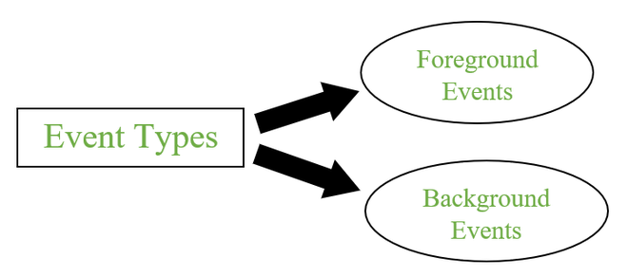  Event Handling  It is a mechanism to control the events and to decide what should happen after an event occur. To handle the events, Java follows the Delegation Event model.  Flow of Event Handling  - User Interaction with a component is required to generate an event.  - The object of the respective event class is created automatically after event generation, and it holds all information of the event source.  - The newly created object is passed to the methods of the registered listener.  - The method executes and returns the result.  Code-Approaches  The three approaches for performing event handling are by placing the event handling code in one of the below-specified places.  - Within Class  - Other Class  - Anonymous Class
24 | Develop a JDBC program to connect and retrieve data from a table and explain.  // Importing SQL libraries to create database  import java.sql.*;  public class GFG {  // Step1: Main driver method  public static void main(String[] args)  {  // Step 2: Making connection using  // Connection type and inbuilt function on  Connection con = null;  PreparedStatement p = null;  ResultSet rs = null;  con = connection.connectDB();  // Try block to catch exception/s  try {  // SQL command data stored in String datatype  String sql = "select * from cuslogin";  p = con.prepareStatement(sql);  rs = p.executeQuery();  // Printing ID, name, email of customers  // of the SQL command above  System.out.println("id\t\tname\t\temail");  // Condition check  while (rs.next()) {  int id = rs.getInt("id");  String name = rs.getString("name");  String email = rs.getString("email");  System.out.println(id + "\t\t" + name  + "\t\t" + email);  } }  // Catch block to handle exception  catch (SQLException e) {  // Print exception pop-up on screen  System.out.println(e);  } }  }

