
ANNA ADARSH COLLEGE FOR WOMEN (AUTONOMOUS) CHENNAI – 600 040

END SEMESTER EXAMINATIONS – APRIL – 2025

Programme : B. Sc. Psychology | Batch : 2024-2027 | Semester : II
Course Title : PSYCHOLOGY OF CHILDHOOD | Course Code :  24UBSPY304
Duration : 3 Hrs | Maximum Marks : 75
SECTION A : (2 X 10 = 20) ANSWER ANY TEN QUESTIONS
1 | Developmental tasks of babyhood and early childhood of Havighurst – learning to take solid foods; walk; talk; body elimination; sex differences; sexual modesty; ready to read; distinguishing right and wrong; conscience development. | 2 | K1 | CO1
2 | Maturation – unfolding of inherent traits like phylogenetic functions of sitting and walking; development comes from maturation.  Learning – development comes from exercise and control on person’s part; ontogenetic functions like writing | 2 | K2 | CO1
3 | Stages of birth – labor stage has latent, active, transition phase; delivery of baby; delivery of placenta. | 2 | K1 | CO2
4 | Denver Developmental Screening test- checks progress between 1 month and 6 years; measures gross and fine motor skills, language development, personality and social development. | 2 | K2 | CO2
5 | Depth perception-perceiving objects and surfaces in 3 dimensions; relies on kinetic cues.  Haptic perception- acquiring information about objects by handling them; relies on cues based on texture, shading and relative size. | 2 | K1 | CO3
6 | Cephalocaudal-development from head to tail  Proximodistal-development from center to extremities. | 2 | K2 | CO3
7 | Patterns of crying – hunger, anger, pain, frustration. | 2 | K1 | CO4
8 | Temperamental patterns 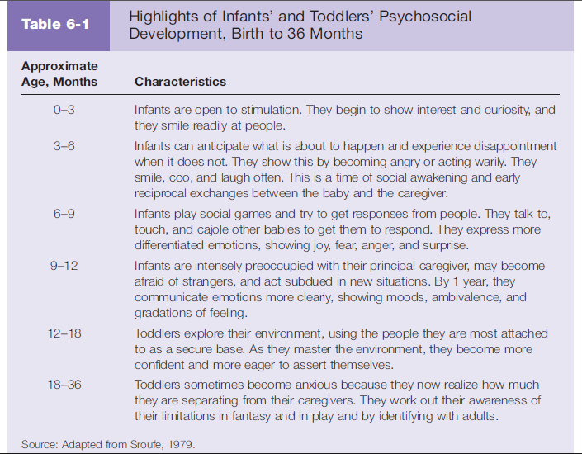 | 2 | K2 | CO4
9 |  | 2 | K1 | CO5

10 | Secular trend – several generations have early attainment of height and sexual maturity; seen in United States, Western Europe and Japan; reasons could be higher standard of living, diet, exercise, environmental toxins, socio-economic status, prepubertal fat, body weight, stress, chronic illnesses, menarche associated with heritability of mother. | 2 | K2 | CO5
11 | Cognitive advance of understanding of identities. Children know that superficial alterations do not change the nature of things. | 2 | K2 | CO1
12 | Pretend play – play involving imaginary situation and persons; fantasy/dramatic/imaginative play; usage of symbolic functions. | 2 | K1 | CO2
SECTION – B (5 X 8 = 40 Marks) Answer any Five Questions

13 | Conditions influencing longevity – heredity; physical characteristics; general physical condition; sex; race; geographic location; intelligence; education; socioeconomic level; smoking; drinking; marital status; efficiency; anxiety; occupation; happiness. | 5 | K3 | CO1
14 | Prenatal period – heredity endowment is foundation for later development; conditions in mother’s body might stunt or foster development; sex is fixed at conception time; good period for growth and development; most hazardous period; attitudes of others influence too. | 5 | K4 | CO1
15 | Early human reflexes – Moro, Darwinian, Tonic neck, Babkin, Babinski, Rooting, Walking and Swimming. | 5 | K3 | CO2
16 | Speech during early childhood – 2 to 3 year olds use two- to three-word sentences, vocabulary expands to 200-300 words, uses pronouns, follows simple instructions.  3 to 4 years - four- to five-word sentences; vocabulary increases to 1000 words, asks ‘why’ and ‘how’ questions, speech becomes more intelligible.  4 to 5 years -complete sentences with proper grammar, uses past and future tense correctly, clear pronunciation, conversations and storytelling  5 to 6 years – vocabulary is 2500+ words, detailed stories and explain events, complex sentences, abstract ideas, speech sounds developed  Factors affecting speech development – social interaction, cognitive growth, hearing ability, parental encouragement. | 5 | K4 | CO2
17 | Sleep needs and problems of late childhood – sleep deprivation; sleeping late; sleeping too less; morning sleepiness; oversleeping on weekends; sleep problems like insomnia, irritability, lack of motivation, concentration issues, not following circadian rhythm. | 5 | K3 | CO3
18 | Psychosocial development | 5 | K4 | CO4
19 | Immature aspects of preoperational thought – centration; irreversibility; focus on states rather than transformations; transductive reasoning; egocentricism; animism; inability to distinguish appearance from reality. | 5 | K3 | CO5
SECTION – C (2 X 15 = 30 Marks) Answer any Two Questions

20 | Characteristics of infancy and babyhood – physical development has height, growth, reflexes, motor skills, crawling, walking, sensory abilities; Cognitive development has sensory exploration, learning through observation, memory, recognition, early problem solving skills, object permanence, language development; Emotional and social development – strong attachment with primary caregivers, expression of basic emotions; stranger anxiety, separation anxiety, social smiling, early attempts at communication; Personality and Behavioral development has temperament, recognition in mirrors and self-awareness, curiosity driven exploration, imitation of other’s behaviors. | 10 | K5 | CO1
21 | Motor development – simple skills to systems of action like pincer grasp and precision grip; screening tests to check cephalocaudal and proximodistal development; head control; hand control; locomotion; social referencing. Haptic perception and motor development; Thelen’s dynamic systems theory; cultural influences on motor development. | 10 | K6 | CO2
22 | Role of mothers- Harlow’s experiment; importance of mother’s responsiveness  Role of fathers- father’s role can be shared by mother’s brother or grandfather; main role of economic support and discipline; might be a caregiver. | 10 | K6 | CO3

23 | Eating disorders – body image issues; anorexia nervosa or self-starvation; bulimia or binge eating disorder; family therapy and cognitive behavior therapy. | 10 | K6 | CO4
24 | Freud’s psychosexual stages- oral, anal, phallic, latency, genital.  Erikson’s psychosocial stages- trust vs. mistrust; autonomy vs. shame and doubt; initiative vs. guilt; autonomy vs. inferiority; identity vs. identity confusion; intimacy vs. isolation; generativity vs. stagnation; integrity vs. despair. | 10 | K5 | CO5

Knowledge Level as per Bloom Taxonomy

K1 – Remember; K2 – Understand; K3- Apply; K4 –Analyse, K5-Evaluate; K6-Create

