Anna Adarsh College for Women (Autonomous)
MSc Degree Program in Food Service Management and Dietetics
CORE VII: RESEARCH METHODOLOGY AND STATISTICS
Answer Key

Section A

- Define research design.
A research design is the overall plan or blueprint for conducting a research study in a systematic and organized manner.
- State the difference between participant and non-participant observation.
In participant observation, the researcher takes part in the activities being observed, whereas in non-participant observation, the researcher observes without direct involvement.
- List any two characteristics of a good sampling process.
  - Representativeness of the population
  - Absence of bias
- State the difference between primary and secondary data sources.
Primary data is collected firsthand by the researcher, while secondary data is already collected and published by others.
- Define standard deviation.
Standard deviation is a measure of the dispersion or spread of data around the mean.
- List any three types of diagrams used in the graphical presentation of data.
  - Bar diagram
  - Pie chart
  - Histogram
- Define simple linear regression.
Simple linear regression is a method to predict the value of one variable based on the value of another using a straight-line relationship.
- Mention the difference between One-Way and Two-Way ANOVA.
One-Way ANOVA tests the effect of one independent variable, while Two-Way ANOVA tests the effects of two independent variables simultaneously.
- List any two types of research reports commonly used in academic research.
  - Thesis or dissertation
  - Technical report
- Name any two tools used to detect plagiarism.
  - Turnitin
  - Scribbr
- Define Type I error in hypothesis testing.
Type I error occurs when a true null hypothesis is wrongly rejected.
- What is a dependent variable?
A dependent variable is the outcome or response that is measured in an experiment and is influenced by the independent variable.

Section B
13. Illustrate the steps involved in the selection and formulation of a research problem.
- Identify a broad area of interest through literature review or field observation.
- Narrow down to a specific issue or gap needing investigation.
- Evaluate the feasibility (time, resources, scope).
- Clearly define and articulate the research problem in a precise and concise manner.

14. Analyze the advantages and limitations of using structured interviews versus unstructured interviews.
- Structured Interviews:
  - Advantages: Consistent format, easy to compare and analyze responses.
  - Limitations: Limited flexibility, may miss deeper insights.
- Unstructured Interviews:
  - Advantages: Open-ended, allows in-depth understanding.
  - Limitations: Time-consuming, harder to analyze statistically.

15. Identify and explain the importance of a pilot study in questionnaire-based research.
- Tests clarity and wording of questions.
- Identifies flaws in the questionnaire structure or order.
- Helps estimate time required for actual data collection.
- Ensures reliability and validity before full-scale implementation.

16. Calculate the mean and standard deviation for the following data set: 4, 6, 8, 10, 12.
Given Data: 4, 6, 8, 10, 12
Find the Mean (𝑋̄)
Formula: Mean (𝑋̄) = ΣX / n
Where:
- ΣX = Sum of all values
- n = Number of values
Calculation:
𝑋̄ = (4 + 6 + 8 + 10 + 12) / 5 = 40 / 5 = 8
Step 2: Find the Deviation from Mean (X − 𝑋̄) and Square Each
X | X − 𝑋̄ | (X − 𝑋̄)²
4 | -4 | 16
6 | -2 | 4
8 | 0 | 0
10 | 2 | 4
12 | 4 | 16
Σ(X − 𝑋̄)² = 16 + 4 + 0 + 4 + 16 = 40
Calculate Standard Deviation
For population:
σ = √[Σ(X − 𝑋̄)² / n] = √(40 / 5) = √8 ≈ 2.83
For sample:
s = √[Σ(X − 𝑋̄)² / (n − 1)] = √(40 / 4) = √10 ≈ 3.16
Final Answer:
Mean = 8
Standard Deviation (Population) ≈ 2.83
Standard Deviation (Sample) ≈ 3.16

17. Illustrate the basic steps involved in hypothesis testing.
- State the null (H₀) and alternative hypothesis (H₁).
- Choose the significance level (commonly α = 0.05).
- Select and compute the appropriate test statistic.
- Compare with critical value or p-value and make a decision (reject or fail to reject H₀).

18. Explain the steps involved in performing a chi-square test of independence.
- Construct a contingency table of observed frequencies.
- Calculate expected frequencies for each cell.
- Compare calculated χ² value with the critical value from chi-square distribution table (based on degrees of freedom).

19. Differentiate between footnotes and endnotes.
- Footnotes: Appear at the bottom of the same page; provide additional info or citations (e.g., explaining a term).
- Endnotes: Appear at the end of the chapter or document; used for references or extended comments.
- Footnotes are more immediate; endnotes help reduce page clutter.
Section C
20. Critically evaluate various types of experimental research designs.
- Pre-Experimental Designs: Simple, lack randomization; e.g., one-group pre-test post-test design. Limited control over variables.
- Quasi-Experimental Designs: No random assignment but have comparison groups; stronger than pre-experimental designs.
- True Experimental Designs: Include random assignment, control group, and manipulation of independent variable (e.g., RCTs). Gold standard in causal research.
- IN VIVO vs IN VITRO: IN VIVO involves whole organism testing; IN VITRO uses controlled lab settings (cells/tissues).
- These designs vary in internal validity, feasibility, and ethical considerations.

21. Discuss probability and non-probability sampling techniques with examples.
- Probability Sampling: Every unit has a known, non-zero chance of being selected.
  - Examples: Simple Random Sampling, Stratified Sampling, Systematic Sampling, Cluster Sampling.
- Non-Probability Sampling: Selection is based on judgment or convenience; not all units have a known chance.
  - Examples: Convenience Sampling, Purposive Sampling, Snowball Sampling, Quota Sampling.
- Probability methods are more statistically valid for generalization.
- Non-probability is quicker and cheaper but may lead to bias.
- Application: Probability for clinical trials; non-probability for exploratory research.

22. Independent Samples t-test (Assume Equal Variance)
Given:
- Group A: n₁ = 10, mean₁ = 1.5, SD₁ = 0.5
- Group B: n₂ = 10, mean₂ = 2.1, SD₂ = 0.4
- Significance Level = 0.05
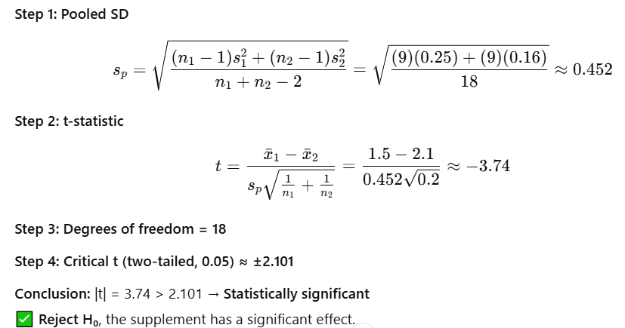

23. Explain simple correlation and rank correlation with examples.
- Simple Correlation: Measures linear relationship between two continuous variables.
  - Example: Correlation between height and weight.
  - Calculated using Pearson’s correlation coefficient (r), range: -1 to +1.
- Rank Correlation: Used for ordinal data or non-linear relationships.
  - Spearman’s rank correlation (ρ) compares ranks, not raw data.
  - Example: Correlation between students’ test ranks and their study hours.
- Interpretation:
  - +ve: Direct relation
  - -ve: Inverse relation
  - 0: No correlation
- Spearman's is preferred when data is non-normal or contains outliers.

24. Explain the different scales of measurement.
- Nominal Scale: Categories without order (e.g., gender, blood group).
- Ordinal Scale: Categories with a meaningful order, but unequal intervals (e.g., satisfaction levels).
- Interval Scale: Ordered, equal intervals, no true zero (e.g., temperature in °C).
- Ratio Scale: Equal intervals with a true zero (e.g., weight, age, income).
- Scale type determines the statistical tests applicable.

25. Discuss the key mechanics of research report formatting.
- Title Page: Includes title, author, affiliation, and date.
- Abstract: Concise summary of the study's purpose, methods, results, and conclusion.
- Main Body: Introduction, Methodology, Results, Discussion, Conclusion.
- References: Cited in-text and listed using consistent style (APA, MLA, etc.).
- Appendices & Footnotes: Supplementary data and clarifications.
- Formatting must be consistent, formal, and follow institutional guidelines.

***************************************************************************

