Scheme of valuation
Cou333rse Title: Fluid Dynamics
Course Code:
Duration: 3 hours Maximum Marks: 75

Section – A (10 $×$ 1 = 10 Marks)
Answer any TEN Questions

1. Define stream line.
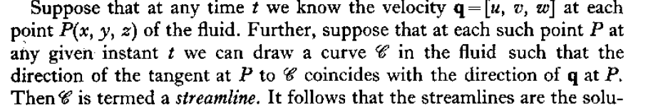
2. Define path lines.
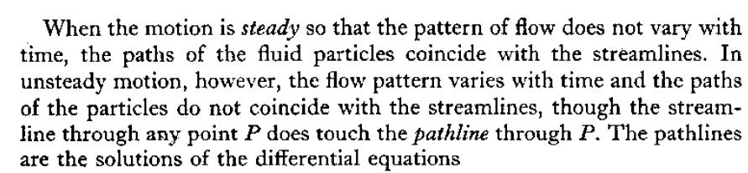
3. Write Euler’s equation of motion.
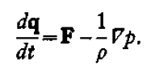
4. Write Laplace equation in cylindrical polar coordinates.

5. Write the Bernoulli’s equation.
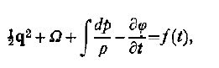
6. Define simple source.
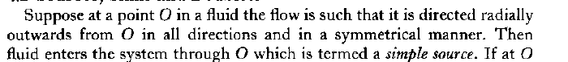
7. Define Strength of a source.
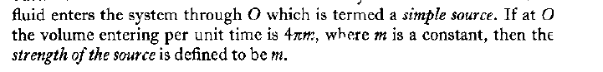
8. Write the Cauchy Riemann equation.
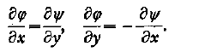

9. Write the Milne-Thomson’s Circle theorem.
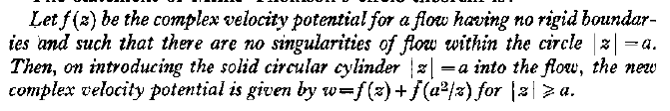
10. Define line sink.
If fluid drains away through such a line and under the same conditions ot symmetry, then the line ts called a line sink.
11. Write the stress matrix.
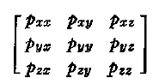
12. Define rate of strain quadric.

Section – B (5 $×$ 5 = 25 Marks)
Answer any FIVE Questions

13. Discuss about velocity of a fluid at point.
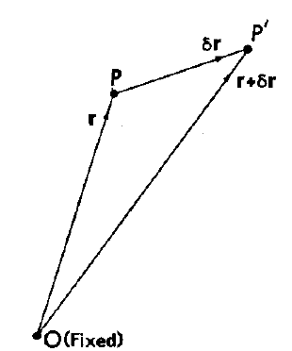
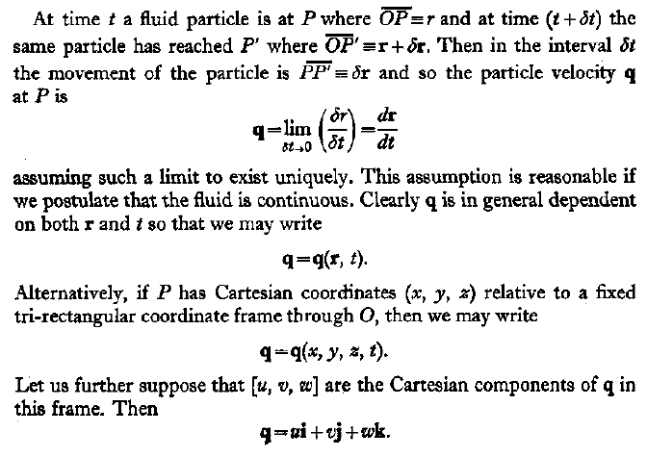
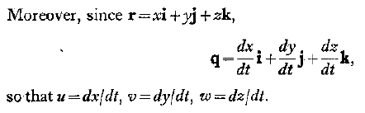
14. For an incompressible fluid, $q=\left[-wy, wx,0\right] (w = constant),$ discuss the nature of the flow.
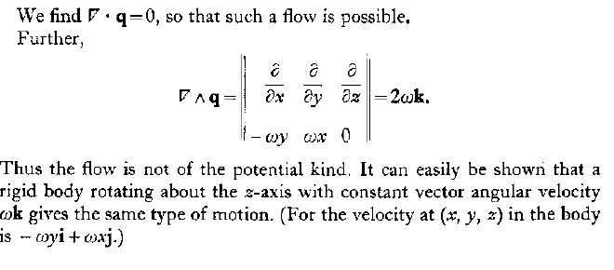
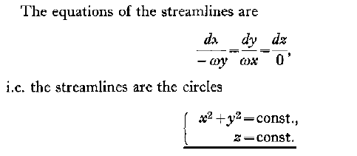
15. Explain the venturi tube.
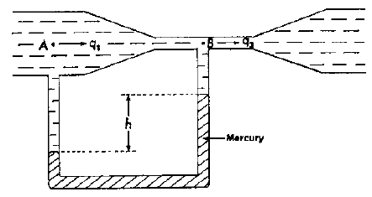
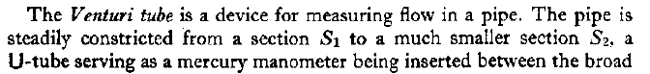
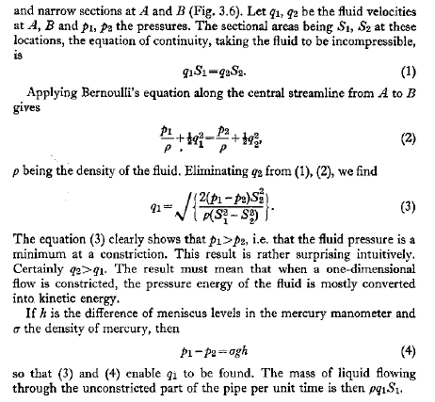
16. Derive the Bernoulli’s equation.
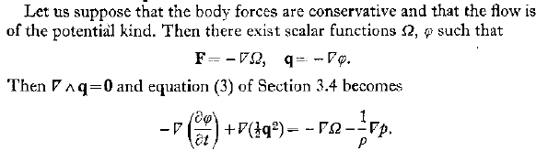
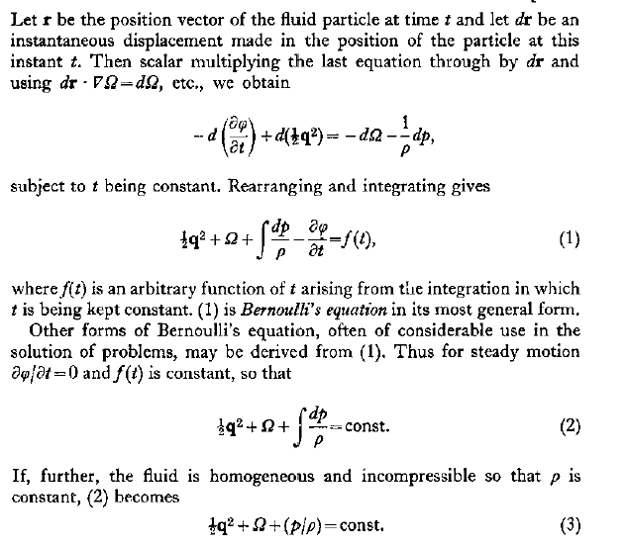

17. Write a short note on images in a rigid infinite plane.
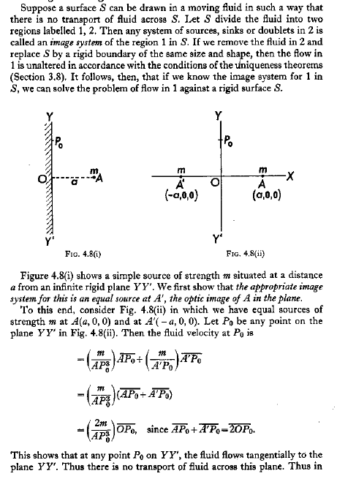
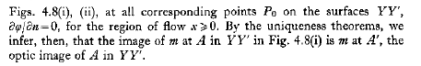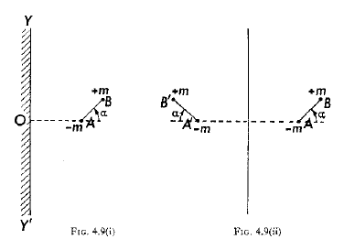

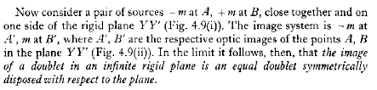
18. Find the equation of the streamlines due to uniform line sources of strength $m$ through the points $A(- c,0),B(c,0)$ and a uniform line sink of strength $2m$ through the origin.
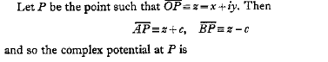
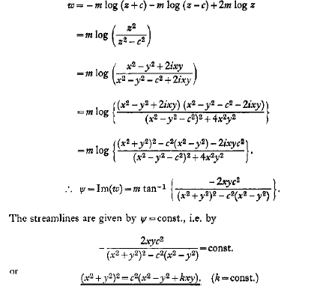
19. Explain the co-efficient of viscosity and laminar flow.
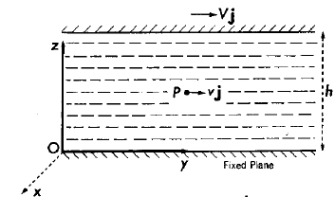
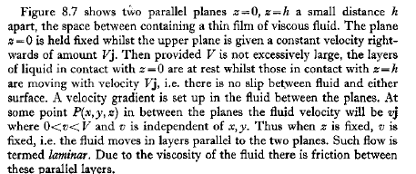
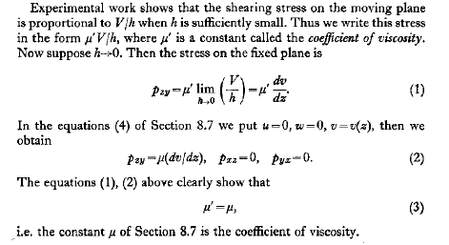
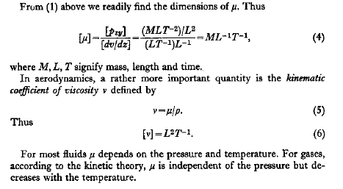

Section – C (4 $×$ 10 = 40 Marks)
Answer any FOUR Questions

20. At the point in an incompressible fluid having spherical polar coordinates $(r, θ, ψ)$, the velocity components are $\left[2Mr^{-3}cosθ, Mr^{-3}sinθ, 0\right],$ where M is a constant. Show that the velocity is of the potential kind. Find the velocity potential and the equations of the streamlines.
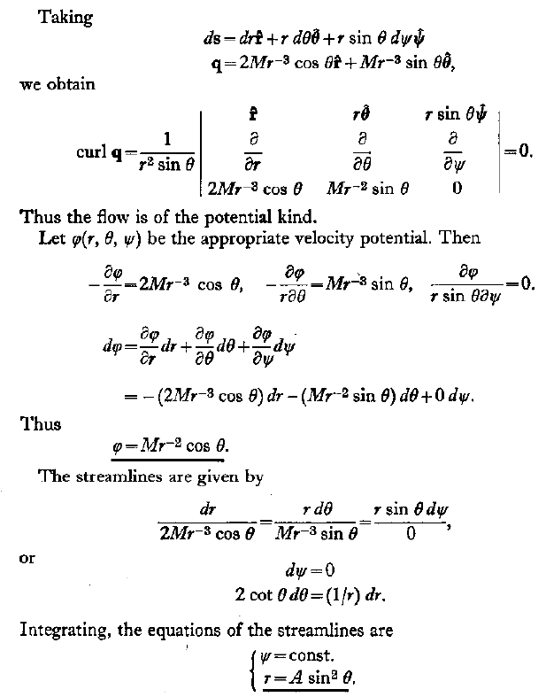
21. Derive the equation of continuity.
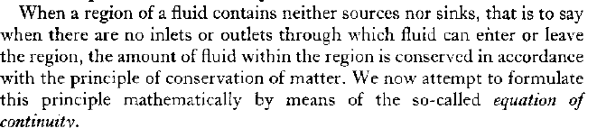
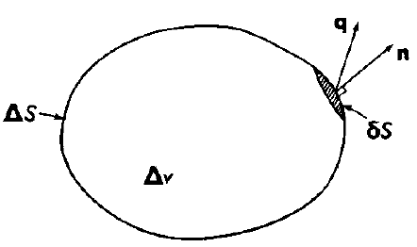
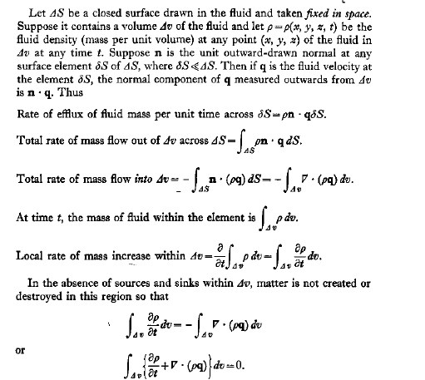
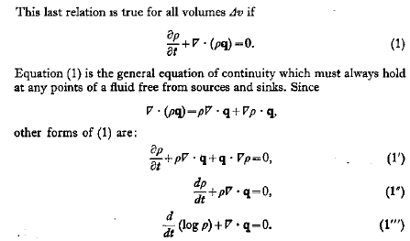
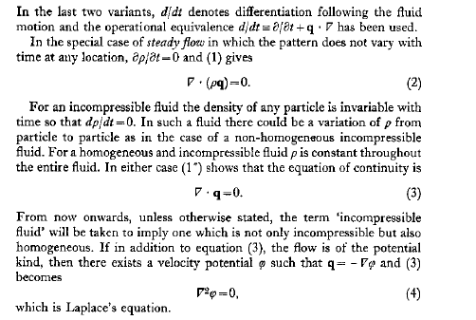

22. Discuss the cases of steady motion under conservative body forces.
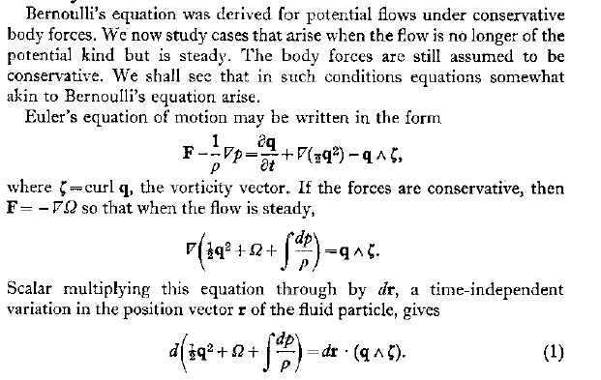
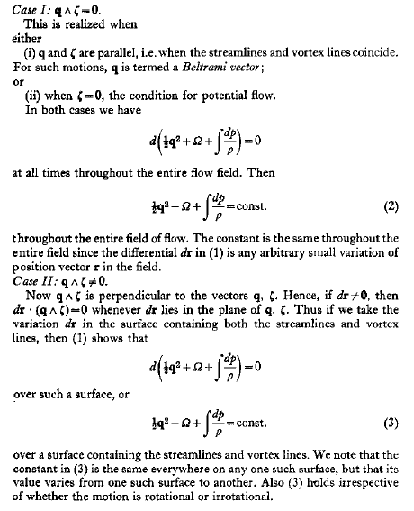
23. Doublets of strengths $μ_{1}, μ_{2}$ are situated at points $A_{1}, A_{2}$ whose Cartesian coordinates are $\left(0,0,c_{1}\right), (0, 0, c_{2})$, their axes being directed towards and away from the origin respectively. Find the condition that there is no transport of fluid over the surface of the sphere $x^{2}+y^{2}+z^{2}=c_{1}c_{2}$
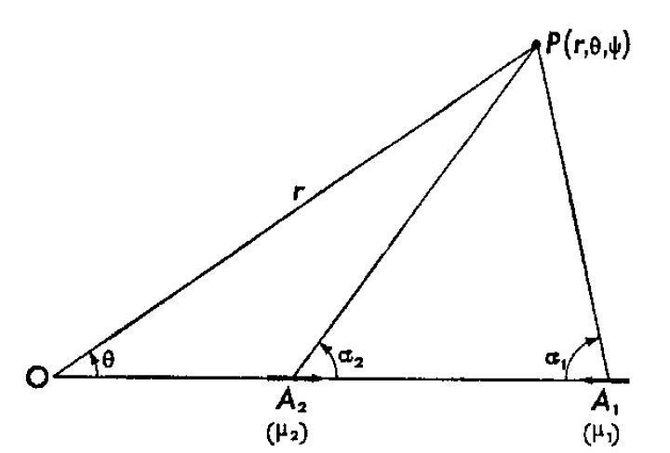
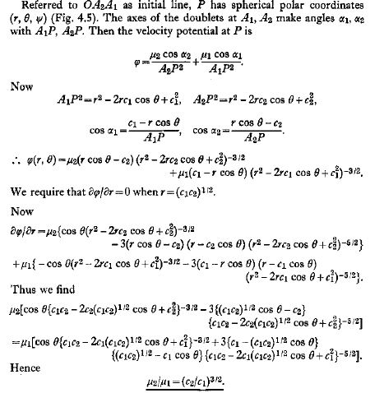
24. A two dimensional doublet of strength $μ i$ is at the point $z = ia$ in a stream velocity $-V i$ in a semi-infinite liquid of constant density occupying the half plane$y > 0$ and having $y = 0$ as a rigid boundary ($i$ is the unit vector in the positive x-axis). Show that the complex potential of the motion is $w = Vz + \frac{2μz}{z^{2}+ a^{2}}$. Show also that, for $< μ < 4a^{2}V$ , there are no stagnation points on this boundary and the pressure on it is minimum at the origin and the maximum at the points $z = ±a\sqrt{3}$.
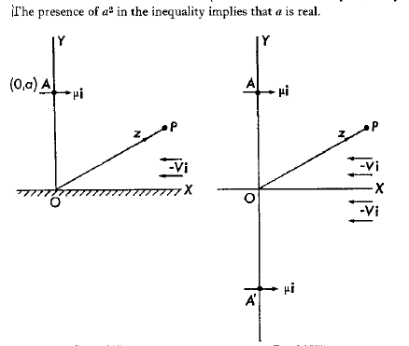
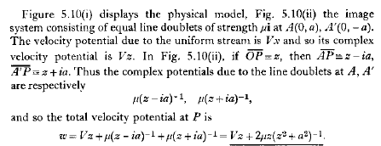
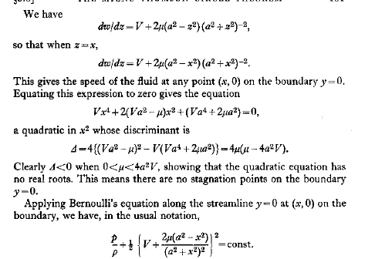
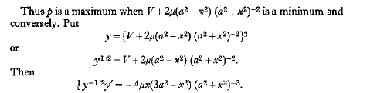
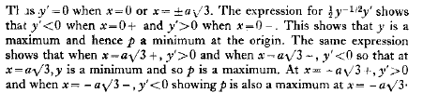
25. Derive Navier-Stokes equations of motion of a viscous fluid.
