ANNA ADARSH COLLEGE FOR WOMEN, CHENNAI-40.
I YEAR BA BUSINESS ECONOMICS
SUB CORE II – STATISTICS FOR ECONOMISTS
SEMESTER: II MAX. MARKS: 75 Marks
SUB CODE: TIME: 3 Hours
Part-A (10x2=20)
(Answer any Ten Questions)
1. What is statistics?
Statistics is the scientific discipline concerned with the collection, organization, analysis, interpretation, and presentation of numerical data
2. State any two characteristics of statistics
Five characteristics of statistics are that they are aggregates of facts, affected by multiple causes, numerically expressed, collected with a reasonable degree of accuracy, collected systematically, and collected for a predetermined purpose.
3. Comment on exclusive and inclusive methods of class Interval.
Exclusive class intervals, like 0–10, 10–20, do not include the upper limit in the current class but include it in the next class, which is suitable for continuous data. Inclusive class intervals, such as 1–5, 6–10, include both the upper and lower limits within the same class, making them ideal for discrete data.
4. Define ‘Frequency Distribution’.
A frequency distribution shows the frequency of repeated items in a graphical form or tabular form.
5. How do you find the central tendency?
The central tendency can be found using the formulas of mean, median or mode in most of the cases. As we know, mean is the average of a given data set, median is the middlemost data value and the mode represents the most frequently occurring data value in the set.

6. Determine the median of the dataset: [23, 18, 12, 35, 27, 19].
First arrange the given dataset in ascending order= [12, 18, 19, 23, 27, 35]. Since the number of observations (n) is 6 (an even number), the 2 mid values are 19 and 23.
Therefore median = [19+23 ] / 2
= 42/2
= 2
7. Find the range and coefficient of range of the following data.
63, 89, 98, 125, 79, 108, 117, 68
Range: L-S = 125-63=62
Coefficient of Range =L-S/L+S=125-63/125+63=62/188=0.33
8. What is the formula for calculating the coefficient of quartile deviation?
For calculating the coefficient of quartile deviation, the following formula is applied:
Q3 − Q1/Q3 + Q1
9. The marks of 5 students are: 20, 25, 30, 35, 80. Determine the
skewness.
- Mean = (20 + 25 + 30 + 35 + 80) / 5 = 38
- Median = 30
- Since Mean > Median, the distribution is positively skewed.

10. Write any two differences between Skewness and Kurtosis.

Difference Between Skewness and Kurtosis
Sr. No. | Skewness | Kurtosis
1. | It indicates the shape and size of variation on either side of the central value. | It indicates the frequencies of distribution at the central value.
2. | The measure differences of skewness tell us about the magnitude and direction of the asymmetry of a distribution. | It indicates the concentration of items at the central part of a distribution.
3. | It indicates how far the distribution differs from the normal distribution. | It studies the divergence of the given distribution from the normal distribution.
4. | The measure of skewness studies the extent to which deviation clusters is are above or below the average. | It indicates the concentration of items.
5. | In an asymmetrical distribution, the deviation below or above an average is not equal. | No such distribution takes place

11. Specify the meaning of secondary data.
Secondary data is information that has already been collected and recorded by someone else for a different purpose, but is then accessed and reused by another researcher.
12. Comment on Lorenz Curve.
A Lorenz curve, developed by American economist Max Lorenz in 1905, is a graphical representation of income inequality or wealth inequality. The graph plots percentiles of the population on the horizontal axis according to income or wealth and plots cumulative income or wealth on the vertical axis.
Part-B (5x5=25)
(Answer any Five Questions)
13. Explain the uses of statistics.

14. Prepare a frequency distribution by exclusive method taking a
Class interval of 10 from the following data.

17, 30, 37, 34, 39, 32, 30, 35, 12, 14, 12, 14, 14, 0, 25, 25, 25, 28, 47, 42, 49, 49, 45, 49, 46, 41, 60, 64, 62, 40, 43, 48, 48, 49, 49, 40, 41, 59, 51, 53, 82, 80, 85, 90, 98, 90,56, 55, 57, 55, 10, 14, 51, 50, 56, 70, 75, 64, 60, 66, 69, 62, 61, 70, 76, 70, 59, 56, 59, 57, 59, 55, 20, 22, 56, 51, 55, 56, 55, 50, 54, 66, 69, 64, 66, 60, 65, 62, 45, 47, 44, 40, 44, 65, 66, 65, 71, 82, 82, 90
Step 1: Determine the range of the data set.
Maximum value = 98
Minimum value = 0
Range = Maximum value – Minimum value = 98 – 0 = 98
Step 2: Divide the range by the number of the classes that we want our data in and then round up.
Let the number of classes be 10.
Class width = 98/10 = 9.8
Thus, we can consider 10 as the class size.
Step 3: Create class intervals using class width.
For the above data, exclusive class intervals can be created and avoid taking the value which is equal to the upper limit of the class while writing the frequencies.
0 – 10, 10 – 20, 20 – 30, 30 – 40, 40 – 50, 50 – 60, 60 – 70, 70 – 80, 80 – 90, 90 – 100.
Step 4: Obtain the frequency for each class.
Class interval | Frequency | Corresponding observations
0 – 10 | 1 | 0
10 – 20 | 8 | 10, 12, 12, 14, 14, 14, 14, 17
20 – 30 | 6 | 20, 22, 25, 25, 25, 28
30 – 40 | 7 | 30, 30, 32, 34, 35, 37, 39
40 – 50 | 21 | 40, 40, 40, 41, 41, 42, 43, 44, 44, 45, 45, 46, 47, 47, 48, 48, 49, 49, 49, 49, 49
50 – 60 | 23 | 50, 50, 51, 51, 51, 53, 54, 55, 55, 55, 55, 55, 56, 56, 56, 56, 56, 57, 57, 59, 59, 59, 59
60 – 70 | 19 | 60, 60, 60, 61, 62, 62, 62, 64, 64, 64, 65, 65, 65, 66, 66, 66, 66, 69, 69
70 – 80 | 6 | 70, 70, 70, 71, 75, 76
80 – 90 | 5 | 80, 82, 82, 82, 85
90 – 100 | 4 | 90, 90, 90, 98
Total | 100

15. Find the mean for the following distribution.

x_{i} | 15 | 21 | 27 | 30 | 35
f_{i} | 3 | 5 | 6 | 7 | 8
Solution:
x_{i} | f_{i} | f_{i}x_{i}
15 | 3 | 45
21 | 5 | 105
27 | 6 | 162
30 | 7 | 210
35 | 8 | 280
Total | ∑f_{i} = 29 | ∑f_{i}x_{i} = 802
Mean = ∑f_{i}x_{i}/∑f_{i}
= 802/29
= 27.655
16. The rainfall recorded in various places of five districts in a week are given below.
Find its standard deviation.

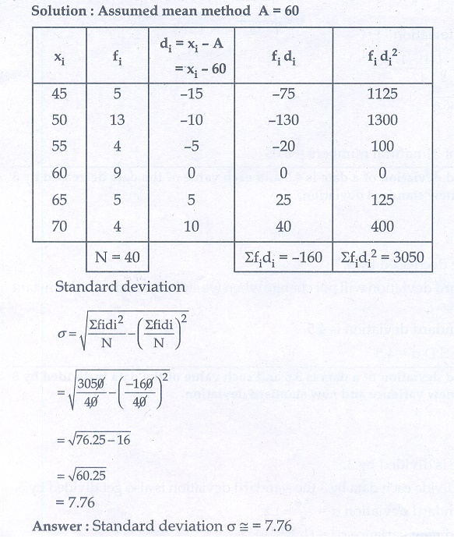

17. Calculate Bowely’s coefficient of Skewness from the following data.
Marks | 0-5 | 5-10 | 10-15 | 15-20 | 20-25 | 25-30 | 30-35 | 35-40
No of Students | 7 | 10 | 20 | 13 | 17 | 10 | 14 | 9

Q1=12
Q3=29
Coeff of Skewenns: 0.059

18. Describe the various types of diagrams.

One-Dimensional Diagrams
- Simple Bar Diagram
- Multiple Bar Diagram
- Sub-Divided Bar Diagram or Component Bar Diagram
- Percentage Bar Diagram
- Broken-Scale Bar Diagram
- Deviation Bar Diagram

Two -Dimensional Diagrams
1. Rectangle
2. Square
3. Circle
4. Pie diagram
Three - Dimensional Diagrams
Cubics

19. Explain the sources of Primary data?
* Direct Personal Interview
* Indirect and Interviews
* Information from the Correspondents,
*Mailed Questioners methods
* Schedules sent through enumerraters
Part-C (3x10=30)
(Answer any Three Questions)
20. Explain different types of Sampling.
- Probability Sampling Methods
  - Simple random sampling
  - Systematic sampling
  - Stratified sampling
  - Clustered sampling
- Non-probability Sampling Methods
  - Convenience sampling
  - Consecutive sampling
  - Quota sampling
  - Purposive or Judgmental sampling
  - Snowball sampling

21. Distinguish between diagram and graph.
(i) Diagrams are very attractive to eyes and hence, they are invariably used in advertisement and publicity. But graphs are not attractive to eyes and hence, generally, they are not used in advertisement and publicity.
(ii) Diagrams do not add anything to the meaning of the data and hence, they cannot be used by statisticians or research scholars in the further analysis of data. But graphs make the data more meaningful and hence, they are very much used by statisticians and research scholars in the analysis and interpretation of data.
(iii) Diagrams create effective and long lasting impression in the minds of the onlookers but graphs do not create such impression.
(iv) Diagrams help us in making comparison between the data but graphs help us in studying the cause and effect relationship between two variables.
(v) Diagrams are better drawn on plain papers but graphs are accurately drawn on graph papers.
(vi) Diagrams are rarely used to present frequency distributions. But graphs are mostly used to present such distributions.
(vii) Diagrams never present any mathematical relationship between the variables. But graphs always present mathematical relationship between the variables.

22. Consider the following distribution.

X | 0-10 | 10-20 | 20-30 | 30-40 | 40-50
f | 12 | 18 | 20 | 25 | 23
Compute Mean, Median and Mode.

Mean: 27.96
Median : 29.5
mode: 37.14

23. Calculate the quartile deviation and coefficients of quartile
deviation from the data.

Wages in Rs | 32-34 | 35-37 | 38-40 | 41-43 | 44-46
Mo of Wage earners | 14 | 62 | 99 | 18 | 7
Ans:
Q1=36.16
Q3=39.49
QD=1.67
Coefficient of QD: 0.044.

24. Find the following data calculate Karl Pearson,s coefficient of
skewness.

Marks | 0-10 | 10-20 | 20-30 | 30-40 | 40-50 | 50-60 | 60-70 | 70-80
No of Students | 5 | 6 | 11 | 21 | 35 | 30 | 22 | 11

Ans:
Mean: 46.84
Mode : 40-50
S D: 17.08
Coeff. of Skew: 0.031.
********************

