ANNA ADARSH COLLEGE FOR WOMEN, CHENNAI-40.
II YEAR BA BUSINESS ECONOMICS
SUB: MATHEMATICS FOR ECONOMICS
SEMESTER: III MAX. MARKS: 75 Marks
SUB CODE: TIME: 3 Hours
Part-A (10x2=20)
(Answer any Ten Questions)
- Write any two types of equation
- Linear equations
- Quadratic equations
- Cubic equations
- Radical equations
- Exponential equations
- Trigonometric equations
- Rational equations
- What do you mean by variable?
A Variable is a symbol or placeholder that represents a value that can change or vary.
- Define Constant function.
Any function can be considered as a constant function if it is of the form y = k, where k is a constant and k is any real number. It is also written as f(x) = k.
- Write scalar matrix with suitable example.
A scalar matrix is a type of diagonal matrix. The diagonal elements of the scalar matrix are equal or same. If the elements of the scalar matrix are all equal to 1, then it becomes an identity matrix.
Eg.
A=$\left[\begin{matrix}1 & 0 \\ 0 & 1\end{matrix}\right]$
- If A= $\begin{matrix}3 & 5 & 8 \\ 5 & 7 & 6\end{matrix}$ , find A^{T.}

A^{T}= $\begin{matrix}3 & 5 \\ 5 & 7 \\ 8 & 6\end{matrix}$
- Compute the minor for the Matric A= $\left[\begin{matrix}2 & 4 \\ 7 & 4\end{matrix}\right]$
M₁₁=4
M₁₂₌7
M₂₁=4
M₂₂=2
- Point out any two assumptions of input output analysis.
1.The economy is in perfect equilibrium
- The whole economy can be divided into two sectors. The inter-industry sector and the final demand sector. Each section can be subdivided further.
- Each industry produces only one product, and no two products are produced together.
- A company’s total production is used as input by another company or the final demand section.
- Production is followed according to the law of constant returns to scale.
- In the economic area, the level of technological progress remains constant, so the input coefficients remain constant.
- There are no external economies or production diseconomies.

8.Differenciate (w.r.t) q, If y=q⁵+3q³+6q²-q+7
$$\frac{dy}{dq}=5q4+9q2+12q-1$$
9.If y=log x, find $\frac{dy}{dx}$
$$\frac{dy}{dx}=\frac{1}{x}$$
10. Draw the Diagram of Total cost, Fixed Cost and Variable Cost.
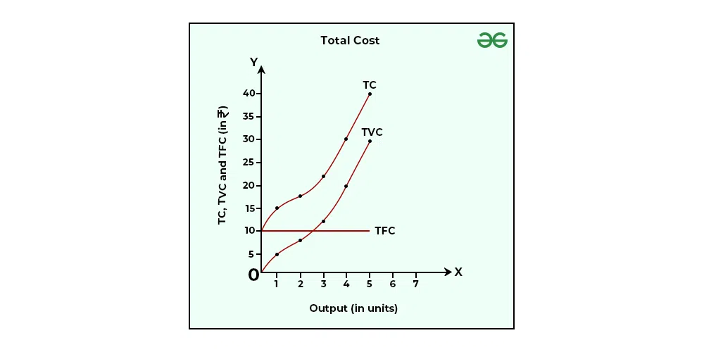

11. Find the marginal cost for Total cost function, C= 3x⁴-4x³+2x²-9x
$$MC=\frac{dC}{dx}={12x}^{3}-{12x}^{2}+4x-9$$
12. State the Condition for Maxima and minima.
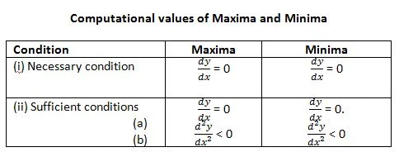

SECTION -B
13. Explain the uses and limitations of mathematical Economics.
USES
- Modeling economic relationship
- Quantitative analysis
- Optimization
- Game theory
- Financial Modeling
- Economic Dynamics
- Policy Simulation
LIMITATIONS
- Assumption and Specification
- Complexity of Human Behaviour
- Data limitation
- Overreliance on model
14.
Ans:

- (A+B)+C = $\left(\begin{matrix}11 & 1 & 0 \\ 9 & 1 & 9 \\ 2 & 10 & 0\end{matrix}\right)$

- A+(B+C) = $\left(\begin{matrix}11 & 1 & 0 \\ 9 & 1 & 9 \\ 2 & 10 & 0\end{matrix}\right)$

Hence (A+B)+C = A+(B+C)

15. Find the Inverse of matrix A=$\left(\begin{matrix}4 & 0 & 2 \\ 2 & 10 & 2 \\ 3 & 9 & 1\end{matrix}\right)$
Ans=
A⁻¹ =$\frac{Adj A}{IAI}$ = $\left(\begin{matrix}8/56 & 18/-56 & 20/56 \\ 4/-56 & 2/56 & 4/56 \\ 12/56 & 26/56 & 40/-56\end{matrix}\right)$
16.Solve the following set of linear simultaneous equation by using matrix Inversion
Technique.
Ans: x₁=1 and x₂=1
17. Find the elasticity of demand and MR at P=1, if the demand function is given by
Q= 7-2P
Ans :
1.$\frac{dQ}{dp}= -2$
2.η= $\frac{2}{5}$
3. MR= -$\frac{3}{2}$
18. By applying Quotient rule, differentiating the following equation,
Ans: $\frac{dy}{dx}= \frac{2}{{(x+1)}^{2}}$
19. Investigate the maximum and minimum value of the following function.
Z=48-4x²-2y²+16x+12y
Ans:
1.x=2
2.y=3
3. $\frac{∂2z}{∂x2}=-8$
4. $\frac{∂2y}{∂y2}= -4$
(2,3 )= 48-4x²-2y²+16x+12y
=48- 4(2)²-2(3)²+16(2)+12(3)
= 48-16-18+32+36
= 116-34
= 82.
SECTION C
20. Explain the Power function and homogenous function.
Power Function
In mathematical economics, a power function has the form f(x) = kxⁿ, where k is a coefficient and x is a variable raised to a constant real power n. It describes relationships where one economic variable is directly proportional to the nth power of another, and is used to model phenomena like how demand changes with price or how factors like the area of a circle or volume of a sphere relate to their radius.
Mathematical Definition
- Form: f(x) = kxⁿ
- k (coefficient): A constant that multiplies the variable, not changing the shape of the graph but its position.
- x (variable): The input variable.
- n (exponent): A constant real number that the variable is raised to.
Homogeneous Function:
Multivariate functions that are “homogeneous” of some degree are often used in economic theory. For a given number k, a function is homogeneous of degree k if, when each of its arguments is multiplied by any number t > 0, the value of the function is multiplied by t^{k}. For example, a function is homogeneous of degree 1 if, when all its arguments are multiplied by any number t > 0, the value of the function is multiplied by the same number t.
In economic theory we often assume that a firm's production function is homogeneous of degree 1 (if all inputs are multiplied by t then output is multiplied by t). A production function with this property is said to have “constant returns to scale”.
Suppose that a consumer's demand for goods, as a function of prices and her income, arises from her choosing, among all the bundles she can afford, the one that is best according to her preferences. Then we can show that this demand function is homogeneous of degree zero: if all prices and the consumer's income are multiplied by any number t > 0 then her demands for goods stay the same.
21. Describe the different types of Matrices?
- Row Matrix
- Column Matrix
- Rectangular Matrix
- Square Matrix
- Identity Matrix
- Zero Matrix
- Diagonal Matrix
- Singular Matrix
- Non-singular Matrix
- Hermitian Matrix
- Skew-Hermitian Matrix
- Upper & Lower Triangular Matrices
- Symmetric Matrix
- Skew Symmetric Matrix
- Orthogonal Matrix
22. Solve the following set of equation by using Crammer’s rule.
2x-3y+4z=5
x+2y-3z =8
x- y -z =1
Ans:
Δ= -16
x= Δx/Δ=-80/16=5
y= Δy/Δ= -48/-16=3
z= Δz/Δ = -16/-16= 1
x=5
y=3
z=1

23. Find $\frac{dy}{dx}$
1. y=(x³+3)(2x²-3x³)
- $\frac{dy}{dx}=u\frac{dv}{dx}+v.\frac{du}{dx}$

Ans:
=-18x⁵+10x⁴-27x²+12x
2.y=(x²+1)/(x²+2x)
Ans:
$\frac{dy}{dx}=$-x⁴-x^{2—}2/(x³⁺2x)²
24. A firm has the Total Cost Function C=1/3Q³ -7Q²+110Q+50 and demand
function Q = 100-P. Find the output that maximizes profits. What is the
maximum Profit, Total Revenue, Average Revenue, marginal revenue, Total
Cost, Average Cost and Marginal Cost?

Answer:
- Output that maximises profit Q = 11
- Profit ($π$)=Rs.111.30
- TR = 979
- AR= 89
- MR=78
- TC=867.30
- AC= 78.88
- MC= 78.

