ANNA ADARSH COLLEGE FOR WOMEN (AUTONOMOUS)

End Semester Examination, November 2025
Programme : B.Com (Honours) | Batch : 2025-26 | Semester : I | Course Title : Financial Accounting-I
Course Code : | Duration : 3 Hrs | Maximum Marks : 75

Section A
SECTION – A (10 X 2 = 20 Marks)
Answer ALL Questions
- What are the fundamental principles of accounting?
- Why suspense account is prepared?
- List any two differences between revenue and capital expenditure.
- Give an example for error of principle.
- State the meaning of depletion and amortization.
- Who can endorse a bill?
- Why single entry system is accepted by income tax authorities?
- Mention any two differences between single and double entry system.
- How short working is recouped in royalty computation?
- When Average Clause is applied in Fire Insurance Claim?
SECTION – B (5 X 5 = 25 Marks)
Answer any FIVE Questions
- Rectify the following errors:
  - Salary of Rs.1,000paid to Mr.Mohan due to him has been debited to his personal account
  - Rs.1,500, paid in cash for repair of office gadget was charged to office expenses account
  - Rs.5,000 paid for furniture purchased has been charged to purchases account
  - Repairs made were debited to building account for Rs.250
  - An amount of Rs.500 withdrawn by the proprietor for his personal use has been debited to trade expenses account.
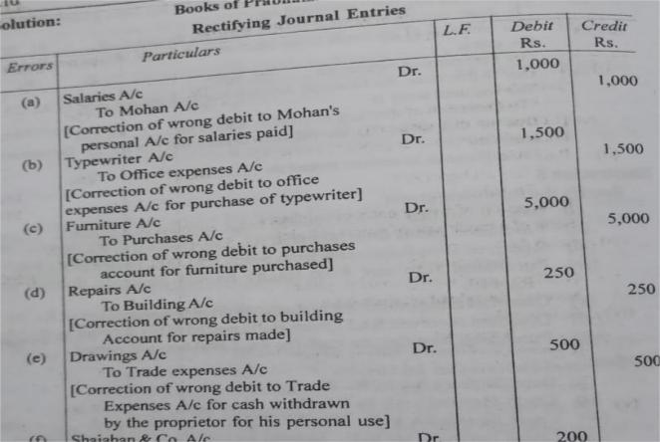
- Enter the following in the double column cash book
Rs.
  - 2019 Jan 1 Cash balance 18,500
  - 3 Cash sales 33,000
  - 7 paid David 15850
Discount allowed by him 150
  - 13 Sold goods to Manohar on credit 19200
  - 15 cash withdrawn for personal expenses 2400
  - 16 purchased goods from charles on credit 14300
  - 22 Paid into bank 22750
  - 25 cash received from Manohar 19000
  - Allowed him discount 200
  - 26 Drew a cheque for office use 17500
  - 27 paid cash to saravanan 2950
  - 28 paid cash to charles less discount 14200
  - 29 cash purchases 13500
  - 30 paid for advertising 600
  - 31 paid salaries 12000
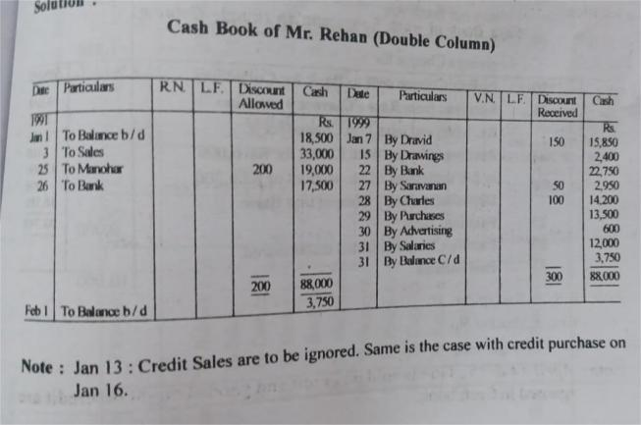
- Find out the amount of salaries to be debited to income and expenditure account for the year 1999 from the following details: Rs.
  - Payment made for salaries during 1999 48,000
  - Outstanding salary as on 31.12.1998 2,000
  - Outstanding salary as on 31.12.1999 3,200
  - Prepaid salary as on 31.12.1998 1,200
  - Prepaid salary as on 31.12.1999 1,600
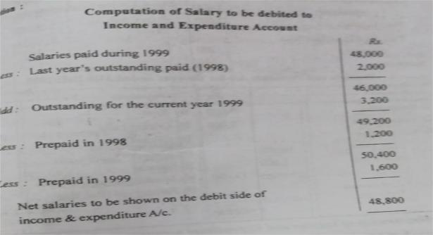
- 1. X owes Y the following sums of money due on the dates stated:
  - Rs. 4.000 due on 5th January, 2000.
  - Rs. 2,000 due on 20th January, 2000.
  - Rs. 8,000 due on 4th February, 2000.
  - Rs. 1,000 due on 26th February, 2000.
  - Rs. 500 due on 10th March, 2000.
Calculate such a date as payment may be made by X in one instalment resulting in no loss to either party.
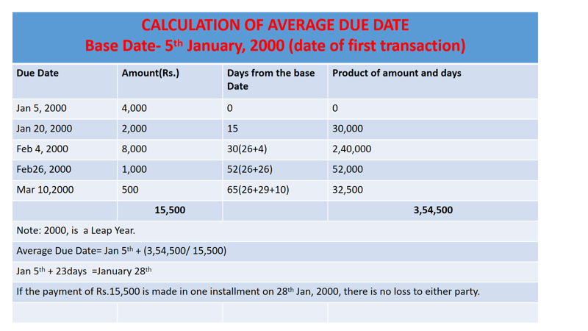
- On 1.1.94 machinery was purchased for Rs. 80,000. On 1.7.1996 the machine upto 31.12.1996 assuming that the business charges depreciation @ 10% on the machine in part exchange at a valuation of Rs. 16,000. Show the machinery A/C upto 31.12.96. Assuming the business charges depreciation@10% on the diminishing value of the machinery and the machinery employed at the end of each year.
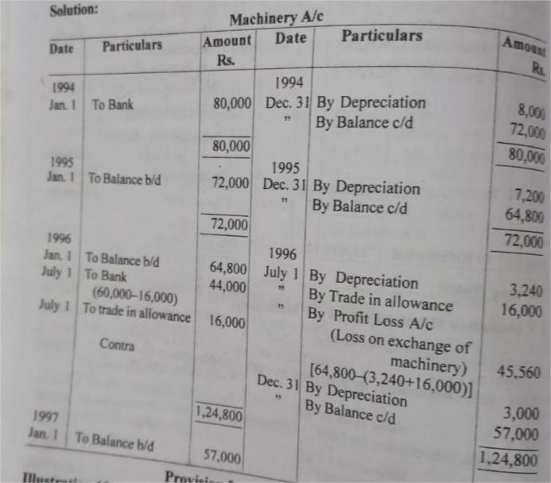
- From the following particulars calculate the closing balance of debtors and creditors:
Rs.
  - Sundry debtors as on 1.4.21 28,600
  - Sundry creditors as on 1.4.21 41,840
  - Credit purchases 1,51,400
  - Credit Sales 1,65,900
  - Discount received 5,200
  - Discount allowed 4,800
  - Return Outward 7,440
  - Return Inwards 6,444
  - Cash received from debtors 1,50,536
  - Cash paid to creditors 1,43,765

Debtors Account
Particulars | Amount in Rs. | Particulars | Amount in Rs.
To Balance b/d  To Credit Sales | 28,600  1,65,900 | By Return Inwards  By Cash Received  By Discount Allowed  By Balance c/d | 6,444  1,50,536  4,800  32,800
 | 1,94,580 |  | 1,94,580

Creditors Account
Particulars | Amount in Rs. | Particulars | Amount in Rs.
To Return Outwards  To Discount Received  To Cash Paid  To Balance c/d | 7,440  1,43,765  5,200  36,805 | By Balance b/d  By Credit Purchases | 41,810  1,51,400
 | 1,93,210 |  | 1,93,210

- A fire occurred in the premises of Mr.Aravind on 19th sept2022, from the following information estimate the claim to be lodged: Rs.
  - Stock as on 1st April 2022 1,00,000
  - Purchases till the date of fire 3,00,000
  - Manufacturing Expenses 2,00,000
  - Sales till the date of fire 7,00,000
  - Rate of GP on Sales 25%
  - Stock Salvaged 16,000

Memorandum trading account for the period ending 19th sept 2022
Particulars | Amount in Rs. | Particulars | Amount in Rs.
To Opening Stock  To Purchases  To Manufacturing Expenses  To GP | 1,00,000  3,00,000  2,00,000  1,75,000 | By Sales  By Closing Stock(B/F) | 7,00,000  75,000
 | 7,75,000 |  | 7,75,000
Statement of Claim:
Stock as on the date of Fire 75,000
Less: Salvaged 16,000
Goods Destroyed by Fire/ Value of Claim Rs. 59,000

- Mr,Ram had patented a cookware product and gave M/S Laxman the right to manufacture and sell under a license for seven years:
  - A royalty of Rs.5 to be paid for each product
  - A Minimum rent of Rs.50,000 per annum
  - The right to recoup in the first two years only
  - The number of units sold were
Year | No. Of units
2000 | 9000
2001 | 9600
2002 | 10800
2003 | 12000
Prepare a Royalty Analytical Table to record the above.
Year | No. Of units | Royalty | Minimum Rent | Short Workings | Shortworking recouped | Short working lapsed | Royalty to be paid
2000 | 9000 | 45000 | 50000 | 5000 | - | - | 50000
2001 | 9600 | 48000 | 50000 | 2000 | - | - | 50000
2002 | 10800 | 54000 | 50000 | - | 4000 | 1000 | 50000
2003 | 12000 | 60000 | 50000 | - | 2000 | - | 58000

SECTION – C (2 X 15 = 30 Marks)
Answer any TWO Questions of which Q.No.19 is Compulsory
- Construct, Trading, Profit and Loss Account and Balance Sheet from the following Trial Balance of Mr. Madesh.
Trial Balance as on 31.12.2023
Particulars | Amount Rs. | Particulars | Amount Rs.
Sundry Debtors | 92,000 | Madesh’s Capital | 70,000
Plant & Machinery | 20,000 | Purchase Returns | 2,600
Interest | 430 | Sales | 2,50,000
Rent, Rates and Taxes | 5.600 | Sundry Creditors | 60,000
Conveyance Charges | 1.320 | Bank Overdraft | 20,000
Wages | 7,000
Sales Returns | 5,400
Purchases | 1,50,000
Opening Stock | 60,000
Madesh’s Drawings | 22,000
Trade Expenses | 1,350
Salaries | 11,200
Advertising | 840
Discount | 600
Bad Debts | 800
Business Premises | 12,000
Furniture & Fixtures | 10,000
Cash in Hand | 2,060
 | 4,02,600 |  | 4,02,600
Adjustments:
- Stock as on 31.12.23: Rs,90,000
- Provide Depreciation on Premises @2.5%, Plant & Machinery @ 7.5% and Furniture & Fixtures @10%
- Write off further Bad Debts of Rs.800
- Provide a doubtful debts @5% on sundry debtors
- Outstanding rent was Rs.500 and outstanding wages Rs.500
- Prepaid Insurance Rs.300 and Prepaid Salaries Rs.700

Trading and Profit and Loss Account for the year ending 31.12.2023
Particulars | Amount Rs. | Particulars | Amount Rs.
To Opening Stock | 60,000 | By Sales-Returns | 2,44,000
To Wages+ O/S | 7,500 | By Closing Stock | 90,000
To Purchases- Returns | 1,47,500
To Gross Profit | 1,19,700
 | 3,34,600 |  | 3,34,600
 |  | By Gross Profit | 1,19,700
To Interest | 430
To Rent, Rates & Insurance  Less: Prepaid Insurance  Add: Outstanding Rent | 5800
To conveyance charges | 1320
To Trade Expenses | 1350
To Salaries  Less: Prepaid | 10500
To Advertising | 840
To Discount | 600
To Bad Debts(800+800+4560) | 6160
To Depreciation on Premises | 300
To Depreciation on P & M | 1500
To Depreciation on Furniture | 1000
To Net Profit | 89,900
 | 1,19,700 |  | 1,19,700
Balance Sheet as on 31.12.2023
Capital 70000  Add: Net Profit89900  Less: Drawings22000 | 1,37,900 | Sundry Debtors92000  Less: Bad Debts800  91200 | 86,640
Sundry creditors | 60,000 | Less: New Provision4560 | 86,640
Bank overdraft | 20,000 | Plant & Machinery20000  Less: Depreciation1500 | 18500
Outstanding wages | 500 | Business Premises12000  Less: Depreciation300 | 11700
Outstanding rent | 500 | Furniture & Fixtures10000  Less: Depreciation 1000 | 9000
 |  | Cash in hand | 2060
 |  | Closing stock | 90000
 |  | Prepaid salaries | 700
 |  | Prepaid insurance | 300
 | 2,18,900 |  | 2,18,900

- M/S Devi Purchased a new machinery on 1st April 2009 for Rs.3,60,000. on 1st October,2009 another machinery was purchased for Rs.1,80,000. on 30th September 2010, the second machine was sold for Rs.2,60,000. Rate of Depreciation to be provided at 10% under diminishing balance method. Books are closed on 31st March every year. Create machinery account for 3 years.
Machinery 1
Value of Machinery as on 1.4.12 | 2,62,440
Machinery 2
Profit on sale of machinery | 97,550
- Mr. Sathya commenced business as a cloth merchant on 1st Jan 2015 with a capital of Rs.70,000. on the same day, he purchased furniture for Rs.21,000. from the following particulars obtained from his book on single entry, prepare trading, P &L a/c and Balance Sheet as on 31.12.15.
Particulars | Amount Rs.
Sales including cash sales Rs.49000  Purchases including cash purchases Rs.28000  Drawings  Salaries  Bad Debts Written Off  Business Expenses | 119000  105000  8400  14000  3500  4900
Mr.Sathya took cloth worth Rs.3500 from the shop for private use and paid Rs.1400 to his son but omitted to record these transactions in his books. On 31st December 2015, his sundry debtors were Rs.36400 and sundry creditors were Rs25200. stock in hand on 31st December 2015 was Rs45500.

Gross Profit | 63,000
Net Profit | 40,600
Total Assets and Liabilities | 1,22,500
Cash received from debtors | 30,100
Cash received from creditors | 51,800

