COMPANY LAW – ANSWER KEY
PART - A
- According to Section 2(20) of the Companies Act, 2013, "A company means a company incorporated under this Act or under any previous company law.”
- Piercing the corporate veil or lifting the corporate veil is a legal decision to treat the rights or duties of a corporation as the rights or liabilities of its shareholders. Usually a corporation is treated as a separate legal person, which is solely responsible for the debts it incurs and the sole beneficiary of the credit it is owed.
- Name Clause, Registered Office Clause, Object Clause, Liability Clause, Capital Clause, and Association (or Subscription) Clause.
- As per the Companies Act, 2013, only two kinds of shares can be issued by a company. Section 43 of the Act provides that the share capital of a company limited by shares shall be of two kinds only*, namely –equity share capital and preference share capital.
- A quorum refers to the minimum acceptable level of individuals with a vested interest in a company needed to make the proceedings of a meeting valid under the corporate charter. This clause or general agreement ensures there is sufficient representation present at meetings before any changes can be made by the board. A quorum normally consists of a group that is considered as large as possible to be depended on to attend all corporate meetings, which is a qualitative assessment. The plural of a quorum is "quora."
- Statutory meeting, AGM, EGM, Class meeting, meeting of directors.
- In company law, a proxy refers to a person appointed by a member of a company to attend and vote at a meeting on their behalf. It allows members who cannot attend in person to still have their votes represented. This is often used when shareholders are unable to attend the Annual General Meeting (AGM).
- In terms of section 204(1), only a member of the Institute of Company Secretaries of India holding certificate of practice (company secretary in practice) can conduct Secretarial Audit and furnish the Secretarial Audit Report to the company.
- The National Company Law Tribunal (NCLT) is a quasi-judicial body in India established under the Companies Act, 2013, to handle corporate disputes and insolvency matters. It was formed to streamline the resolution of corporate legal issues and to provide a specialized forum for dealing with company-related cases.
- Insider trading meaning is the unlawful act of buying and selling securities, such as bonds or stocks, based on material non-public knowledge about a firm. Their position within the business involves people with access to sensitive insider information, such as managers, directors, or workers.
- Voluntary Winding Up by Members.
Voluntary Winding Up by Creditors.
Compulsory Winding Up by Tribunal.
- The process that the liquidator undertakes is called “liquidating the succession” or “settling the succession”. To do this, the liquidator must close accounts, file taxes, collect money owed, make an inventory of property and debts, distribute property to heirs, etc.
PART – B

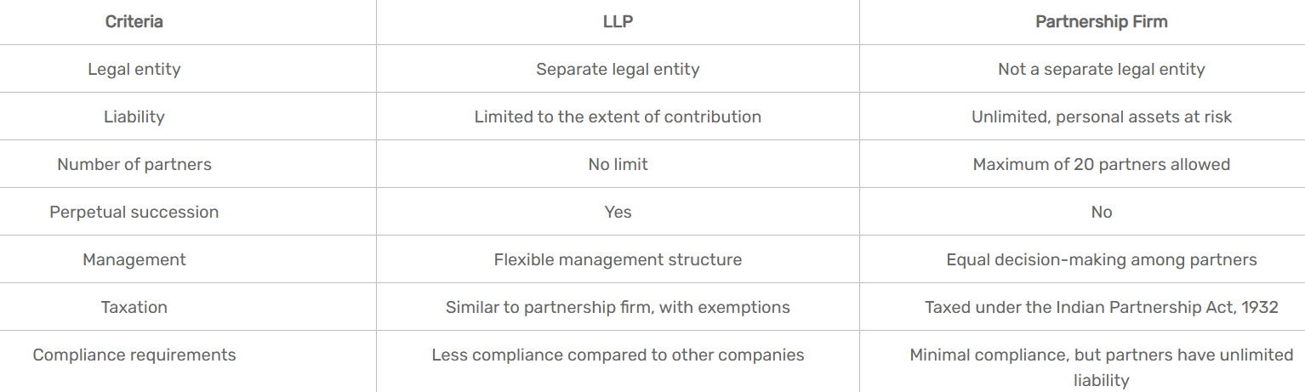
- The word “ultra” means beyond and “vires” means power. So ultra-vires means beyond power i.e. an act done by the Company beyond its legal power and authority. It had been observed that a Company has an independent legal existence and is a separate body corporate, distinct from its members. The Company can therefore perform act on its own. The acts which the Company performs are authorized by (a) the objects specified in the MOA of the Company with which it is registered. And (b) The Companies Act. Any act done by the Company which is neither authorized by the object nor by the Companies Act, that Act is called “ultra vires” the powers and authority of the Company. Any Act which is ultra vires to the Company is void and cannot bind the Company.
- CONTENTS OF MEMORANDUM Section 4 of the Act, 2013, lays down the following particulars in Memorandum of Association :
(a) Name Clause: As per section 4(1)(a), the name of the Company with the word “Limited” in case of Public Company, “Private Limited” in case of Private Company should be written with the Companies name.
(b) Registered Office Clause: Section 4(1)(b), this clause states the place i.e. state at which the registered office of the Company is to be situated.
(c) Object Clause: Section 4(1)(c), it includes the objects for which the Company is proposed to be incorporated and any matter considered necessary in furtherance thereof. (d) Liability of the members of the Company, whether limited or unlimited under section 4(1)(d).
(e) Details about the share capital of the Company having a share capital under section 4(1)(e).
(f) For One person Company, the name of the person who, in the event of death of the subscriber, shall become the member of the Company under section 4(1)(f).
(g) Subscription or association clause under section 3 & 4(1)(e).
- Special Resolution (SR) is a Resolution that needs three times as many votes cast in support of the proposal as votes cast against it. A minimum of 75% of members should demonstrate a strong favour for the motion. Many stuff can only be achieved by the organization if a special resolution is approved at the well-established general meeting. The members should be duly notified to the general meeting and the communication should contain the intention of making a resolution as SR specially mentioned.
Following are some actions for which Special Resolution required:
- For changing registered office of company as per sec 12(5) of Companies Act,2013
- For altering Memorandum of association
- For altering Article of Association including alteration having effect of conversion of Private company into Public company and vice versa
- For variation of shareholders right as per section 48(1)
- For reducing share capital of company
- Voting by show of hands, electronic means, demand for poll, passing resolution by postal ballot.
- In company law, a Director Identification Number (DIN) is a unique 8-digit identification number assigned to individuals who are or intend to be directors of a company in India. It's a mandatory requirement under the Companies Act, 2013, and serves as a unique identifier for directors across all companies they are associated with.
Significance of DIN
- Unique Identification: DIN acts as a unique identifier for each director, facilitating tracking and regulatory oversight.
- Compliance: It helps directors fulfill their legal and regulatory obligations.
- Combating Fraud: DIN helps prevent fraudulent activities and unauthorized appointments of directors.

- A winding up petition is a formal legal tool used by creditors against a company that owes them money and is unable to pay its debts. It's a crucial step in the process of compulsory liquidation, where a company is forced to stop its operations and liquidate its assets to pay off debts.
Subject to the provisions of this section, a petition to the Tribunal for the winding up of a company shall be presented by--

(a) the company;

(b) any contributory or contributories;

(c) all or any of the persons specified in clauses (a) and (b);

(d) the Registrar;

(e) any person authorised by the Central Government in that behalf; or

(f) in a case falling under clause (b) of section 271, by the Central Government or a State Government.

(2) A contributory shall be entitled to present a petition for the winding up of a company, notwithstanding that he may be the holder of fully paid-up shares, or that the company may have no assets at all or may have no surplus assets left for distribution among the shareholders after the satisfaction of its liabilities, and shares in respect of which he is a contributory or some of them were either originally allotted to him or have been held by him, and registered in his name, for at least six months during the eighteen months immediately before the commencement of the winding up or have devolved on him through the death of a former holder.

(3) The Registrar shall be entitled to present a petition for winding up under section 271, except on the grounds specified in clause (a) ²[of that section]:
PART – C
- Voluntary association.
Company is an artificial person created by law.
Company is not a citizen.
Separate legal entity.
Company has limited liability.
Company has a perpetual succession.
Transferability of shares.
Separate property.
Capacity to sue and be sued.
Contractual rights.
Limitation of action.
Separate management.
Termination of existence.
- Step-1 Filling the proposed name of a Company for approval to the Registrar of the Company (ROC)
Step -2 Obtaining Director Identification Number
Step- 3 The Company must have to select the name of persons who will act as Director. Step-4 Drafting of Memorandum of Association (MOA)
Step- 5 Drafting of Article of Association (AOA)
Step-6 Registered Office
Step- 7 Application for Incorporation of a Company
Step-8 Issue of certificate of Incorporation

- 1. Notice of Meeting - Length of Notice- Content of Notice
2. Place of Meeting
3. Quorum
4. decision making process
5. minutes of meetings

Step 1: Filing Of The Winding-Up Petition. ...
Step 2: Statement Of Affairs Of The Company. ...
Step 3: Advertisement. ...
Step 4: Appointment Of Provisional Liquidator. ...
Step 5: Send Notice To The Provisional Liquidator. ...
Step 6: Winding-Up Order. ...
Step 7: Custody Of Company Property.

- Adjudicating Insolvency and Bankruptcy
Handling Corporate Disputes
Investigating Company Affairs
Winding Up of Companies
Other Powers
Powers Similar to Civil Courts
Investigating Globally

