ANNA ADARSH COLLEGE FOR WOMEN (AUTONOMOUS),
CHENNAI – 40
END SEMESTER EXAMINATION– OCT/NOV 2025
Business Economics

Answer Key: Blue print
Part A
- Welfare definition:Economics is the study of mankind in the ordinary business of life; it examines that part of individual and social action which is most closely connected with the attainment and with the use of the material requisite of well being. Thus it is on oneside a study of wealth and on the other and more important side a part of the study of man
- Derived demand means demand for one product , that product arises the demand for the some other product. Ex. Agricultural land
- Giffen paradox: Exceptions of law of demand.
- Demand forecasting means to predict the future.
- Indifference map: A collection of indifference curve.
- “During the course of consumption, as more and more units of a commodity are used, everysuccessive unit gives utility with a diminishing rate, provided other things remaining the same; although, the total utility increases.”
- Production is the creation of economic value of the commodity.
- Land labour capital and organisation
- Market, a means by which the exchange of goods and services takes place as a result of buyers and sellers being in contact with one another, either directly or through mediating agents or institutions
- Large number of buyer and sellers , Homogenous product.
- Satisfaction means after consuming a commodity consumer gets some realized satisfaction about the commodity.
- Relationship between price and quantity demand.
Part-B
13. Accounting Profitis the net income of the company earned during a particular accounting year. Economic Profit is the remaining surplus left after deducting total costs from total revenue.Economic profit means residual left after contractual cost have been met including transfer cost management, depreciation, investment maintains at its current level.

14.Number of consumers, level of income, prices of the related goods, weather conditions, anticipated the future demand.

15. LawOf Equi-Marginal Utilitystates that the consumer will distribute his money income between the goods in such a way that the utility derived from the last rupee spend on each good is equal.MU_{A}/P_{A}= MU_{B}/P_{B}= MU_{C}/P_{C} = ……… = MU_{n}/P_{n.}

16. Increasing Returns to Scale: Output increases by a larger proportion than the increase in inputs. For example, if all inputs are doubled, and output more than doubles, then the production function exhibits increasing returns to scale.
Decreasing Returns to Scale: Output increases by a smaller proportion than the increase in inputs. For example, if all inputs are doubled, and output increases by less than double, then the production function exhibits decreasing returns to scale
- The kinked demand curve model in an oligopoly suggests that firms are hesitant to change prices because competitors will react differently to price increases and decreases, leading to price stability. If one firm raises its price, others likely won't follow, causing a significant drop in the firm's sales due to increased price elasticity above the current price. Conversely, if a firm lowers its price, competitors will likely match the reduction, resulting in only a small increase in sales for the initial firm due to decreased price elasticity below the current price. This creates a "kink" in the demand curve at the prevailing market price, making firms reluctant to deviate from it.
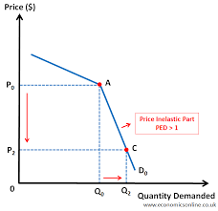

- Assumptions of indifference curve: consumer is rational, transitivity and consumer taste and preference remaining same. Consumer possess complete information about the goods.
- Survey method includes the opinion survey method, complete enumeration method, sample survey method, end use method.
Part-C
- .Scope of economics: Production, consumption, exchange and distribution. Importance : To conquer poverty, to useful to householder, to useful to the MLA’s and MP’s, to useful to the business man and industrialists.
- . Methods of measuring elasticity of demand: Arc method, point method, percentage method.
- When a consumer gets maximum satisfaction from his expenditure, he is said to be in equilibrium consumer's equilibrium means maximum satisfaction level consumer can attain at given income and prices. We can explain the equilibrium of consumer with the help of the indifference curve technique
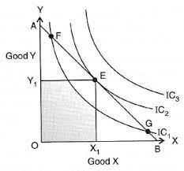
- Short run production function: Changes in the factors of production is not possible in the short run .increasing doses of one factors and held the other factors constant in the production and also effects in production.

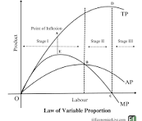
24. A monopoly exists when a single firm controls the entire market for a particular product or service, meaning there are no close substitutes and significant barriers to entry prevent other firms from competing. This allows the monopolist to act as a "price maker," influencing the market price by adjusting the quantity it produces. The diagram below illustrates how a monopolist determines its profit-maximizing price and quantity.
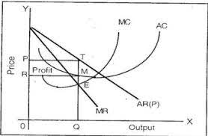
Diagram Explanation:
- Demand (AR) Curve:
This downward-sloping curve represents the market demand for the product. It also represents the average revenue the monopolist receives at each quantity level.
- Marginal Revenue (MR) Curve:
The MR curve lies below the AR curve because to sell more, the monopolist must lower the price, not just for the additional unit but for all units. It has twice the slope of the demand curve.
- Marginal Cost (MC) Curve:
This curve shows the additional cost of producing one more unit.
- Average Total Cost (ATC) Curve:
This curve shows the total cost of production divided by the quantity produced.
- Profit Maximization:
A monopolist maximizes profit where Marginal Revenue (MR) equals Marginal Cost (MC). This point (Qm) determines the profit-maximizing quantity.
- Price Determination:
To find the profit-maximizing price (Pm), draw a vertical line from the intersection of MR and MC up to the demand curve.
- Supernormal Profit:
If the price (Pm) is higher than the average total cost (ATC) at the profit-maximizing quantity (Qm), the monopolist earns supernormal profit, represented by the shaded rectangle.
Key Characteristics of a Monopoly:
- Single Seller: One firm controls the entire market.
- No Close Substitutes: Consumers have limited alternatives.
- Barriers to Entry: High barriers prevent new firms from entering the market, such as patents, high startup costs, or government regulations.
- Price Maker: The monopolist can influence the market price.
- Potential for Supernormal Profits: Monopolies can earn profits above normal profits in the long run due to the lack of competition.

