ANNA ADARSH COLLEGE FOR WOMEN (AUTONOMOUS),
CHENNAI – 40
END SEMESTER EXAMINATION– OCT/NOV 2025
BUSINESS MATHEMATICS AND STATISTICS
Max. Marks: 75 TIME:3 Hrs
PART- A (10 × 2 = 20 Marks)
Answer any TEN questions.

- What is Proportion?
A proportion is an equality of two ratios. $(i.e.) a:b=c:d$

- Find $x$ if ${\left(4^{2x}\right)}^{2}=4^{x-2}$
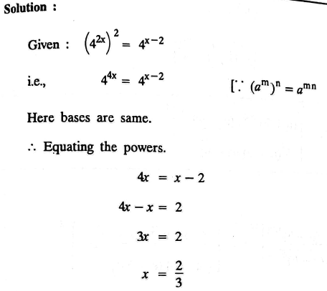

- What are the types of annuities?
- Ordinary annuity
- Annuity due
- Deferred annuity
- Perpetuity
- Growing
- In an AP, if $d=-4,$ $n=7,$ $a_{n}=4$ then find $"a"$.
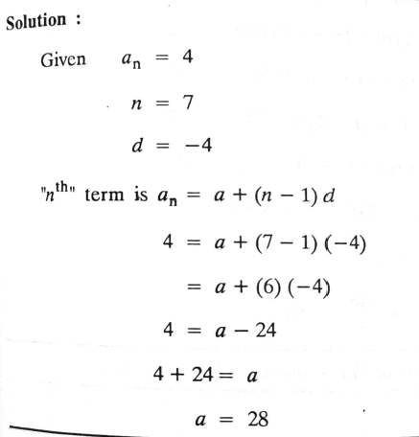
- Define Mode with an example.
The value that occurs most frequently in a data set is defined as mode. For example: 2,4,4,6,5,4,2,8,6
Mode=4
- Find the first quartile for the following data
$$5, 22, 26, 14, 30, 18, 11, 35, 41, 12, 32,25$$
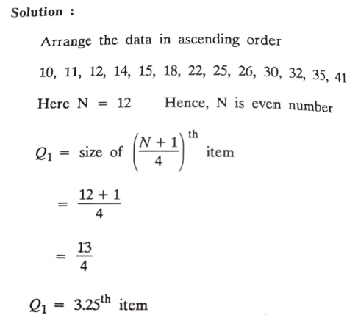

- What is rank correlation?
Rank correlation is the relation between two variables based on their ranks or position
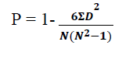
When ranks are repeated 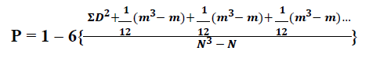
- Write the two regression line equations
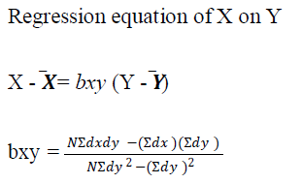
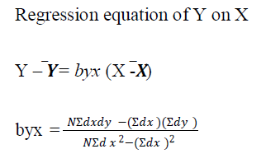
- What are the types of Index numbers?
- Price
- Quantity
- Value
- Define time series.
A time series is a sequence of data points collected at regular time intervals over a period of time. It is used to analyze trends, patterns, and forecasts based on temporal data.

- Define Range.
Range in statistics is the difference between the highest and lowest values in a dataset.
Example: For the data set {5, 8, 12, 20}, the range is 20 − 5 = 15.
- Find the mean for the following data $x:7,9,12, 15, 5, 4, 11$

Sol: Mean$=\frac{\sum{x}}{n}$
x$=\frac{7+9+12+15+5+4+11}{7}$
Mean$=9$
PART - B (5 × 5 = 25 Marks)
Answer any FIVE questions.

- Find the ratio of $x:y$ if $\left(10x+3y\right):\left(5x+2y\right)=9:5$
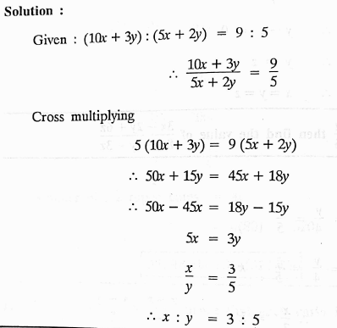

- A person borrows $Rs. 10,000$ at $10\%$ simple interest for $3$years. He immediately lends the same amount at compound interest for same period at the same rate. What is his profit?
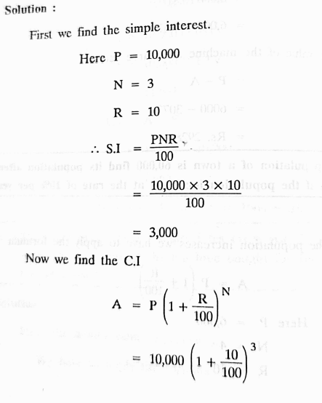
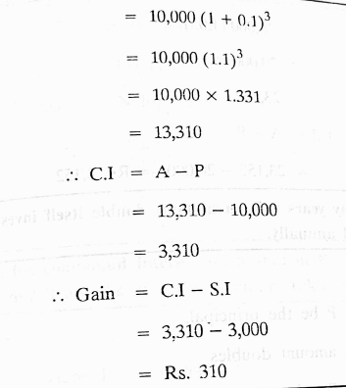

- Find the Harmonic mean for the following data
CI | 15-25 | 25-35 | 35-45 | 45-55 | 55-65 | 65-75
Frequency | 4 | 11 | 19 | 14 | 0 | 2

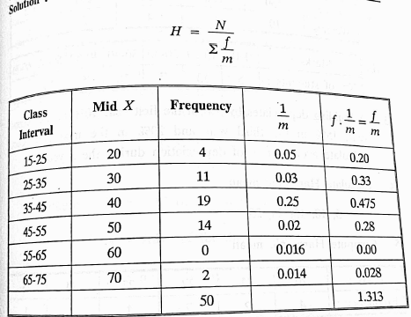
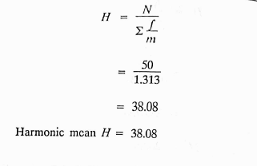
- Calculate Spearman’s rank correlation coefficient for the following data
Marks in accountancy | 97 | 51 | 68 | 75 | 42 | 33
Marks in Statistics | 15 | 53 | 47 | 28 | 64 | 82

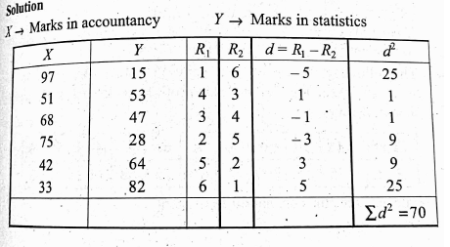
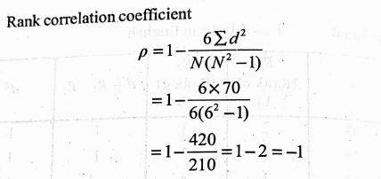

- Determine trend in the following time series taking $3-$yearly moving average
Year | 1996 | 1997 | 1998 | 1999 | 2000 | 2001 | 2002 | 2003 | 2004 | 2005 | 2006
Profit | 2.7 | 2.9 | 3.4 | 5.2 | 5.8 | 6.4 | 9.3 | 9.2 | 9.8 | 10.2 | 11.0

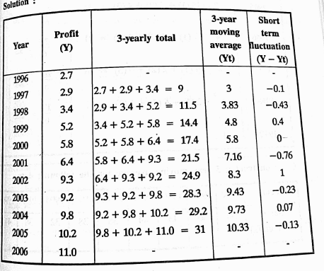

- Calculate Mean deviation about mean for the below data $153, 147, 151, 156, 153$
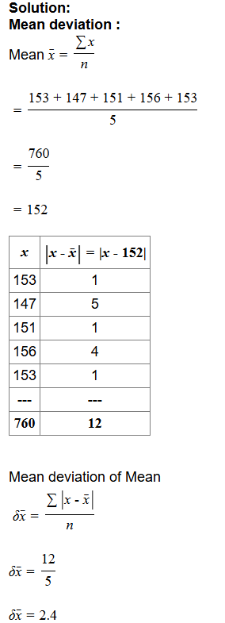

- Find the true discount and present worth on a bill of $Rs.2040$due in 6 months at $4\%$.
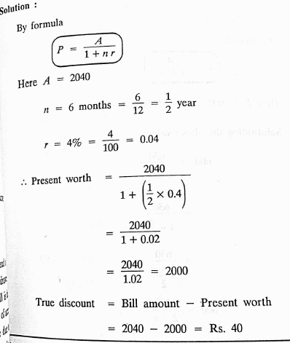

PART - C (3 × 10 = 30 Marks)
Answer any FOUR questions

- Simplify: ${\left[\frac{5^{-1}.7^{2}}{5^{2}.7^{-4}}\right]}^{7/2}÷{\left[\frac{5^{3}.7^{-5}}{5^{-2}.7^{3}}\right]}^{-5/2}$
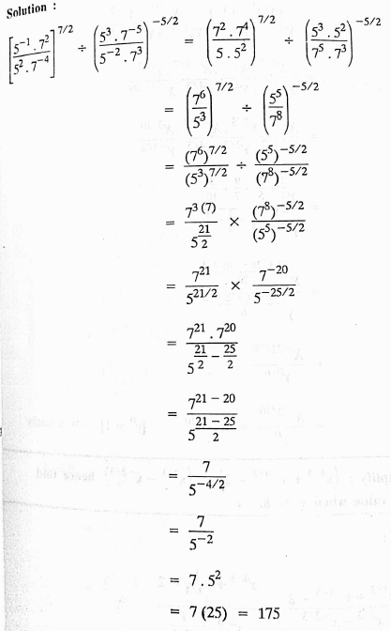

- Find the three numbers in geometric progression such that their sum is $130$ and their product is $27000.$
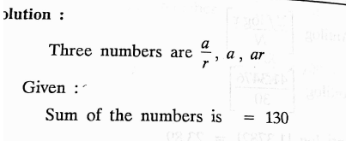
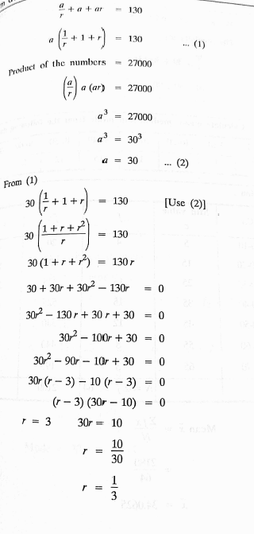
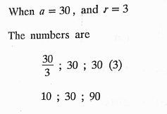
- Calculate Mean, Median and Mode for the following data

CI | 0-10 | 10-20 | 20-30 | 30-40 | 40-50 | 50-60 | 60-70 | 70-80
F | 4 | 12 | 24 | 36 | 20 | 16 | 8 | 5

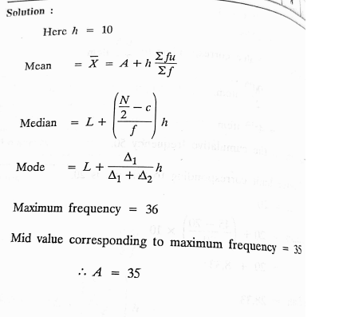
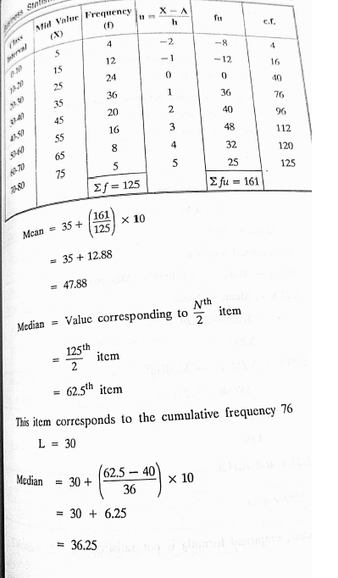
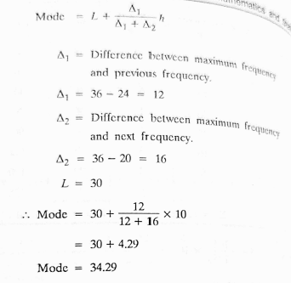
- Obtain the correlation coefficient for the following data:
X | 4 | 6 | 8 | 10 | 12 | 14 | 16 | 17
Y | 3.0 | 3.5 | 4.0 | 4.5 | 5.0 | 5.5 | 6.0 | 6.25

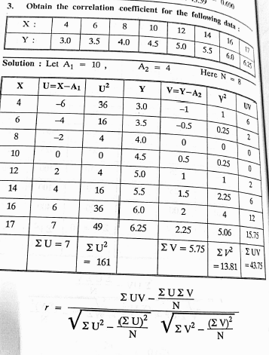
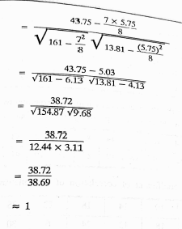

24. Calculate Fisher’s ideal index from the given data and prove that it satisfies both the time reversal and factor reversal tests.
Commodity | 2006 |  | 2007
Commodity | Price | Value | Price | value
A | 8 | 80 | 10 | 120
B | 10 | 120 | 12 | 96
C | 5 | 40 | 5 | 50
D | 4 | 56 | 3 | 60
E | 20 | 100 | 25 | 150
