PART A ( 1 mark)
- Define the Cauchy problem for the first order partial differential equation
.Ans: $F\left(x,y,u,u_{x},u_{y}\right)=0 with initial data u=u_{0}(s)on Γ$
- Eliminate the arbitrary function from $z=xy+f(x^{2}+y^{2})$
Ans: $p=y+f^{'}\left(u\right)2x;q=x+f^{'}\left(u\right)2y where u=x^{2}+y^{2};$
$$\frac{p-y}{2x}=\frac{q-x}{2y}$$
- Write Charpit’s auxiliary equation for the partial differential equation $z^{2}=pqxy.$
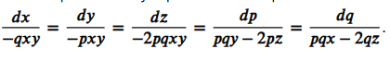
- Write the two dimensional Laplace equation in spherical coordinates.
Ans:
$$\frac{∂}{∂r}\left(r^{2}\frac{∂u}{∂r}\right)+\frac{1}{\sin{θ}}\frac{∂}{∂θ}\left(\sin{θ}\frac{∂u}{∂θ}\right)+\frac{1}{\sin^{2}{θ}}\frac{∂^{2}u}{∂ϕ^{2}}=0$$
- Define Neumann problem defined on a rectangle.
Ans: $∇^{2}u=0 in R and u_{x}\left(0,y\right)=g_{1}\left(y\right);u_{x}\left(a,y\right)=g_{2}\left(y\right);u_{y}\left(x,0\right)=f_{1}\left(x\right);u_{y}\left(x,b\right)=f_{2}(x)$
- Define interior Dirichlet problem for a circle.
Ans: $∇^{2}u=0;0≤r≤a;0≤θ≤2π; u\left(a,θ\right)=f\left(θ\right), 0≤θ≤2π$
- Define Dirac delta function
Ans:
$$δ\left(x\right)=0 when x≠0 and \int_{-∞}^{∞}{δ\left(t\right)dt=1}$$
- Write one dimensional Burger’s equation
Ans: $\frac{∂u}{∂t}+u\frac{∂u}{∂x}=v\frac{∂^{2}u}{∂x^{2}}$
- Write Poisson equation
Ans: It is a second order partial differential equation $∇^{2}u =f\left(x,y\right), here f is forcing term$

- Define the one-dimensional wave equation in cylindrical coordinates.
Ans: $\frac{1}{r}\frac{∂}{∂r} \left(r\frac{∂u}{∂r}\right)=\frac{1}{c^{2}}\frac{∂^{2}u}{∂t^{2}}$
- Define Green’s function
Ans: For a linear operator $L$ defined on a domain $Ω$, the greens function $G\left(x,ξ\right)$ is the impulse response such that $L\left[G\left(x,ξ\right)\right]=δ(x-ξ)$
- Define Heaviside unit step function.
Ans: $H\left(x\right)= \left\{\begin{aligned}0, x<0 \\ 1, x≥0\end{aligned}\right.$

Ans:
PART B (5 marks)
13. Solve $\left(D^{2}-4DD^{'}+4{\left(D^{'}\right)}^{2}\right)u=e^{2x+y}$
Ans: A.E. $(m-{2)}^{2}=0;$CF: $ϕ_{1}\left(y+2x\right)+xϕ_{2}(y+2x)$
$$PI=\frac{1}{{\left(D-2D^{'}\right)}^{2}}e^{2x+y}$$
$$PI=\frac{x^{2}}{2}e^{2x+y}$$
- Find the complete integral of $p^{2}+q^{2}=x+y$
Ans: $p^{2}-x=q^{2}-y;$
$$p=\sqrt{x+a }; q=\sqrt{y+a}$$
$$dz=pdx+qdy gives z=\frac{2}{3}{\left(x+a\right)}^{\frac{3}{2}}+{\left(y+a\right)}^{\frac{3}{2}}$$
- Obtain the Laplace equation in polar coordinates.
Ans:
$$x=rcos θ; y=rsinθ; r^{2}=x^{2}+y^{2}; θ=tan^{-1}\left(\frac{y}{x}\right)$$
$$u_{x}=u_{r}r_{x}+u_{θ}θ_{x}; u_{y}=u_{r}r_{y}+u_{θ}θ_{y}$$
$$u_{xx}+u_{yy}=u_{rr}+\frac{1}{r}u_{r}+\frac{1}{r^{2}}u_{θθ}=0$$
- Obtain the solution of $T_{t}=αT_{xx}$ when $T\left(x,t\right)=X\left(x\right)β(t)$ with the separation constant as positive.
Ans: $T\left(x,t\right)=X\left(x\right)β\left(t\right);$
$$\frac{X^{''}}{X}=\frac{1}{α}\frac{β^{'}}{β}=K$$
When K is positive; $X=c_{1}e^{λx}+c_{2}e^{-λx} ;β=c_{3}e^{αλ^{2}t}$
- Obtain the D’Alemberts solution of the initial problem of Cauchy type $u_{tt}-c^{2}u_{xx}=0$ with $\left(x,0\right)=η\left(x\right), u_{t}\left(x,0\right)=v\left(x\right).$
Ans:
$$u\left(x,t\right)=ϕ\left(x+ct\right)+ψ(x-ct)$$
$$ϕ\left(x\right)+ψ\left(x\right)=η\left(x\right); c\left[ϕ^{'}\left(x\right)-ψ^{'}\left(x\right)\right]=v(x)$$
$$ϕ\left(x\right)-ψ\left(x\right)=\frac{1}{c}\int_{0}^{x}{v\left(ξ\right)dξ}$$
$$ϕ\left(x\right)=\frac{η\left(x\right)}{2}+\frac{1}{2c}\int_{0}^{x}{v\left(ξ\right)dξ}$$
$$ψ\left(x\right)=\frac{η\left(x\right)}{2}-\frac{1}{2c}\int_{0}^{x}{v\left(ξ\right)dξ}$$
$$u\left(x,t\right)=\frac{1}{2}\left[η\left(x+ct\right)+η\left(x-ct\right)\right]+\frac{1}{2c}\int_{x-ct}^{x+ct}{v\left(ξ\right)dξ}$$
- Solve $u_{tt}-c^{2}u_{xx}=F\left(x,t\right); -∞<x<∞, t≥0 with F\left(x,t\right)=4x+t ;u\left(x,0\right)=0;u_{t}\left(x,0\right)=\cosh{bx}.$
Ans: $u\left(x,t\right)=\frac{1}{2}\left[η\left(x-ct\right)+η\left(x+ct\right)\right]+\frac{1}{2c}\int_{x-ct}^{x+ct}{v\left(ξ\right)dξ}+\frac{1}{2c}∫\int_{R}{F\left(x,t\right)dxdt}$
$$u\left(x,0\right)=0 gives$$
$$\frac{1}{2c}\int_{x-ct}^{x+ct}{coshbξdξ}=cosh bx sinh \left(bct\right) /bc$$
$\frac{1}{2c}∫\int_{R}{4x+t dxdt}=2x_{0}t_{0}^{2}+t_{0}^{3}/6$
$u\left(x,t\right)= \frac{cosh bx sinh \left(bct\right)}{bc}$ + $2x_{0}t_{0}^{2}+t_{0}^{3}/6$
- Solve $∇^{2}u=0;x≥0, -∞<y<∞, such that u\left(0,y\right)=f\left(y\right)$using Green’s function.
Ans: $G=\ln{\frac{1}{\left|r-r^{'}\right|}+H=\ln{\frac{1}{PQ}+H}}$ where PQ=PQ’ . Here P’ is the image point of P and Q’ is the point on the boundary.
$$H= -\ln{\frac{1}{\left|ρ-r^{'}\right|}=-\ln{\frac{1}{P^{'}Q}; }}G=\ln\left(\frac{P^{'}Q}{PQ}\right),$$
$$∇^{2}H=0 and G=0 on the boundary.$$
Hence $G\left(x,y;x^{'},y^{'}\right)=\frac{1}{2}\ln\left[\frac{{\left(x+x^{'}\right)}^{2}+{\left(y-y^{'}\right)}^{2}}{{\left(x-x^{'}\right)}^{2}+{\left(y-y^{'}\right)}^{2}}\right]$
$$u\left(x,y\right)=\frac{x}{π}\int_{-∞}^{∞}{\frac{f\left(y^{'}\right)}{x^{2}+{\left(y-y^{'}\right)}^{2}} dy'}$$

PART C (10 marks)
- Classify the differential equation $u_{xx}+2u_{xy}+4u_{yy}+2u_{x}+3u_{y}=0$ and transform it into its canonical form
Ans: $B^{2}-4AC=-12<0;$The given PDE is Elliptic.
$$y=\left(1-i\sqrt{3}\right)x+c_{1}; \left(1+i\sqrt{3}\right)x+c_{2}$$
$$Characteristic equations ξ= y-\left(1-i\sqrt{3}\right)x; η=y+ \left(1+i\sqrt{3}\right)x$$
Let $α=\frac{ξ+η}{2}; β=\frac{ξ-η}{2}; gives α=y-x;β=\sqrt{3x}$
Canonical Form $3u_{αα}+3u_{ββ}+u_{α}+2\sqrt{3}u_{β}=0.$
- Solve $∇^{2}=0, 0≤x≤a;0≤y≤b such that u_{x}\left(0,y\right)=u_{x}\left(a,y\right)=0;u_{y}\left(x,0\right)=0, u_{y}\left(x,b\right)=f\left(x\right).$
Ans: The general solution is
$$u\left(x,y\right)=(c_{1}cos px+c_{2}sin px)(c_{3}e^{py}+c_{4}e^{-py})$$
$$Applying u_{x}\left(0,y\right)=0 gives c_{2}=0;$$
$$Applying u_{x}\left(a,y\right)gives \sin{pa}=0; p=\frac{nπ}{a};n=0,1,2…$$
$$u\left(x,y\right)=\cos{\frac{nπx}{a}\left(Ae^{\frac{nπy}{a}}+Be^{-\frac{nπy}{a}}\right)}$$
$Using u_{y}\left(x,0\right)=0 gives$ B=A
$$u\left(x,y\right)=2A\cos{\frac{nπx}{a}}\cosh{\frac{nπy}{a}}$$
$Define 2A=A_{n}$, $u\left(x,y\right)= \sum_{n=0}^{∞}{A_{n}}\cos{\frac{nπx}{a}}\cosh{\frac{nπy}{a}}$
Using $u_{y}\left(x,b\right)=f\left(x\right)gives,f\left(x\right)= \sum_{n=0}^{∞}{A_{n}}\cos{\frac{nπx}{a}}\frac{nπ}{a}\cosh{\frac{nπb}{a}}$
$$u\left(x,y\right)=A_{0}+\sum_{n=1}^{∞}{A_{n}}\cos{\frac{nπx}{a}}\cosh{\frac{nπy}{a}}$$
- State and prove any four properties of dirac delta function.
Ans:
- $\int_{-∞}^{∞}{δ\left(t\right)dt=1}$
- $\int_{-∞}^{∞}{f(t)δ\left(t\right)dt=f(0)}$
- $\int_{-∞}^{∞}{δ\left(t-a\right)f(t)dt=f(a)}$
- $δ\left(-t\right)=δ(t)$
- $δ\left(at\right)=\frac{1}{a}δ(t)$
- $\int_{-∞}^{∞}{f^{'}\left(t\right)δ\left(t\right)dt=-f'(0)}$

- Obtain the solution of $u_{tt}=c^{2}u_{xx};$ such that $u\left(0,t\right)=u\left(2,t\right)=0; u\left(x,0\right)=\sin^{2}{\frac{πx}{2}};u_{t}\left(x,0\right)=0$
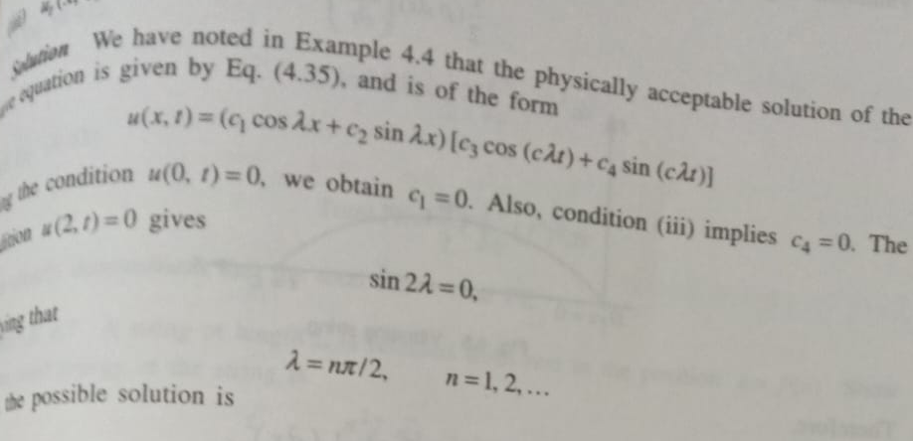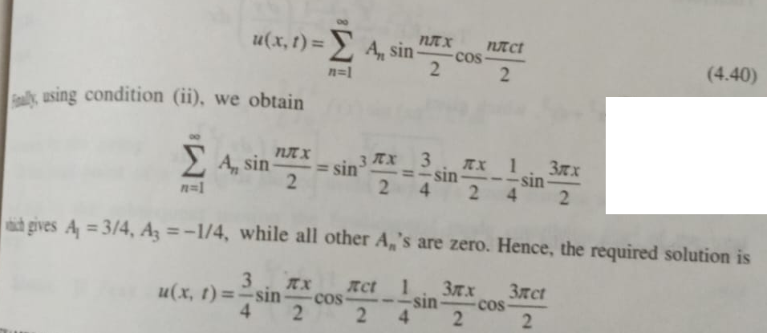
- State and prove Duhamel’s principle for wave equation
Ans: Statement $v_{tt}\left(X, t\right)- c^{2} ∇^{2} v\left(X, t\right)= 0, X in R_{3},$
$$v(X, 0, τ) = 0, v_{t}(X, 0, τ) = F(X, τ)$$
and $u\left(X, t\right)= \int_{0}^{t}{ v\left(X, t -τ, τ\right)} dτ$
then u(X, t) satisfies:
$u_{tt} - c^{2} ∇^{2} u = F(X, t), X in R_{3}, t > 0$
u(X, 0) = u_t(X, 0) = 0
Proof:
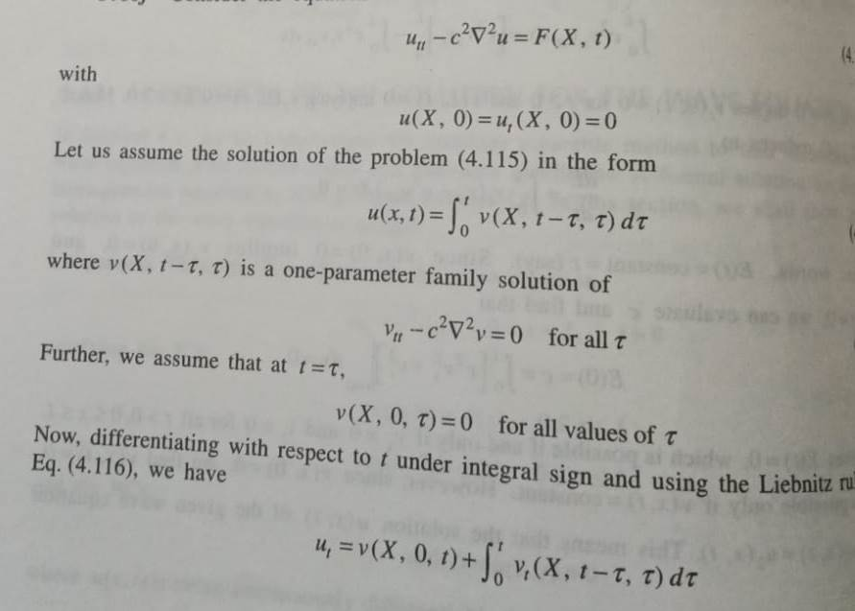
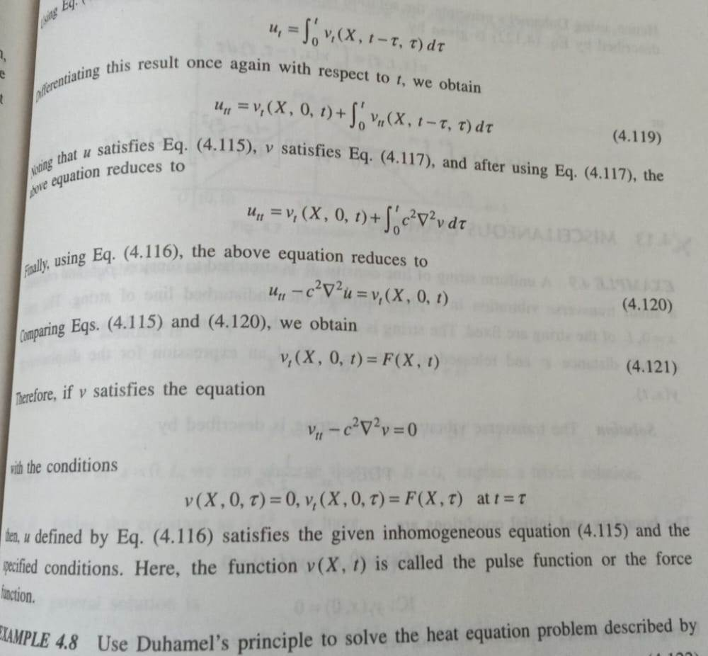
- Find the Green’s function for the Dirichlet problem on the rectangle $R:0≤x≤a, 0≤y≤b$ such that $\left(Δ^{2}+λ\right)u=0 in R with the boundary condition u=0 on ∂R.$

