STATISTICS FOR BUSINESS ANALYSIS 24UBBEC304

SECTION – A (10 X 2 =20 Marks)
Answer Any Ten Questions
1. Define sampling design.
Sampling design refers to the process of selecting a subset of individuals or items from a larger population, using a well-defined procedure, to collect data and make inferences about the population.
2. Summarize the questionnaire.
A questionnaire is a research instrument used to collect data from respondents, consisting of a series of questions designed to gather information on a specific topic or issue.
3. List the types of correlation.
Positive correlation, Negative correlation, Zero correlation, Linear correlation and Non-linear correlation.
4. Review the Karl Pearson’s coefficient of correlation.
A statistical measure that calculates the strength and direction of a linear relationship between two variables, denoted by r
5. Write the formula for the regression line of Y on X.
Y = a + bX, where: a = intercept, b = slope (regression coefficient).
6. Name the two types of regression lines.
Regression line of Y on X and Regression line of X on Y
7. Extend the Wholesale Price Index.
The Wholesale Price Index (WPI) is an economic indicator that measures the average change in prices of goods at the wholesale level.
8. Recall the uses of index numbers.
Measure price changes over time, Assist in economic policy decisions and Help in cost of living adjustments
9. Define secular trend.
A secular trend refers to a long-term, persistent pattern or direction in a time series, often representing a gradual change or shift in the underlying phenomenon.
10. Name any two components of seasonal variation in time series.
Quarterly fluctuations and Monthly fluctuations
11. State the meaning of sampling error.
Sampling error refers to the difference between the sample statistic and the population parameter, arising due to the selection of a sample rather than the entire population.
12. Relate the term of correlation.
A statistical relationship between two variables, indicating how one variable moves in relation to the other
SECTION – B (5 X 5 =25 Marks)
Answer Any Five Questions
13. Identify the essential components of a good questionnaire.
- Clear Objective
- Simple Language
- Logical Sequence
- Relevant Questions
- Avoid Leading Questions
- Balanced Options
- Proper Length
- Pilot Testing
14. Prepare correlation graph from the following data:
Period | Jan. | Feb. | Mar. | Apr. | May | June
Advt. (Rs. ‘000) | 20 | 25 | 28 | 32 | 36 | 40
Sales (Rs. ‘0000) | 30 | 36 | 37 | 41 | 43 | 48
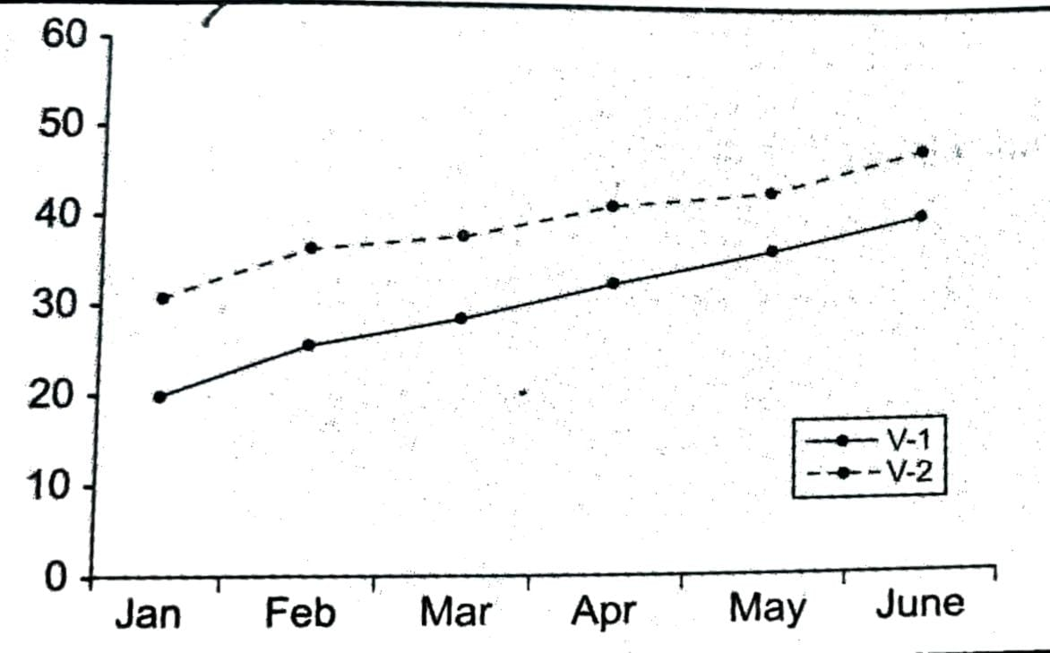

15. Construct the limitations and uses of regression analysis.
Limitations of Regression Analysis:
- Assumption-based
- Cannot prove causation
- Affected by outliers
- Limited to numerical data
- Model risk
Uses of Regression Analysis:
- Prediction
- Relationship Analysis
- Decision Making
- Trend Analysis
- Control and Planning
16. Find the Marshal – Edgeworth method of Index number from the following data:
 | 2005 |  | 2006
Commodity | Price | Quantity | Price | Quantity
A | 20 | 10 | 15 | 20
B | 25 | 20 | 21 | 16
C | 22 | 15 | 18 | 13
D | 35 | 5 | 23 | 15
E | 40 | 3 | 31 | 9
F | 30 | 10 | 18 | 12
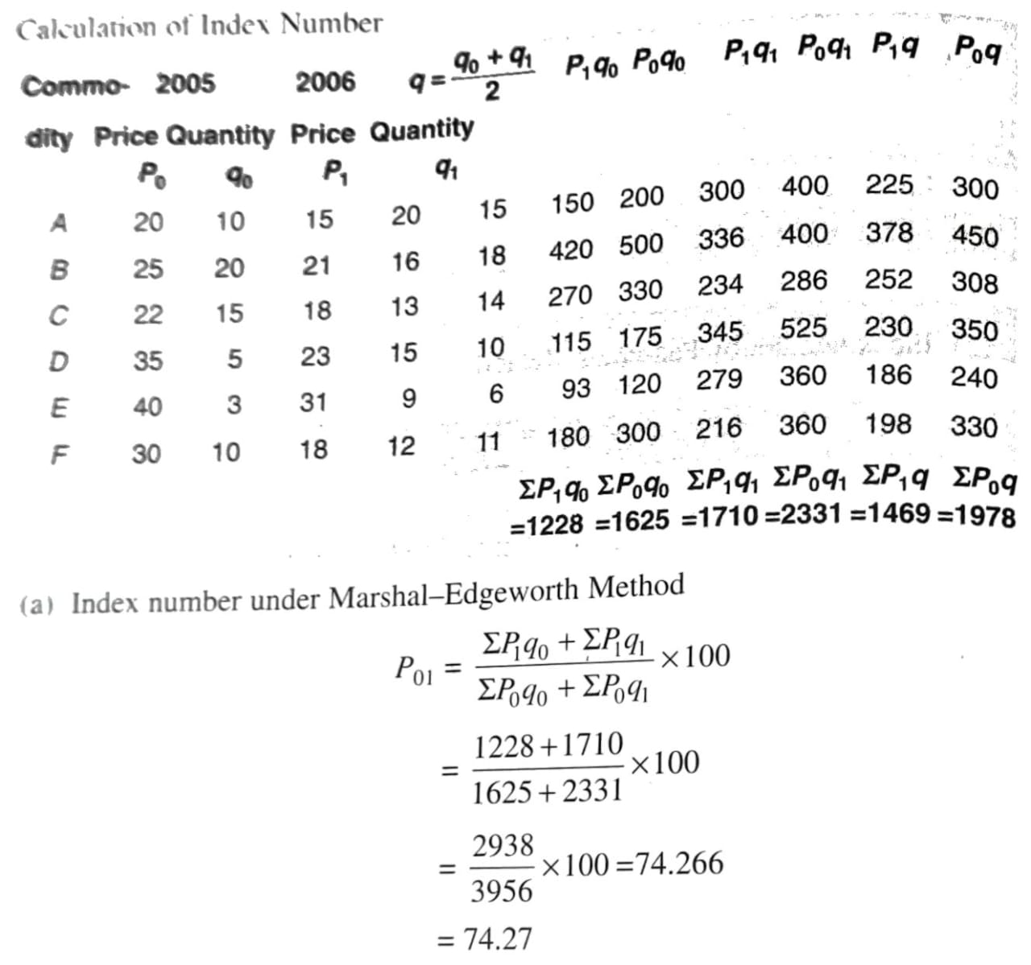

17. Compute the five yearly moving averages from the following data:
Year | 1991 | 1992 | 1993 | 1994 | 1995 | 1996 | 1997 | 1998 | 1999 | 2000
No of Students | 705 | 685 | 703 | 687 | 705 | 689 | 715 | 685 | 725 | 730
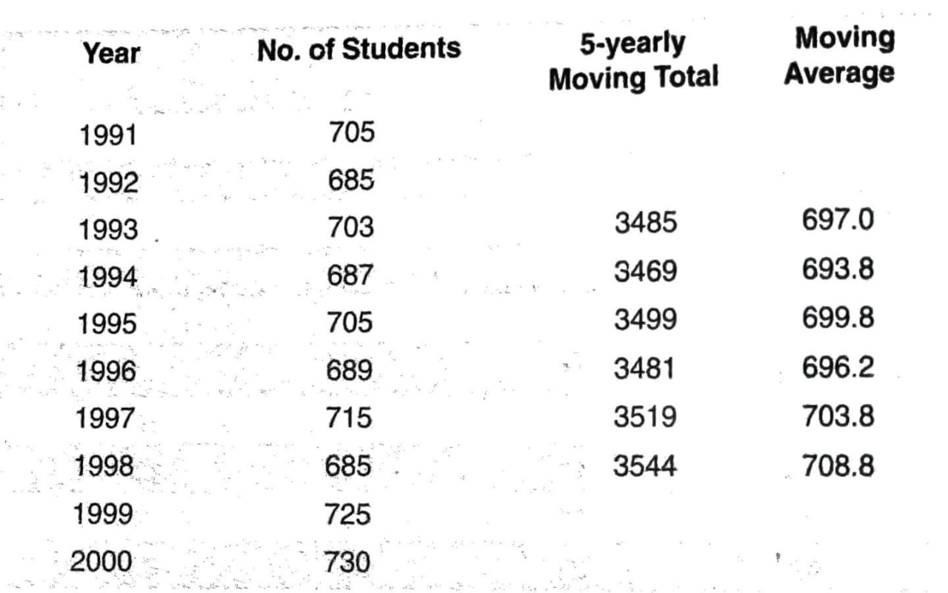

18. Analyse the steps involved in designing a sampling strategy.
- Define the population
- Determine the sample frame
- Select sampling method
- Decide sample size
- Plan data collection
- Implement sampling
- Check for sampling errors
19. Distinguish between positive and negative correlation.
Aspect | Positive Correlation | Negative Correlation
Direction | Both variables move in the same direction | One variable increases, the other decreases
Correlation coefficient (r) | r > 0 (e.g., +0.7) | r < 0 (e.g., -0.6)
Example | Height and weight | Price and demand
Graph pattern | Upward sloping line | Downward sloping line
Interpretation | Higher X → Higher Y | Higher X → Lower Y

SECTION – C (3 X 10 =30 Marks)
Answer Any There Questions
20. Describe the different types of sampling techniques.
Probability Sampling Techniques:
- Simple Random Sampling
- Systematic Sampling
- Stratified Sampling
- Cluster Sampling
Non-Probability Sampling Techniques:
- Convenience Sampling
- Judgment Sampling
- Quota Sampling
- Purposive Sampling
Other Sampling Techniques:
- Multistage Sampling
- Snowball Sampling
- Theoretical Sampling
21. From the following data relate to the marks obtained by 10 students of a class in Statistics
and Costing.
Statistics | 30 | 38 | 28 | 27 | 28 | 23 | 30 | 33 | 28 | 35
Costing | 29 | 27 | 22 | 29 | 20 | 29 | 18 | 21 | 27 | 22
Calculate Spearman’s rank correlation of co-efficient.
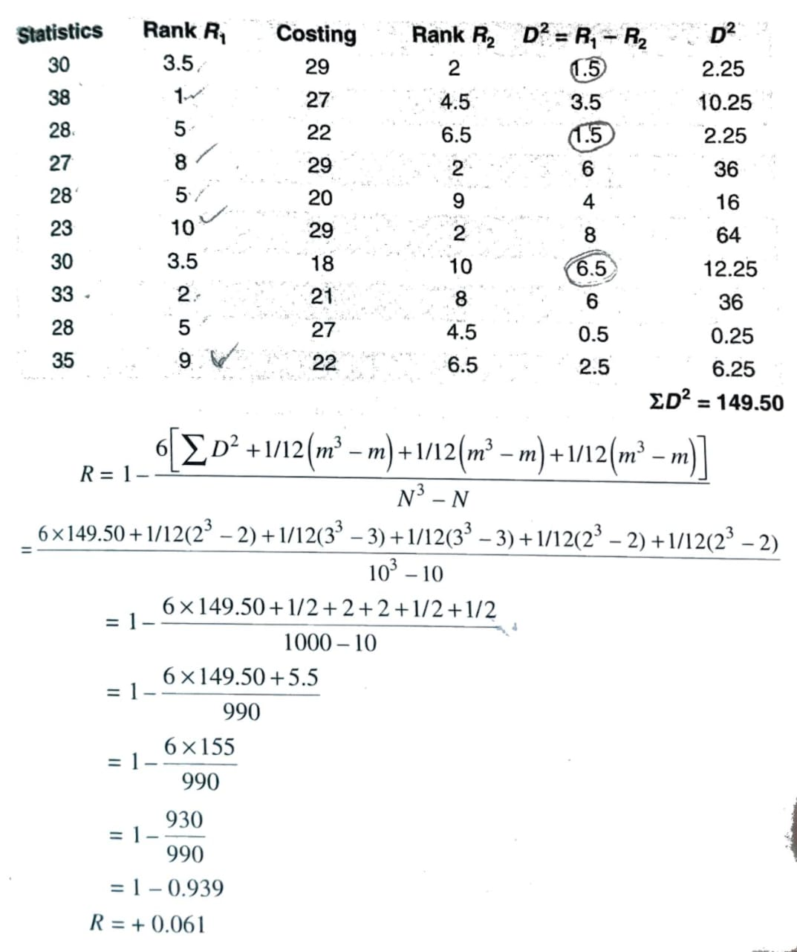

22. The following results were worked out from the scores in Economics and statistics in a
certain examinations:
 | Scores in Economics | Scores in Statistics
Mean | 39.5 | 47.5
S.D. | 10.8 | 17.8
Correlation co-efficient | -0.4
Find both the regression lines. Find the value of y for x = 50 and also find the value
of x for y = 30.
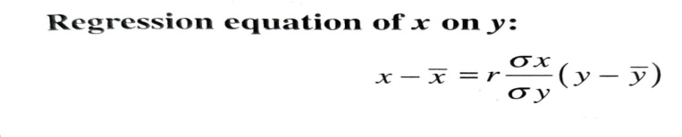

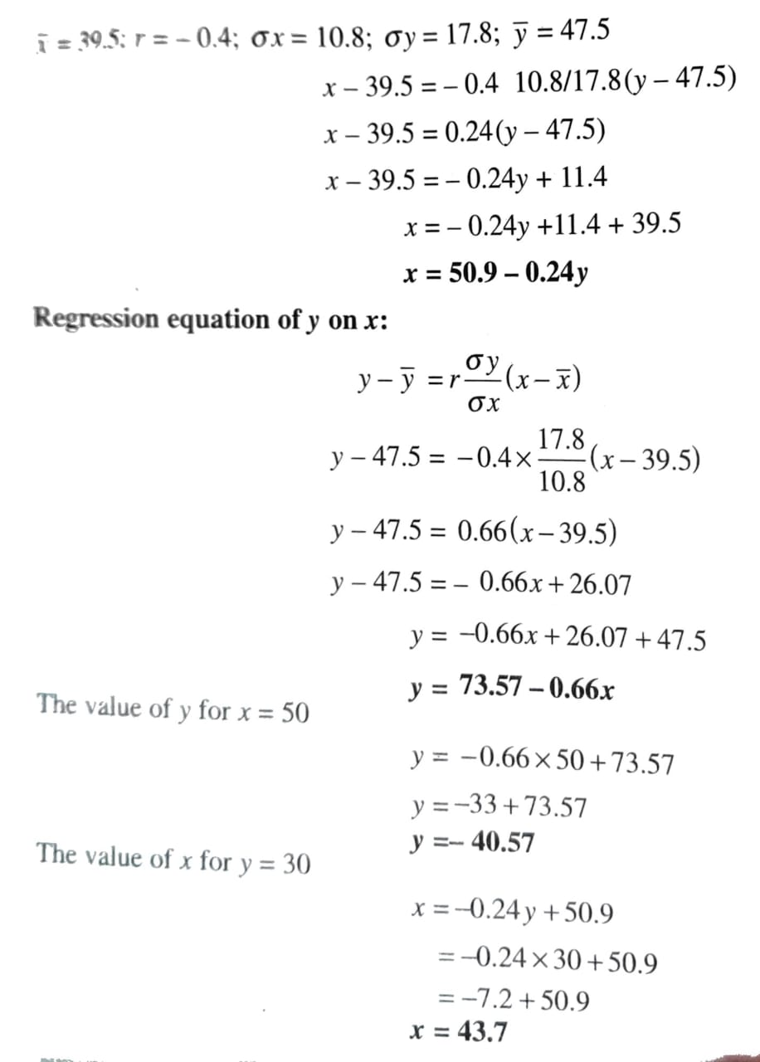

23. Calculate quantity index from the following data through (i) Laspeyre’s method
(ii) Paasche’s method and (iii) Fisher’s method.
 | 2005 |  | 2006
Commodity | Price | Quantity | Price | Quantity
A | 35 | 10 | 35 | 12
B | 31 | 15 | 42 | 16
C | 23 | 12 | 32 | 10
D | 20 | 14 | 25 | 15
E | 40 | 8 | 35 | 10
F | 32 | 6 | 45 | 6
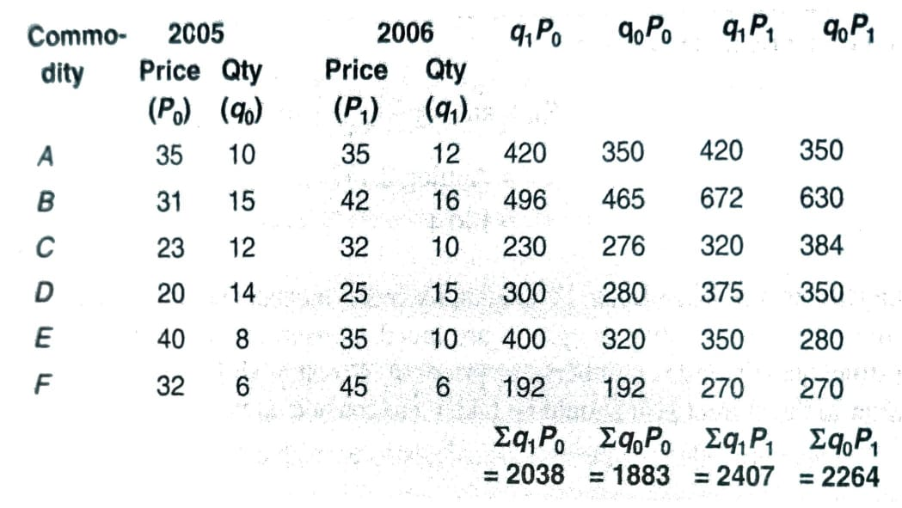

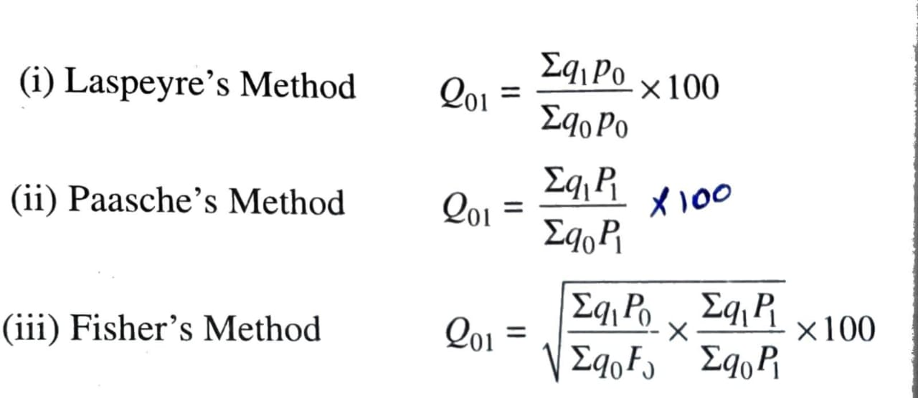

(i) Laspeyre’s method = 108.23
(ii) Paasche’s method = 127.83
(iii) Fisher’s method = 107.27
24. Explain the components of a time series. What are the main objectives of constructing the
a time series?
Components of a Time Series:
- Trend
- Seasonal Variation
- Cyclical Variation
- Irregular or Random Variation
Main Objectives of Constructing a Time Series:
- To understand past behaviour
- To identify patterns
- To forecast future values
- To aid decision-making
- To compare performance

