ANNA ADARSH COLLEGE FOR WOMEN (AUTONOMOUS),
CHENNAI – 40
END SEMESTER EXAMINATION– April/May 2026
Subject Name
Answer Key

PART- A (10 × 2 = 20 Marks)
Answer any TEN questions.

- Hypothesis testing is a statistical method used to make decisions about a population parameter based on sample data by either accepting or rejecting a hypothesis.
- Correlation is a statistical measure that indicates the degree and direction of relationship between two variables.
- Analysis of Variance (ANOVA) is a statistical technique used to test whether there are significant differences among the means of three or more groups by analyzing the variance within and between groups.
- It helps predict or understand how changes in the independent variable(s) are associated with changes in the dependent variable.

The sign test is a non-parametric test used to compare paired observations by considering only the direction of difference (+ or −).

One-Tailed Test
A test where the critical region lies entirely on one side of the distribution.
- Right-tailed: H₁: μ > μ₀
- Left-tailed: H₁: μ < μ₀
- Confidence Interval:
An interval estimate with a specified confidence level.
- Degree of freedom is the number of independent observations, usually n – 1.
- A large F-value indicates that the between-group variance is much larger than the within-group variance, meaning that the differences among group means are statistically significant.
- Statistics is the branch of science that deals with the collection, organization, presentation, analysis, and interpretation of numerical data to make meaningful decisions and conclusions.
- It tests whether the observed frequencies fit a theoretical or expected distribution.
- Post hoc tests are statistical tests conducted after a significant ANOVA result to determine which specific group means differ from each other.

PART - B (5 × 5 = 25 Marks)
Answer any FIVE questions.

Steps in Hypothesis Testing
- Formulate hypotheses
- Choose level of significance
- Select test statistic
- Determine critical value or p-value
- Make decision (accept or reject H₀)

14.. Types of t-tests:
1. One Sample t-test
Used to compare sample mean with population mean.

2. Independent Sample t-test
Used to compare means of two independent samples.

3. Paired Sample t-test
Used when observations are related or paired.
15 .
X | Y | X² | Y² | XY
2 | 40 | 4 | 1600 | 80
4 | 50 | 16 | 2500 | 200
6 | 60 | 36 | 3600 | 360
8 | 65 | 64 | 4225 | 520
10 | 70 | 100 | 4900 | 700
 |  | ΣX = 30 | ΣY = 285
 |  | ΣX² = 220 | ΣY² = 16825 | ΣXY = 1860

  - In simple linear regression, we assume that there is a linear relationship between the two variables, which means that the change in the independent variable is directly proportional to the change in the dependent variable.

Multiple linear regression is a statistical technique used to model the relationship between two or more independent variables and a dependent variable.

Wilcoxon’s Signed Ranks Test
- Alternative to paired t-test
- Considers rank and sign of differences

Kruskal-Wallis Test
- Alternative to one-way ANOVA
- Compares 3 or more independent groups

Uses:
- Educational and psychological research
- Non-normal data sets

Assumptions of z-test
- Random sampling
- Normal population or large sample size
- Known population variance
  - Calculation of total sum of squares
Calculation of With in group sum of squares
Calculation of between group sum of squares
Calculation of df
Computation of F Value

PART - C (3 × 10 = 30 Marks)
Answer any Three questions

20. Hypothesis: Types, and Characteristics
A hypothesis is a tentative assumption made to test its validity using statistical methods.
Types: Null hypothesis, Alternative hypothesis, Simple hypothesis, Composite hypothesis.
Characteristics: Clear, testable, specific, consistent with known facts.

21.
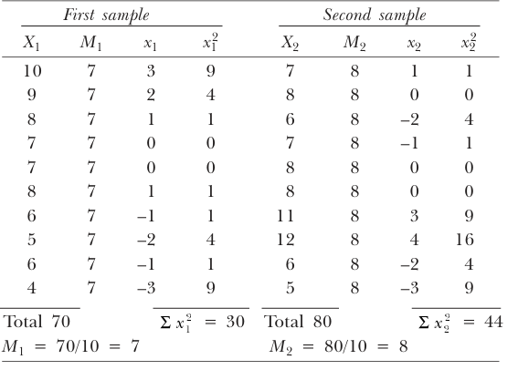

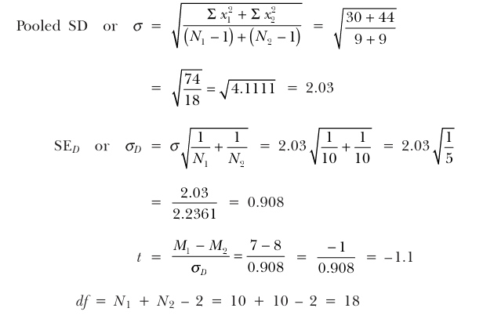

22. One-Way ANOVA
One-way ANOVA is used to test whether three or more group means differ significantly based on one independent variable (factor).

(a) Between-Group Variation
- Measures differences between group means.
- Caused by the effect of the independent variable.
- Large between-group variance indicates real differences among groups

Within-Group Variation
- Measures differences within each group.
- Caused by individual differences or random error.
- Smaller within-group variance improves sensitivity of ANOVA.

23. Concept of Regression Line
A regression line is a straight line that represents the best possible relationship between the independent variable (X) and the dependent variable (Y).
- It is also called the line of best fit.
- The regression line minimizes the sum of squared deviations between observed and predicted values of Y.
- It shows how Y changes when X changes.

Concept of Regression Equation
The regression equation is the algebraic expression of the regression line.

Simple Linear Regression Equation
Y=a+bXY = a + bXY=a+bX
Where:
- Y = dependent variable
- X = independent variable
- a = intercept (value of Y when X = 0)
- b = regression coefficient or slope

24. A non-parametric test is a statistical test that does not require assumptions about the form of the population distribution and is often based on ranks, signs, or frequencies rather than raw scores.

Characteristics of Non-Parametric Tests
- Do not require normal distribution
- Can be used with small samples
- Suitable for ordinal and nominal data
- Based on ranks, signs, or frequencies
- Less powerful than parametric tests, but more flexible

