ANNA ADARSH COLLEGE FOR WOMEN (AUTONOMOUS),
CHENNAI – 40
END SEMESTER EXAMINATION– April/May 2026
Subject Name: Operations Research
Max. Marks: 75 TIME:3 Hrs
PART- A (10 × 2 = 20 Marks)
Answer any TEN questions.
- The ambiguous term operations research (O.R.) was coined during World War II, when the British military management called upon a group of scientists together to apply a scientific approach in the study of military operations to win the battle. The main objective was to allocate scarce resources in an effective manner to various military operations and to the activities within each operation.
- An optimal solution to a linear program is the solution which satisfies all constraints with maximum or minimum objective function value.
- A slack variable is a non-negative variable added to a "less than or equal to" (≤) inequality constraint in linear programming to convert it into an equality, representing unused resources or the gap between the current usage and the maximum limit.
- An Initial Basic Feasible Solution (IBFS) in Operations Research, especially for Transportation Problems, is a starting allocation of goods that meets all supply and demand constraints, uses only basic variables (non-zero allocations at specific routes), and satisfies non-negativity, often found using methods like North-West Corner, Least Cost, or Vogel's Approximation Method (VAM) to serve as a foundation for finding the optimal solution.
- An assignment problem is a particular case of transportation problem where the objective is to assign a number of resources to an equal number of activities so as to minimise total cost or maximize total profit of allocation.
- The main methods for finding an Initial Basic Feasible Solution (IBFS) in a Transportation Problem are the North-West Corner Rule (NWCR), the Least Cost Method (LCM), and Vogel's Approximation Method (VAM).
- In game theory, a Saddle Point is an element in a payoff matrix that's the minimum in its row and maximum in its column, representing a stable pure strategy solution; the payoff at this point is the Value of the Game.
- A Pure Strategy in game theory is a player's definitive plan to always choose one specific action or course of action with certainty, without any randomization, often based on knowing the opponent's moves or seeking a deterministic optimal outcome.
- The lower limit for the stock is fixed at which the purchasing activities must be started for replenishment. With this replenishment, the stock reached at a level is known as maximum stock. The level between maximum and minimum stock is known as the reorder level.
- The just-in-time (JIT) inventory system times the arrival of materials so companies only receive what they need exactly when production calls for it, helping them reduce waste and lower holding costs. This method hinges on accurate demand forecasting, seamless supplier coordination, and reliable production scheduling.
- Network Analysis is the process of modelling project activities, dependencies, and sequences using diagrams (like PERT/CPM) to identify critical paths, manage time/resources, and optimize project flow.
- Dummy Activity is a zero-duration, zero-resource link (dashed line) in these diagrams used solely to show logical precedence, maintain network rules (like unique activity identification), and clarify complex dependencies between real tasks.

PART - B (5 × 5 = 25 Marks)
Answer any FIVE questions.
- The limitations of Operations Research (OR) include:
Heavy Dependence on Accurate Data: OR relies heavily on precise and reliable data; even a small error can lead to misleading results. Simplifying Assumptions: Models often make simplifying assumptions that may not reflect realworld complexities, leading to suboptimal solutions. Complexity of Models: OR involves complex mathematical and statistical models that can be difficult for nonexpert users to understand and implement.
Human Factors: OR models often ignore human behavior, emotions, and biases, which can significantly impact decisionmaking. Cost and Time: Implementing OR solutions can be expensive and time-consuming, making them less accessible for small organizations.

- max z = 147.5, x₁ = 2.5, x₂ = 35

- Transportation cost = Rs.153

FROM | TO
FROM | 2  3 | 11  1 | 10 | 3 | 7
FROM | 1 | 4  2 | 7  4 | 2  2 | 1
FROM | 3 | 9 | 4 | 8  3 | 12  6

- consider the problem of assigning n jobs to n machines (one job to one machine). Let C_{ij} be the cost of assigning i^{th} job to the j^{th} machine and x_{ij} represents the assignment of i^{th} job to the j^{th} machine.

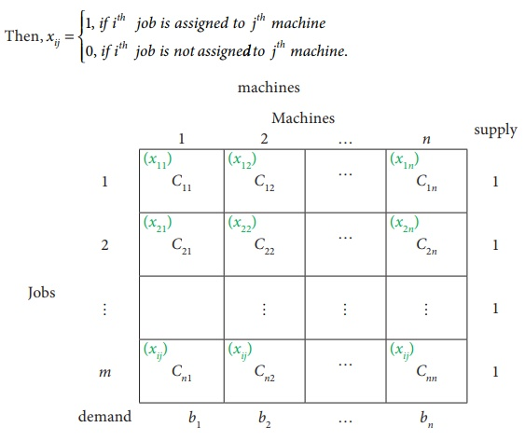

- The best strategy for A is II.
The best strategy for B is III.
The value of the game A is 4 and B is – 4.
- The Economic Order Quantity (EOQ) model is a formula in inventory management that finds the ideal order size to minimize total costs, balancing expensive holding costs (storage, obsolescence) against ordering costs (placing an order), preventing both stockouts and overstocking by determining the most economical quantity to purchase at once. It assumes steady demand, fixed lead times, and constant costs, using parameters like annual demand (D), ordering cost per order (S), and annual carrying cost per unit (H) to find the optimal quantity (Q).
Core Concept
Objective: Minimize total inventory costs (ordering + carrying).
Trade-off: Larger orders reduce ordering frequency but increase holding costs; smaller orders do the opposite. EOQ finds the "sweet spot" where these costs balance.
- Network diagram.

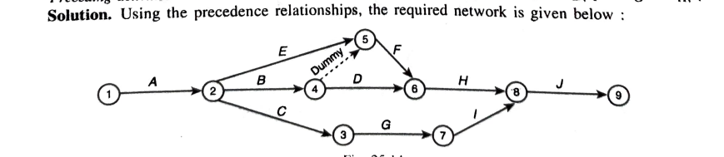

PART - C (3 × 10 = 30 Marks)
Answer any Three questions

- min Z = 3 x₁ + 8 x₂
Sub to the constriants
x₁ + x₂ = 200
x₁ ≤ 80
x₂ ≥60
x₁≤ 0, x₂≤ 0.

- Transportation cost = Rs.1710

6 | 1 | 9 25 | 3  45
11  30 | 5 | 2  25 | 8
10  55 | 12  35 | 4 | 7

- The reduced matrix is

$\begin{matrix}2 & 4 \\ 5 & 2\end{matrix}$

- Data: λ = 9,000 units per year, C₁ = Rs. 2.40 per year per unit, C₃ = Rs. 100/- per procurement.
(a) q₀ = sqrt of 2C₃λ / C₁ = sqrt of 2 ×100 × 9000) / 2.40 = 866 units per procurement.
(b) N = (1/t₀) = sqrt of C₁ × λ / 2 C₃ = 2.40 × 9 000 / 2 x 100 = sqrt of 108 = 10.4 orders per year.
(c) t₀ = 1 / N = 1 / 10.4 = 0.0962 years between orders.
(d) C₀ = sqrt of 2 C₁C₃ λ = 2 × 2 .40 × 100 × 9000 = Rs. 2,080/-
Total cost including material cost = 9000 × 1 + 2,080 = Rs. 11, 080/- per year.

- Network diagram no dummy activity.
a) Critical path = 1-2-4-6-7-8-10
b) expected duration = 29 weeks.
c) expected variance of the project length = 1.67.

