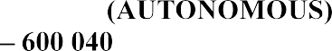

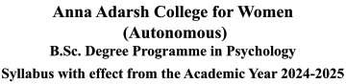

SECTION – A (10X2=20 MARKS) Answer any ten questions

1 | Differentiate between algorithms and heuristics | K2 | CO1
2 | Distinguish inductive and deductive reasoning with examples. | K2 | CO1
3 | Define encoding failure and retrieval failure | K1 | CO2
4 | Infer the role of schemas in memory distortion. | K2 | CO2
5 | State Flashbulb memory. | K1 | CO2
6 | State Arousal theory of motivation | K1 | CO3
7 | Define ERG theory of motivation | K1 | CO3
8 | List the factors that play in the regulation of eating | K1 | CO
9 | Outline cognitive basis of intelligence | K1 | CO4
10 | Interpret how emotional intelligence influence decision making | K2 | CO4
11 | Differentiate between male and female Oedipus state | K2 | CO5
12 | Define phylogenetic endowment. | K1 | CO5

SECTION - B (5 × 5 = 25 Marks) Answer any FIVE questions.

13 | Analyse the components of language | K4 | CO1
14 | Examine Atkinson and Shiffrin model of memory. | K4 | CO2
15 | interpret Psychological motives | K3 | CO3
16 | Appraise the significance of Thurstone’s contribution to intelligence theory. | K4 | CO4
17 | Illustrate OCEAN model with suitable examples | K3 | CO5
18 | Investigate the role of mental imagery in cognition | K4 | CO1
19 | Outline the evolution of intelligence testing. | K4 | CO4

PART - C (3 × 10 = 30 Marks) Answer any Three questions

20 | Explain the process of problem solving and discuss the barriers that affect it. | K5 | CO1
21 | Describe the causes of forgetting and suggest effective study strategies. | K5 | CO2
22 | Describe Biological basis of hunger and thirst motivation | K4 | CO3
23 | Appraise with evidence suggesting intelligence is influenced by genetic factor | K5 | CO4
24 | Evaluate the trait theory of personality. | K5 | CO5

Knowledge Level as per Bloom’s Taxonomy
K1 – Remember; K2 – Understand K3 – Apply K4 – Analyse K5- Evaluate K6 - Create

